[](https://www.youtube.com/channel/UCEaRcNDVl6TFhn29PMt5pmw)

[**Microsoft Power BI Vlogs**](https://www.youtube.com/channel/UCEaRcNDVl6TFhn29PMt5pmw)

**Power BI Desktop Installation**

Power BI Desktop lets you build advanced queries, models, and reports that visualize data. With Power BI Desktop, you can Prepare/Transform data, build data models, create reports, and share your work by publishing to the Power BI service or Power BI Report Server.

**Data Preparation 🡪 Query Editor**

**Data Modeling 🡪 Relationship View+ Data View**

**Data Visualization 🡪 Report View**

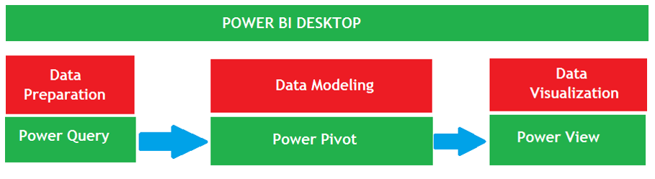

Power BI Desktop is free Software where Companies and Individuals can use it for Free.

**System Requirements**

**Supported Operating System**

* Windows 10, Windows 7, Windows 8, Windows 8.1, Windows Server 2008 R2, Windows Server 2012, Windows Server 2012 R2.

**Pre-installed software’s required**

* Internet Explorer 9 or Later.
* Microsoft .NET Framework 4.7 or Later

[**Install Instructions**](https://www.microsoft.com/en-us/download/details.aspx?id=45331&751be11f-ede8-5a0c-058c-2ee190a24fa6=True&e6b34bbe-475b-1abd-2c51-b5034bcdd6d2=True)

* Download the version of Power BI Desktop that matches the architecture (x86 or x64) of your Windows OS.
* Microsoft Power BI Desktop is available for 32-bit (x86) and 64-bit (x64) platforms.
* Power BI Desktop is free software and it is available at Below Microsoft's Power BI Site ([Downloads | Microsoft Power BI](https://powerbi.microsoft.com/en-us/downloads/))

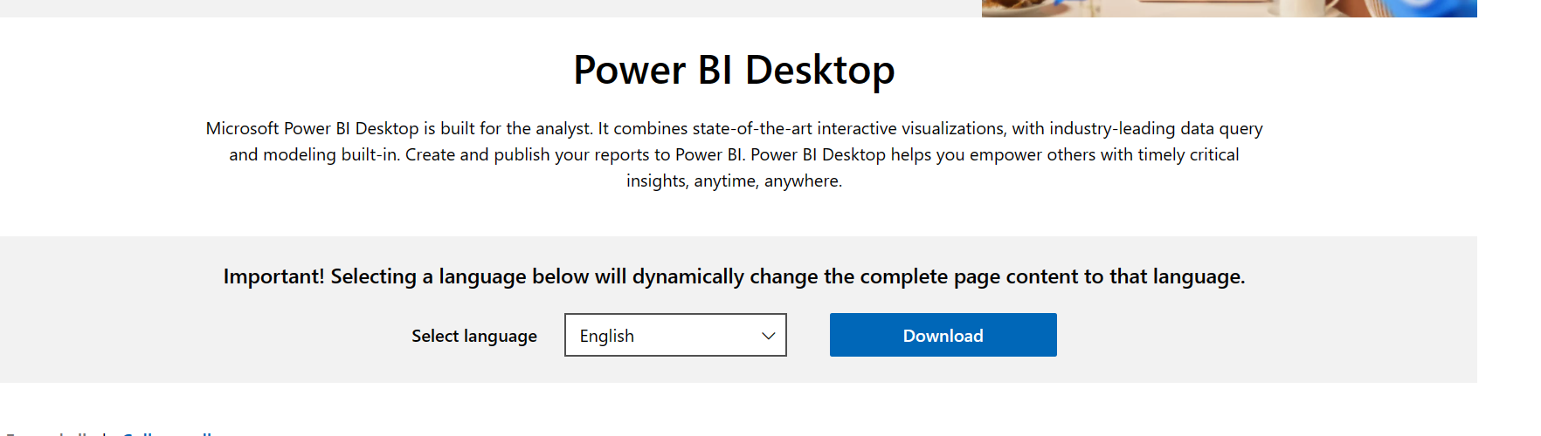

When you click on “See Download or Language Options”, it will open the Below Link where you can download the Power BI Desktop Software.

([Download Power BI Desktop from Official Microsoft Download Center](https://www.microsoft.com/en-us/download/details.aspx?id=58494))

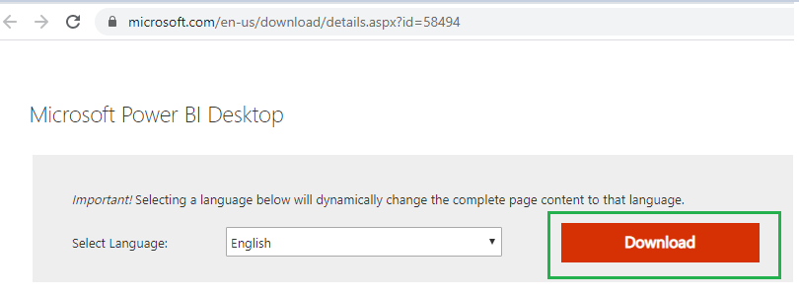

* By clicking on Download, it will open a Page where it will ask which Version of Software you need. If you have Windows 64 Bit Operating System installed in your Computer the select 64 Bit Power BI Software.

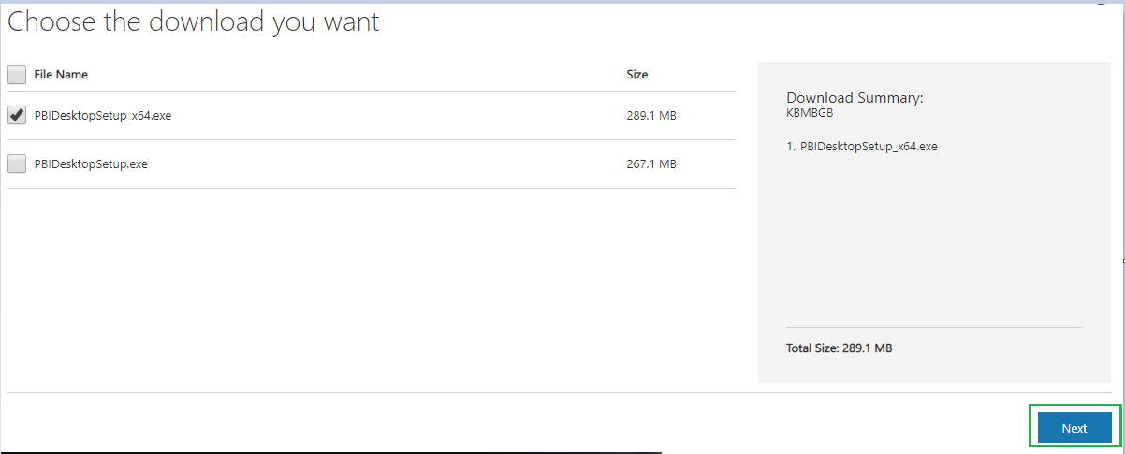

* Once Click on Next Software will be downloaded. Once after download Double Click on the Software to run the **EXE** installer and follow the setup steps, No Configuration Required.

**Opening Power BI Desktop**

* All Programs 🡪 Microsoft Power BI Desktop 🡪Power BI Desktop (OR)
* Double Click on the Shortcut Created in Desktop to Open Power BI Desktop
* The following image shows the Start Screen of Power BI Desktop, which appears when you start the application.

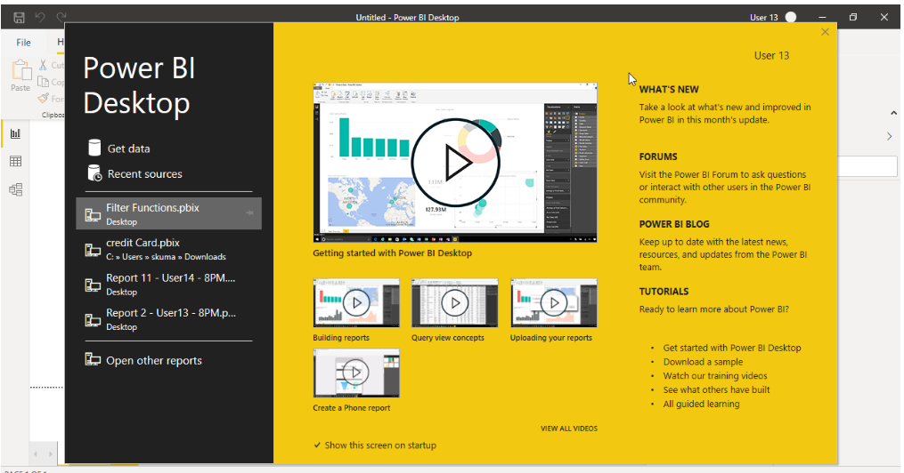

* From the start page or start screen you can connect to different data sources, can connect to recent sources, you can open existing saved reports, can access power BI Blogs, Forums, Tutorials so on.
* Once you close the start page then we will enter in Power BI Desktop Home page.
* If you close the screen (select the x in the top right corner), the Report view of Power BI Desktop is displayed as shown below.

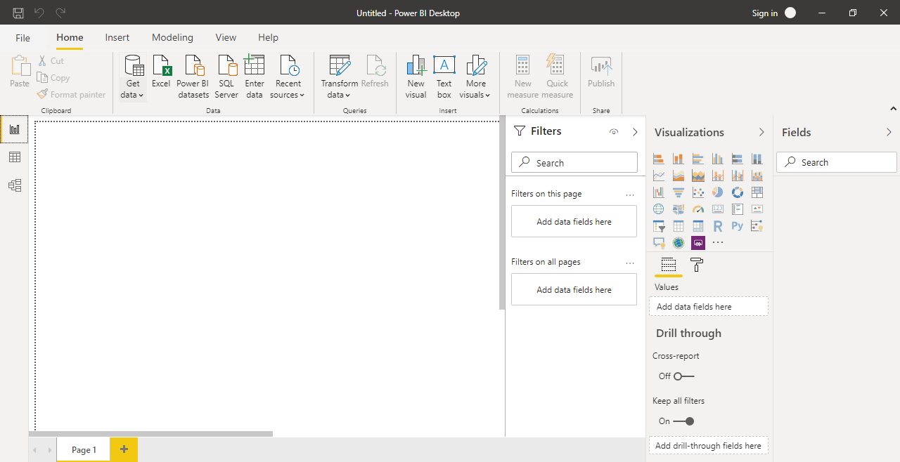

We know that Power BI Desktop Software Contains three Software’s internally. Let’s Start understand about them now.



**Power Query Software Overview**

* Power Query is used for Data Extraction, Transformation and Loading. It’s an ETL Software in Power BI.

**Opening Power Query Software**

To Open Power Query Software Go to Home Tab 🡪 Transform Data

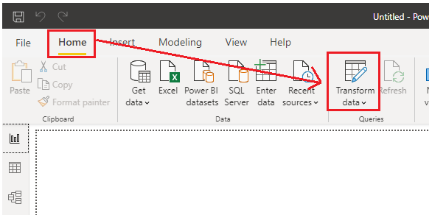

Once Click on Transform Data Power Query Software / Power Query Editor User Interface will open to perform ETL Activities as Shown Below

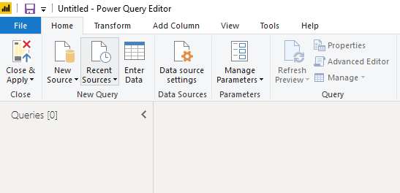

In Power Query first we need to extract the Data from Data Sources. Let’s see how to extract the Data from Excel. To Extract the Data from Excel, Go to Home Tab 🡪Click on New Source and select Excel as Source.

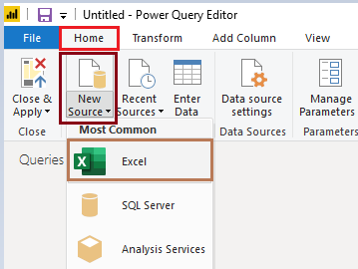

Once you select Excel it will ask to Browse where your Excel File is Located. Select your Excel workbook from the Open dialog that appears 🡪 Select Open

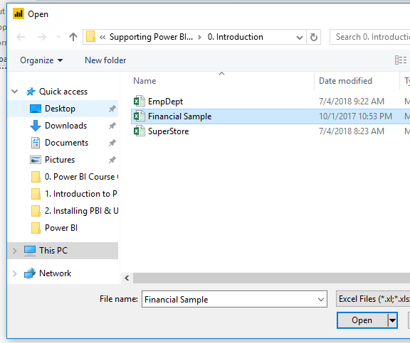

**Connecting to Excel**

Select Get Data > Excel from the Home ribbon.

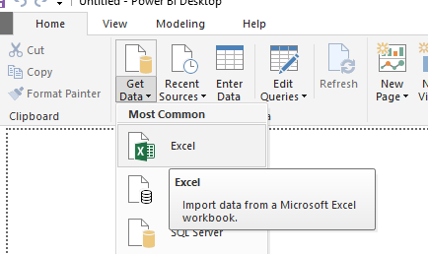

Select your Excel workbook from the Open dialog that appears 🡪 Select Open



Power BI Desktop presents the tables and other data elements from the workbook in the Navigator window. When you select a table in the left pane, a preview of the data appears in the right pane.

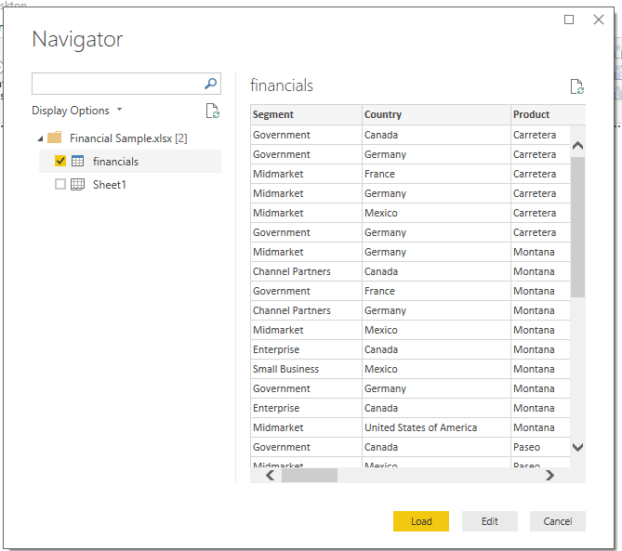

You can select the Load button to import the data, or if you want to edit the data using Query Editor before bringing it into Power BI Desktop, select the Edit button.

When you load the data, Power BI Desktop displays the Load window and displays the activity associated with loading the data.

* Once you load data into Power BI Desktop you will see the below screen.

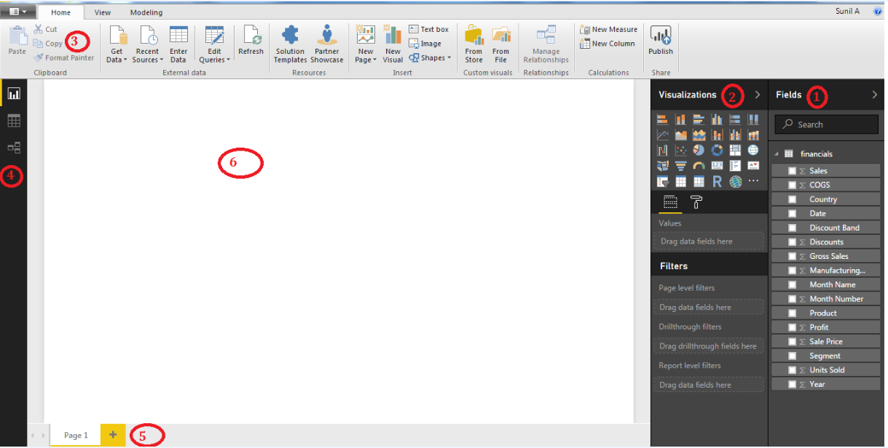

The Visualizations and Fields pane can be collapsed by selecting the small arrow along the edge, providing more space in the Report view to build cool visualizations.

**Understanding Power BI Desktop User Interface (UI)/ Report View**

1. **Data Pane**

* Data Area will contain the tables with columns that are loaded into Power BI Desktop.

1. **Visualizations pane**

The Visualizations pane will contain list of visualizations available in Power BI. And you can also download a custom visual from the visuals gallery. Here you can change visualizations, customize colors or axes, apply filters, drag fields, and more.

1. **Ribbon**

* It will contain the options that are associated with reports and visualizations.

1. **Views**

* Report View
* Data View
* Relationships View

1. **Pages Tab**

* The Pages tab area along the bottom, which lets you select or add a report page.

1. **Canvas**

* Canvas is the place where visualizations are created and arranged.

**With Power BI Desktop, you can do**

Data Preparation 🡪 Query Editor

Data Modeling 🡪 Relationship View+ Data View

Data Visualization 🡪 Report View

**Get and Shape or Transform data - Power Query**

* The Power BI Desktop makes discovering data easy. You can import data from a wide variety of data sources.
* After you connect to a data source, you can shape the data to match your analysis and reporting needs.

**Create relationships and enrich your data model with new measures and data formats – Power Pivot**

* When you import two or more tables, oftentimes you'll need to create relationships between those tables.
* The Power BI Desktop includes the Manage Relationships dialog and the Relationships views, where you can use Auto detect to let the Power BI Desktop find and create any relationships, or you can create them yourself.
* You can also very easily create your own measures and calculations or customize data formats and categories to enrich your data for additional insights.

**Create reports – Power View**

* The Power BI Desktop includes the Report View. Select the fields you want, add filters, choose from dozens of visualizations, and format your reports with custom colors, gradients and several other options.

**Power View = Fields + Visualizations + Report View.**

**Save your reports**

* With the Power BI Desktop, you can save your work as a Power BI Desktop file. Power BI Desktop files have “**. pbix”** extension.
* Power BI Report template (pbit) file, which contains the report definition minus the dataset.

**Upload or publish your reports**

* You can upload the reports you created and saved in the Desktop to your Power BI Service or Power BI Report Server.

**Report View / Power View in Power BI Desktop**

Power BI Desktop includes Report View, where you can create any number of report pages with visualizations. Report View in provides pretty much the same design experience as a report’s Editing View in the Power BI service. You can move visualizations around, copy and paste, merge, etc.

The difference is, when using Power BI Desktop, you can work with your queries and model your data to make sure your data supports the best insights in your reports. You can then save your Power BI Desktop file wherever you like, whether it be your local drive or to the cloud.

Once you load data into Power BI Desktop you will enter into the Report View and you will see the below screen.



The Visualizations and Fields pane can be collapsed by selecting the small arrow along the edge, providing more space in the Report view to build cool visualizations.

**Understanding Power BI Desktop User Interface (UI)/ Report View**

1. **Fields Pane**

* Fields Area will contain the tables with columns that are loaded into Power BI Desktop.

1. **Visualizations pane**

The Visualizations pane will contain list of visualizations available in Power BI. And you can also download a custom visual from the visuals gallery. Here you can change visualizations, customize colors or axes, apply filters, drag fields, and more.

1. **Ribbon**

* It will contain the options that are associated with reports and visualizations.

1. **Views**

* Report View
* Data View
* Relationships View

1. **Pages Tab**

* The Pages tab area along the bottom, which lets you select or add a report page.

1. **Canvas**

* Canvas is the place where visualizations are created and arranged.

You can switch between Report View, Data View, and Relationship View by clicking on the icons in the left hand navigation bar.



Once you’ve added some data to Power BI, you can add fields to a new visualization in the canvas.

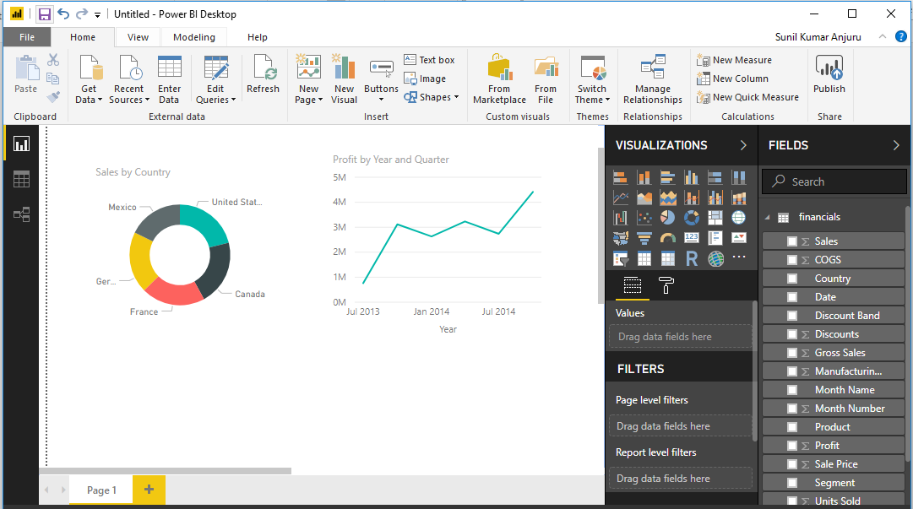

To change the type of visualization, you can select it from the **Visualizations** group.

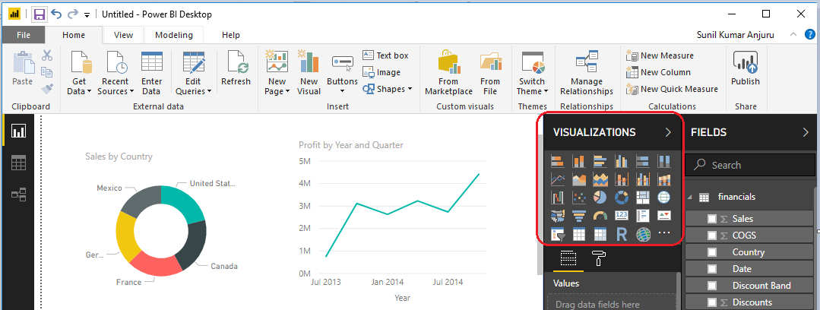

Be sure to experiment with different visualization types. It’s important your visualization convey information in your data clearly.

A report will have at least one blank page to start. Pages appear in the navigator pane just to the left of the canvas. You can add all sorts of visualizations to a page, but it's important not to overdo it. Too many visualizations on a page will make it look busy and difficult to find the right information. You can add new pages to your report, just click **New Page** on the ribbon.

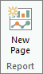

To delete a page, click the X on the page's tab at the bottom of the Report View.

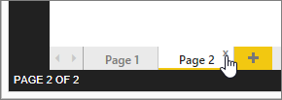

**Power BI Visual Interactions (Ad-hoc filtering and highlighting)**

Power BI visuals are interactive with each other. Selecting an item in a visual will effect on the display of another Visual. Sometimes this effect is highlighting items in another Visuals, and sometimes filtering values in the other visuals. By default, all visuals in a report page are interactive with each other. However, this interactivity can be controlled and modified.

**Default Behavior**

All visuals in Power BI report page are interactive with each other. If you click on a chart other charts will be highlighted or filtered.

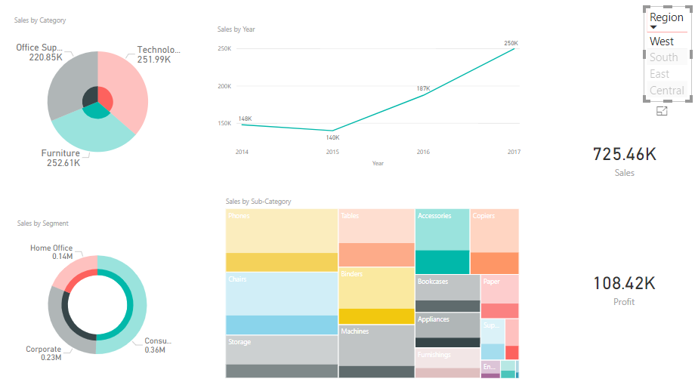

**Changing the Interaction**

To change the interaction of a visual with other visuals, select the main Visual (the chart that you want to control effect of that on other Visuals), and then from menu select Format, click on Edit Interactions.

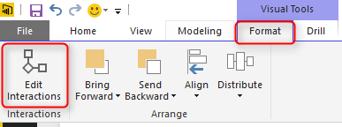

You will now see all other visuals in the page with two or three buttons on the top right hand side corner of each. These are controls of interaction. Based on the requirement we will select the interaction Type.

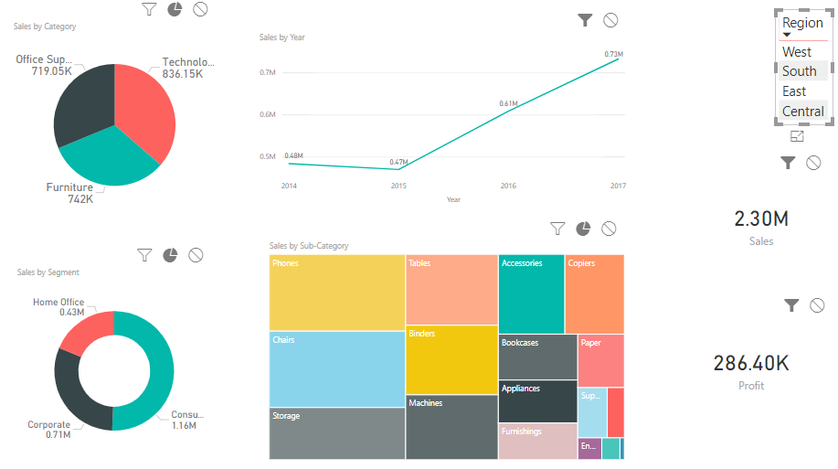

If you want to cross-filter the visualization, select the filter icon.

If you want to cross-highlight the visualization, select the highlight icon.

If you don’t want to filter or highlight the Visualization, select the no impact icon.

**Drillthrough in Power BI Desktop**

With drillthrough in Power BI Desktop, you can create a page in your report that focuses on a specific entity - such as a supplier, customer, or manufacturer. Users can right-click on a data point in other report pages and drillthrough to the focused page to get details that are filtered to that context.

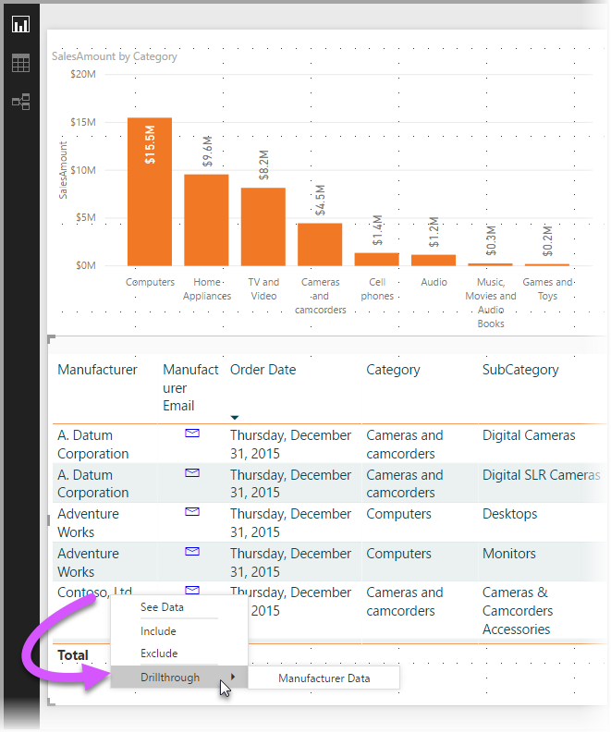

**Using drillthrough**

To use drillthrough, create a report page that has visuals you'd like to see for the type of entity on which you'll provide drillthrough.

For example, if you're interested in providing drillthrough for manufacturers, you might create a drillthrough page with visuals that show total sales, total units shipped, sales by category, sales by region, and so on. That way, when you drillthrough to that page, the visuals will be specific to the manufacturer you selected.

Then, on that drillthrough page, in the Fields section of Visualizations pane, drag the field about which you want to drillthrough into the Drillthrough filters well.

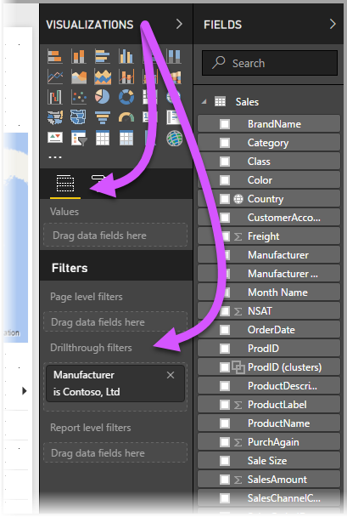

When you add a field to the Drillthrough filters well, Power BI Desktop automatically creates a back button visual. That visual becomes a button in published reports, and lets users who are consuming your report in the Power BI service easily get back to the report page from which they came (the page from which they selected to drillthrough).

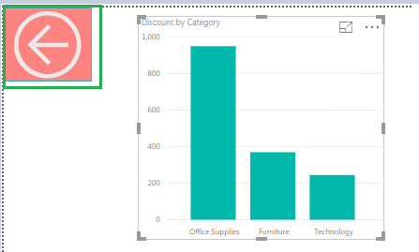

**Filters in Power BI**

Data filtering will involve taking out information that is useless to a reader or information that can be confusing. Generated reports and query results from database tools often result in large and complex data sets. Redundant or impartial pieces of data can confuse a user. Filtering data can also make results more efficient.

Whether you're using Desktop or Power BI service, the Filters pane displays along the right side of the report canvas.

**There are four types of filters**

* Visual Level Filters
* Page Level Filters
* Report Level Filters
* Drillthrough Filters

**Visual Level Filters**

These filters work on only an individual visualization, reducing the amount of data that the visualization can see.

**Page Level Filters**

These filters work at the report-page level. Different pages in the same report can have different page-level filters. These filters work on all the visualizations in that page.

**Report Level Filters**

These filters work on the entire report, filtering all pages and visualizations included in the report.

**Drillthrough filter**

Drillthrough filter applies to a single entity in a report.

In above filters you will see the below filter Types based on requirement we will use any of these types.

* Basic Filtering
* Advanced Filtering
* Top N
* Relative Date Filtering

**Working with Filters**

When a report is open in Desktop or in Power BI service Editing view, the Filters pane displays along the right side of the report canvas in the bottom half of the Visualization pane. If you don't see the pane, select the arrow in the top-right corner to expand it.

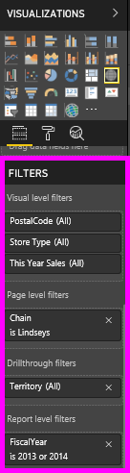

If no visual is selected in the canvas, then the Filters pane displays just the filters that apply to the entire report page or entire report, and any drillthrough filters (if any have been set). In the example below, no visual is selected and there is no page level or drillthrough filters but there is a report level filter.

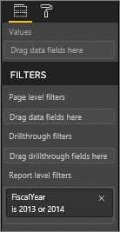

If a visual is selected in the canvas, you will also see the filters that apply to just that visual.

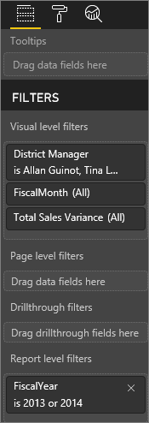

To display options for a particular filter, select the down arrow next to the filter name. In the example below, the report level filter is set to 2013 and 2014. And this is an example of basic filtering. To display the advanced options, select Advanced Filtering.

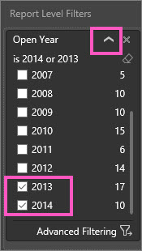

**Clear a filter**

In either advanced or basic filtering mode, select the eraser icon  to clear the filter.

**Add a filter**

In Desktop and in Power BI service Editing view, add a filter to a visual, page, drillthrough, or report by selecting a field from the Fields pane and dragging it into the appropriate filter well, where you see the words Drag fields here. Once a field has been added as a filter, fine-tune it using the Basic filtering and Advanced filtering controls (described below).

Dragging a new field into the Visual level filter area does not add that field to the visual, but it does allow you to filter the visual with this new field.

All the fields that are used to create a visualization are also available as filters. First, select a visual to make it active. The fields that are being used in the visual are listed in the Visualizations pane and in the Filters pane under the Visual level filters heading.

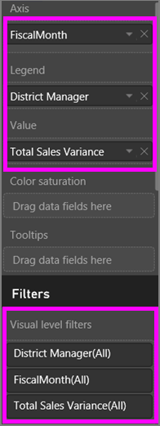

**Types of filters: text field filters**

**List mode**

Ticking a checkbox either selects or deselects the value. The All checkbox can be used to toggle the state of all checkboxes on or off. The checkboxes represent all the available values for that field. As you adjust the filter, the restatement updates to reflect your choices.

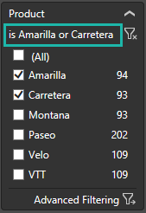

Note how the restatement now says "is Amarilla or Carretera"

**Advanced mode**

Select Advanced Filtering to switch to advanced mode. Use the dropdown controls and text boxes to identify which fields to include. By choosing between **And** and **Or**, you can build complex filter expressions. Select the Apply Filter button when you've set the values you want.

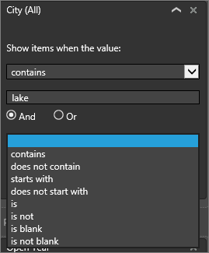

**Types of filters: numeric field filters**

**List mode**

If the values are finite, selecting the field name displays a list. See Text field filters > List mode above for help using checkboxes.

**Advanced mode**

If the values are infinite or represent a range, selecting the field name opens the advanced filter mode. Use the dropdown and text boxes to specify a range of values that you want to see.

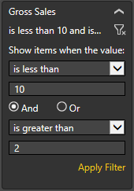

By choosing between **And** and **Or**, you can build complex filter expressions. Select the Apply Filter button when you've set the values you want.

**Types of filters: date and time**

**List mode**

If the values are finite, selecting the field name displays a list. See Text field filters > List mode above for help using checkboxes.

**Advanced mode**

If the field values represent date or time, you can specify a start/end time when using Date/Time filters.

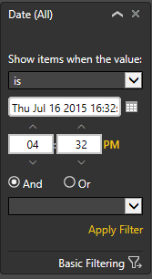

**Hierarchies and Drill-Down in Power BI**

**Hierarchy**

The ordering and grouping of Attributes or Dimensions called as Hierarchy.

Hierarchy is an ordered sequence of dimensions, which is very helpful for analysis of data.

Hierarchy is a relationship, where one of the items is "detail" of another one. Like Continent / country / State /city, Year / month / day.

**Examples**

**Time Hierarchy**

Year 🡪 Quarter 🡪 Month 🡪 Day

**Geographic Location Hierarchy**

Continent 🡪 Country 🡪 State 🡪 City

**Product Hierarchy**

Category 🡪 Sub-Category 🡪 Product Name

Instead of creating the visualizations for each dimension individually we will create a Hierarchy for Related Dimensions (Category 🡪 Sub-Category 🡪 Product Name) and will use that hierarchy in the visualizations.

Power BI Hierarchies provides you the drill down action to the Power BI Visualizations.

When a visual has a Hierarchy, it enables the ability to drill down for additional relevant details.

One very common hierarchy is a date hierarchy, which is used to show data summarized by year, then all the values for the quarters, then the values for three months in each quarter and each month which at the lowest level includes all the values for dates.

There are other hierarchies which may also exist in data, such as Geographic Location Hierarchy, Product Hierarchy.

Geographic Location Hierarchy contains Continent which includes Countries which include states or provinces which include cities.

Product Hierarchy Contains Categories which include Sub-Categories which include Product Names.

**Creating Hierarchy in Power BI**

Before we build a hierarchy, we’ll need to know the levels that comprise the hierarchy. In our example, the levels are Category 🡪 Sub-Category 🡪 Product Name

There is couple of ways to create a hierarchy in power bi.

**First approach to Create Hierarchy in Power BI**

After we know the hierarchy levels, we’ll use simple drag/drop techniques to create the hierarchy. Since Category is our first level in the hierarchy, let’s look for Sub-Category and place it right on top of Category. Notice that there is a new item was created called “**Category Hierarchy**”.

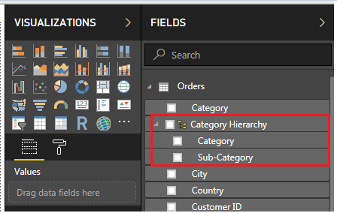

Finally, we’ll drag and drop **Product Name** on the Category Hierarchy we just created and rename Category Hierarchy to Product Hierarchy by right-clicking Category Hierarchy and selecting “Rename”.

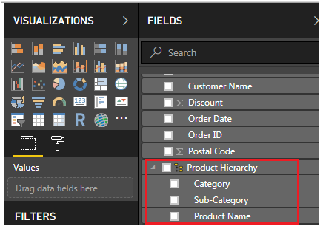

**Second Approach to Create Hierarchy in Power BI**

Right clicking on the ellipse next to any field let’s say **Category** in a table, displays a context menu, and the second item on the context menu is **New Hierarchy**.

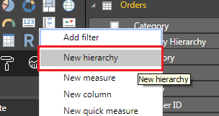

When you select this, a new hierarchy will be created with that field name suffixing with Hierarchy (Category Hierarchy).

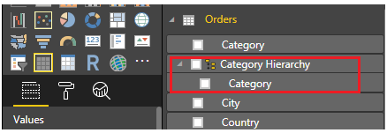

If you want to add other fields to the above hierarchy (Category Hierarchy), select the field and right click on it and select add to the hierarchy.

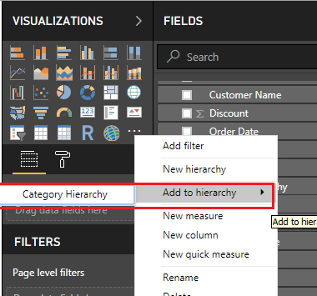

**Change Hierarchy Levels in Power BI**

Please be careful while configuring the hierarchy levels. For instance, if you have the Sub-Category column above the Category, Then Level 1 will be Sub-Category, level 2 will be Category.

Please select the field that you want to change the position or level. Next, right-click on it and select the Move Up option (or move down) from the context menu. Alternatively, you drag and drop the field at the required position.

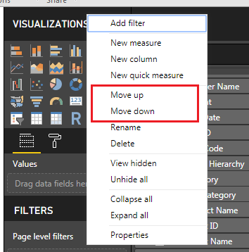

**Drill-Up and Drill-Down Reports in Power BI**

Power BI Drill-Up and Drill-Down Reports help you to drill down the reports to multi-levels. Using this you can see the data at each level.

You can perform Drill up, and Drill down using any of the three options. When you add a Hierarchy to the Visualization then only you can see these options.

1. In Ribbon from Home Tab Go to the Data / Drill tab to see these properties.

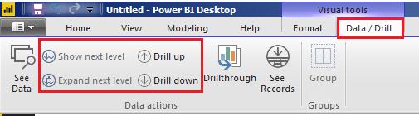

1. If your data has multiple levels then these buttons  will be displayed in the visualization.
2. Right-click on the report will show the context menu. You can use this menu to select the levels.

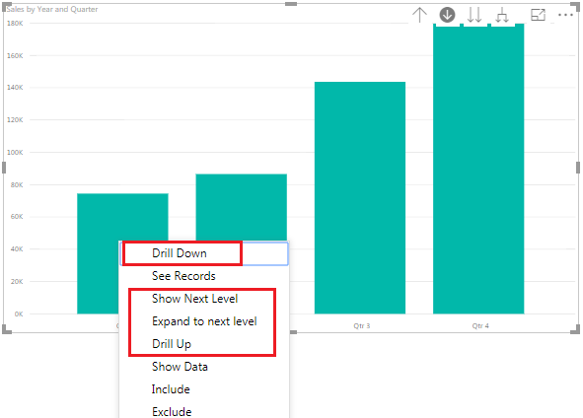

**NOTE:** There is a difference between Shown Next Level, and Drill Down. Show Next level will show you the complete data in the next level but the Drill down option will show you the selected data.

**Drilling filters other visuals**

As you work in Drill mode, you get to decide how drill down and expanding impacts the other visualizations on the page.

By default, drilling will filter other visuals in a report. But this feature can be disabled in Power BI Desktop and Power BI service if you needed.

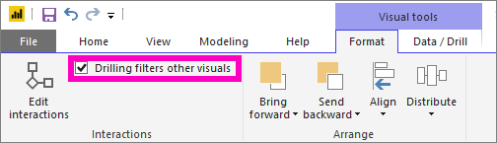

In Desktop, select the Format tab and select the checkbox for Drilling filters other visuals.

**Date Hierarchy in Power BI**

As with most data analysis tasks, working with time can be the most challenging detail to get correct. Power BI has built-in functionality that will display a drillable hierarchy of year, quarter, month and days when a column, formatted as a date, is dropped onto visualization.

If you are creating a table and drag a field, formatted as a date, you do not get a single date but the hierarchy as pictured below. This creates a built-in way to drill down through the year on various graphs and tables. On visualization, this allows you to provide different views of your data over time. You can also remove a level from the list by selecting the ‘X’ next to the level depending on your needs.

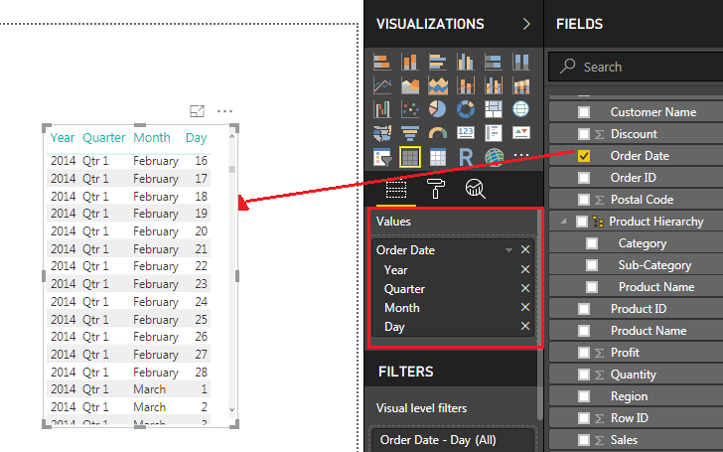

However, this behavior is the default. If you want to show the actual date field, you have to click on the down arrow next to the date field as shown below. This allows changing the selection from the Date Hierarchy to the field that contains your Date Values.

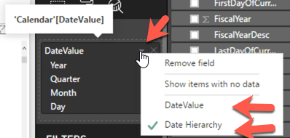

**Considerations**

If adding a date field to visualization does not create a hierarchy, it may be that the “Date” field is not actually saved as a date. If you have owned the data set, open it in Data view in Power BI Desktop, select the column that contains the date, and in the Modeling tab change the Data Type to Date or Date/Time as shown in the picture below. If the report has been shared with you, contact the owner to request the change.

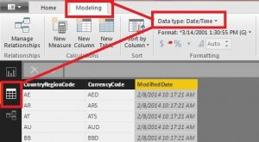

**Visualizing Data**

Visualizing the data means presenting the data in graphical or pictorial format format. Visualizing data is one of the core parts of Power BI - a basic building block as we defined it earlier in this course.

**Why Visualizations**

* Creating visuals is the easiest way to find and share your insights with Clients.
* You can get the insights esaily when you present in the form of visuals rather than text table. In the below figure you can easily identify the highest sales produced product in the visual rather then text table.

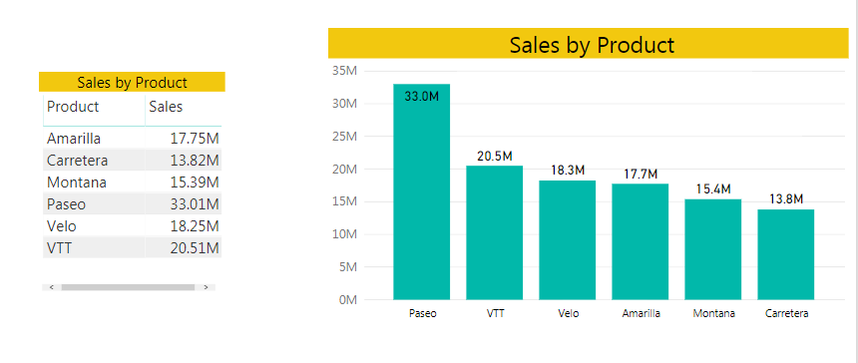

Once you have connected to the data sources and created a data model, the next step is to create visualizations. One of the things that set Power BI apart from other visualization tools is that you can create interactive visualizations—that is, visuals, that can interact with each other by cross-filtering the underlying data.

Up to this point, you have spent some time importing data and modeling it to your specifications. Now, we will begin to visualize the data in efficient and effective ways. The most common association with Power BI for consumers is the ability to create very impactful visualizations of data, and there are many options available to do this. Here, we will look at all the various options that are available to you within the Power BI Desktop application. Additionally, we will take a brief glimpse at the additional visualization options that are available through the Custom Visuals Marketplace. In this section we will discuss about below topics.

* Data visualization basics
* Visuals for Filtering
* Visualizing Categorical Data
* Visualizing Trend Data / Date and Time Data
* Visualizing KPI Data
* Visualizing Tabular Data
* Visualizing Geographical Data
* Leveraging Power BI Custom Visuals

There are Around 30 readily available visuals in the Power BI Desktop application. We will be exploring most of them and how they best work with certain types of Data Sets.

**Data Visualization Basics**

As soon as you launch the Power BI desktop application and close out of the initial splash screen, you will find yourself in the Report View, which is where we will stay for the duration of this chapter. In the previous chapter, you explored the Relationship view as well as the Data view, but these areas are not necessary for the visualization work we will be doing. There are many items of interest in this initial Report view area that we need to discuss so that we can work efficiently.

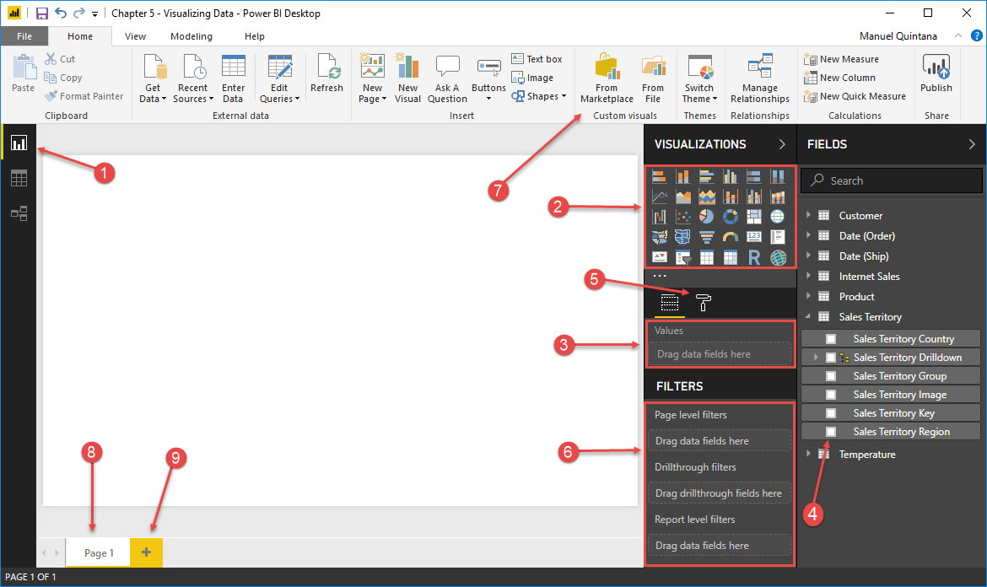

1. **Report view**

This is the button that will place us in the Report canvas and allow us to create visuals.

1. **Visuals area / Visualizations Pane**

This is where we can choose which visual, we would like to use. Once custom visuals are added, they will appear here as well.

1. **Field Area / Fields Well**

This area will change depending on the visual but it is where we place the fields we will use within the selected visual.

1. **Field pane**

These are all the available fields we have to choose from to add to our visuals.

1. **Format area**

Here is where we can decide on many things specific to either the entire report page or the selected visual, such as text size, font style, titles, and so on.

1. **Filters area**

This is where we can apply filters of various scopes

* + **Page-level** **filters**: Any filters applied here will affect every single visual on the selected page.
  + **Drill through** **filters:** This option allows users to pass a filter value from a different report page to this one.
  + **Report-level filters:** Filters applied here will affect every single visual for the entire Power BI report.
  + **Visual-level filters:** This category will only appear when you have a visual selected, and the applied filters will only affect the selected visual.

1. **Custom visuals**

By selecting this button, you will have a menu appear that has access to all the custom visuals from the Microsoft store. You can then add which ever visual you would like to the Visuals area.

1. **Report page**

Here is where you can select which report page you would like to work with. Each page has a limited work area where we can use to create visuals, so it is common to have more than one page in a Power BI report.

1. **Add Report page**

By selecting this symbol, you can add a new report page to add more area in which we can add visuals.

Now that we have familiarized ourselves with the Report page features and layout, it’s time to start visualizing!

**Visuals for filtering**

Filtering the data that users will see within a Power BI report is the most effective way to answer very specific questions about that data, and there are many ways to accomplish this. One of Power BI's best features is its default capability to allow users to interact with a visual, which will then apply that as a filter to the rest of the visuals on that page, and this is known as interactive filtering or Visual Interactions. This behavior really puts the power into the user’s hands, and they can decide how they want to filter the visuals. This now makes a report so much more robust because it can answer so many more questions about the data. Along with this functionality, we, report developers, can add more explicit forms of filtering using the Slicer visual that is available to us in the visuals area. This allows us to choose a very specific field from our data, that we know our end users will want to manipulate to see that data in various different states. So now, let’s dive in and get a better understanding on these two filtering options, as they will most definitely be elements we will see in our finished reports.

**Slicer Visualization**

Slicers are one of the most powerful types of visualizations, particularly as part of a busy report. A slicer is an on-canvas visual filter in Power BI Desktop that lets anyone looking at a report segment the data by a particular value, such as by year or by geographical location.

Slicer Visualization in Power BI is used to filter the results of visuals on your report page. It is used as a user level filter. Users will interact with report using Slicers. And with slicers, you can easily adjust the filter that's applied by interacting with the slicer itself. You can also specify options for how your slicer appears, and how you interact with it.

**When to use a Slicer**

There could be scenarios where we have to filter data dynamically based on some values in such a way that when a particular value is selected, then all the data displayed in the report should get refreshed and aligned with respect to that value. For example, assume a report displaying sales across the globe of a Multinational Company. Imagine the sales viewer wants to view Sales of only United States. In this scenario, we can add filters under the Country. Therefore, when reader clicks particular Country, sales belonging to that country alone are shown. This can be achieved using Slicer.

A slicer is a list of values from which one, multiple or all values can be selected to filter the data shown in report.

When you select an item in the slicer, only that item corresponding information will be shown and the rest of the data gets filtered out. For instance, take your entire sales data. You can set up slicers to look at sales by Country, Category, Subcategory and Product.

**Create and format slicers**

To add a slicer to your report, select Slicer from the Visualizations pane.

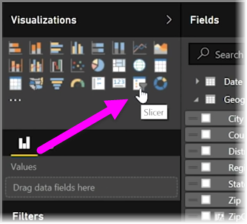

Drag the field by which you want to slice and drop it top of the slicer placeholder. The visualization turns into a list of elements with checkboxes. These elements are your filters, select the box next to one to segment and all other visualizations on the same report page are filtered, or sliced, by your selection.

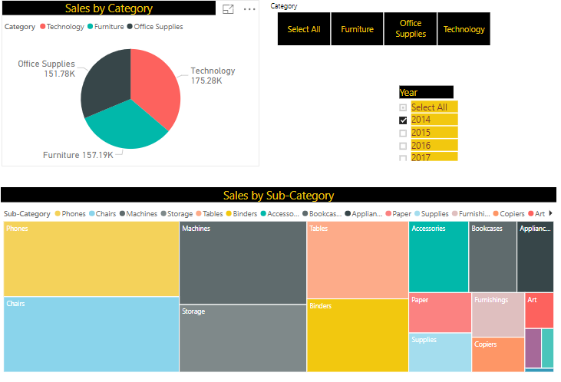

There are a few different options available to format your slicer. You can set it to accept multiple inputs at once, or toggle Single Select mode to use one at a time. You can also add a Select All option to your slicer elements, which is helpful when you have a particularly long list. Change the orientation of your slicer from the vertical default to horizontal, and it becomes a selection bar rather than a checklist.

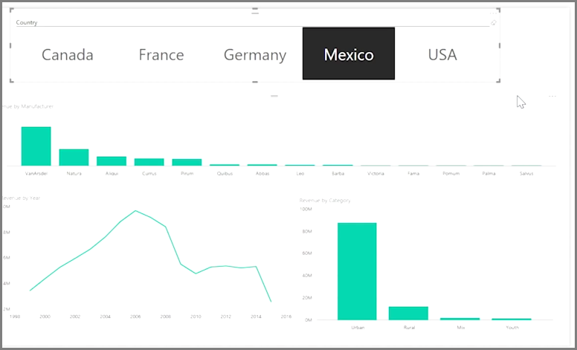

A slicer can be shown from one of various types below based on data type of the column used in slicer.

* List
* Dropdown
* Between
* Before
* After
* Relative
* Less than or equal to
* Greater than or equal to

**When to use a slicer**

Slicers are a great choice when you want to

* Display commonly-used or important filters on the report canvas for easier access.
* Make it easier to see the current filtered state without having to open a drop-down list.
* Filter by columns that are unneeded and hidden in the data tables.
* Create more focused reports by putting slicers next to important visuals.

**Power BI slicers have the following limitations**

* Slicers cannot be pinned to a dashboard.
* Drilldown is not supported for slicers.

**Synchronize slicers across report pages**

In Power BI Desktop you can synchronize slicers across multiple report pages. To synchronize slicers, in the **View** Tab in the ribbon, select Sync slicers. When you synchronize slicers, the Sync Slicers pane appears, as shown in the following image.

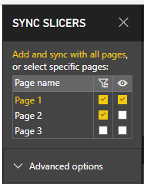

**Hierarchy Slicer - A Custom Visualization in Power BI**

The Hierarchy Slicer visual is a great way to filter your data within a hierarchical view. The hierarchy slicer for Power BI provides the opportunity to simple select multiple members of different levels of a hierarchy as selection. The slicer can be used with an existing hierarchy or a manual created hierarchy.

**Advantages of Hierarchy Slicer**

* Hierarchy Slicer lets you expand and dig into each level of your hierarchy data.
* Hierarchy Slicer allows you to display a measure value at the lowest level.
* Hierarchy Slicer replaces the idea using multiple regular slicers to represent what the Hierarchy Slicer does.

In this Hierarchy Slicer we’re showing the ability to filter down a product hierarchy.

[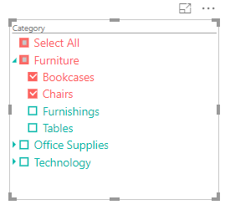](https://devinknightsql.files.wordpress.com/2017/05/image4.png)

**Visualizing Categorical Data**

The following visuals are best for displaying data values across categories. In these visuals, we will be displaying Bars, Columns, and other visual elements, which will be proportional to the data value. All of the visuals allow for interactive filtering and the use of drilldowns. We will focus on how to understand and configure the following visuals.

* Pie and Donut Charts
* Treemap Visual
* Bar and Column Charts
* Scatter Charts

**Pie and Donut charts**

Both the Pie chart and Donut chart are meant to visualize a **particular section to the whole**, rather than comparing individual values to each other. The only difference between the two is that the Donut chart has a hole in the middle or the Center is blank and allows space for a label or icon. Both of these visuals can be very effective in allowing interactive filtering, but if there are too many categories it can become difficult to read and interpret. Pie Charts are very useful to visualize the High level data. If we have many categories where we need to see a particular section to the whole, then go with Treemaps.

**Both charts have four field wells**

**Legend** 🡪 You may use one or more categorical columns.

**Details** 🡪 You may use a categorical column.

**Values** 🡪 You may use one or more numerical fields here. If you use Details, you are limited to one field only.

**Tooltips** 🡪 You may use one or more fields here.

**Treemap**

Treemaps display hierarchical data as a set of nested rectangles. Each level of the hierarchy is represented by a colored rectangle (often called a "branch") containing other rectangles ("leaves"). The space inside each rectangle is allocated based on the quantitative value being measured, with the rectangles arranged in size from top left (largest) to bottom right (smallest).

Treemap charts can be thought of as rectangular pie charts because they also show the relationship of the parts to the whole. You can nest rectangles to further divide the whole. There are five field wells in Treemap.

**Group 🡪** You may use one or more categorical columns.

**Details** 🡪 You may use a categorical column.

**Values** 🡪 You may use one or more numerical fields here. If you use Details, you are limited to one field only.

**Tooltips** 🡪 You may use one or more fields here.

**When to use a treemap**

Treemaps are a great choice

* To display large amounts of hierarchical data.
* When a bar chart can't effectively handle the large number of values.
* To show the proportions between each part and the whole.
* To show the pattern of the distribution of the measure across each level of categories in the hierarchy.
* To show attributes using size and color coding.
* To spot patterns, outliers, most-important contributors, and exceptions.

**Power BI has six variations of bar charts**

It is best to use bar charts when you are **comparing values across categories**. Power BI Bar Chart is useful for the data comparison. Both the Bar and Column charts are very similar in setup and how they visual data. The only difference here will be the orientation. The Bar chart uses rectangular bars horizontally where the length of the bar is proportional to the data, while the Column chart displays the bars vertically, but both are used to compare two or more values. Both of these visualizations have three different formats - Stacked, Clustered, and 100% Stacked.

* Stacked bar chart
* Stacked column chart
* Clustered bar chart
* Clustered column chart
* 100% Stacked bar chart
* 100% Stacked column chart

Stacked 🡪 Arranged one on top of another.

Clustered 🡪 Positioned close together or one beside another

**All six charts share the same five field wells**

**Axis** 🡪 You can use one or more categorical column.

**Legend** 🡪 One categorical column can be used.

**Value** 🡪 You can use one or more numerical fields. If you use a legend or color saturation, you can only put one field into this field well.

**Color saturation** 🡪 one numerical field can be used.

**Tooltips** 🡪 You can use one or more fields here.

There are some situations where the Bar chart will better display data, and the same thing can be said of the Column chart. The biggest limitation for the Column chart would be the limited space on the x-axis where the category would go. So, if you have a lot of data labels or if they are very long, you may find that the Bar chart is the better option. An example where you might choose the Column chart over the Bar chart is if your data set contains negative values. In a Bar chart, the negative values will show on the left side while in a Column chart they will display on the bottom. Users generally associate negative values with a downward direction.

**Scatter Chart / Bubble Chart**

A scatter chart always has two value axes to show one set of numerical data along a horizontal axis and another set of numerical values along a vertical axis. The chart displays points at the intersection of an x and y numerical value, combining these values into single data points. These data points may be distributed evenly or unevenly across the horizontal axis, depending on the data.

A bubble chart replaces the data points with bubbles, with the bubble size representing an additional dimension of the data.

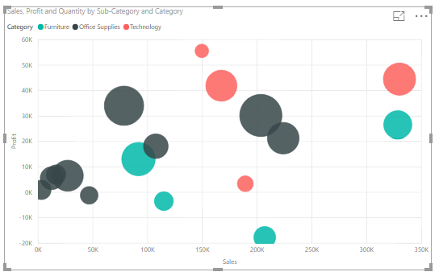

Column or Bar chart can be easily used for showing a single measure’s insight across a category. Mixed charts such as Line and Column chart can be used for showing two measure and comparing their values across a set of categories. However, there are some charts that can be used to show values of three measures, such as Scatter Chart. Scatter chart not only shows values of three measure across different categories, it also has a special Play axis that helps you to tell the story behind the data.

Scatter chart is a built-in chart in Power BI that you can show up to three measure with a categorization in it. Three measures can be visualized in position of X axis, Y axis, and size of bubbles for scatter chart. You can also set up a date field in play axis, and then scatter chart will animate how measure values are compared to each other in each point of a time.

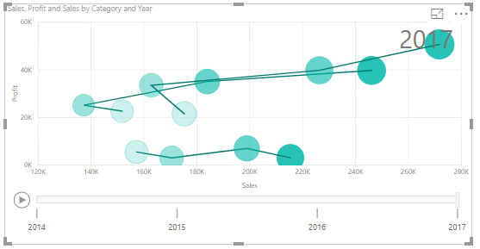

**Visualizing Trend Data**

When we use the term Trend Data, we are talking about displaying and comparing values over time. Power BI gives us many options in this category, each with their own focus. The idea for each of the visuals, though, is to draw attention to the total value across a length of time.

* Line and Area Charts (Line chart, Area chart, Stacked area chart)
* Combo Charts (Line and Stacked column chart, Line and Clustered column chart)
* Ribbon Charts
* Waterfall and Funnel Charts

**Line and Area Charts**

Power BI has a line chart and two area charts, which are similar to the line chart, but have a shaded area under the lines

* Line chart
* Area chart
* Stacked area chart

The Line chart is the most basic of our options when it comes to looking at data over time. Line charts are best used when you are comparing values across time. The Area chart and Stacked Area chart are based on the line chart; the difference is that the area between the axis and the line is filled in with colors to show volume. Because of this, we will focus on the Line chart for our example. Since we have a very nice Date hierarchy, we will use this alongside a couple of measures to see trending.

**All three charts have the following field wells**

**Axis** 🡪 One or more categorical columns.

**Legend** 🡪 You can place one categorical column.

**Values** 🡪 One or more numerical fields can be used; if you use a legend, you can only use one field in this well.

**Tooltips 🡪** One or more fields can be used.

**Single Line Chart**

Put Date/Time value to the Axis field well, this is the X-axis of the line chart.

Put data field that you want to show (here Sales) in the Value field well.

The line chart is basically done. Now it is up to you to customize it as per your need.

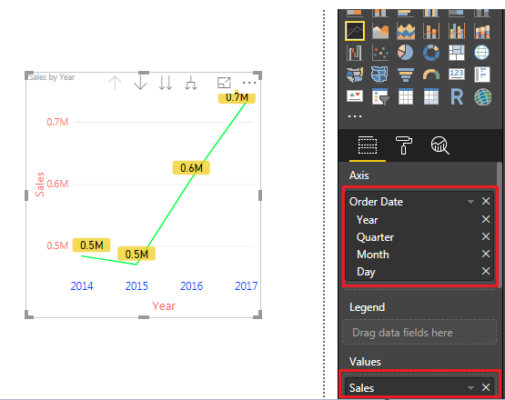

**Multiple Line Chart**

Put Date/Time value to the Axis field well, this is the X-axis of the line chart.

Put data field that you want to show (here Sales) in the Value field well.

To further breakdown the sales by Category, put the required field in the Legend field (here Category). Now it is up to you to customize it as per your need.

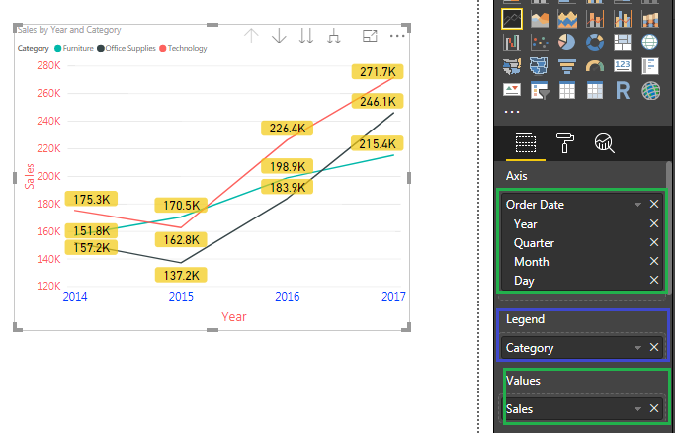

**Area Chart**

Area charts are very similar to line charts. The basic area chart is based on the line chart. The area between axis and line is filled with colors to indicate volume. They both show quantitative data with a time period on the x-axis.

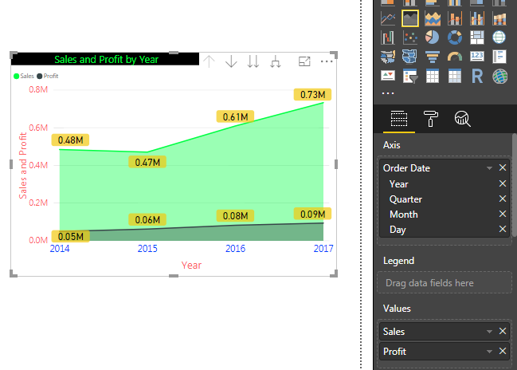

**Stacked Area Chart**

A stacked area chart is used to compare each category of the data against the whole.

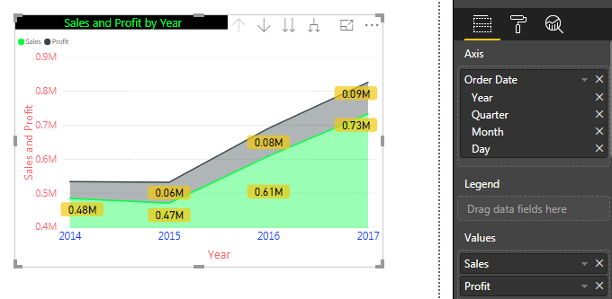

**Combo charts**

There are two combo charts in Power BI

* Line and stacked column chart
* Line and clustered column chart

As the name states, Combo charts combine the Line chart and Column chart together in one visual. Users can choose to have either the Stack Column format or the Clustered Column format. By combining these two visuals together, we can make a very quick comparison of the data. The main benefit of this type of chart is that we can have one or two Y axes. What this means is that we can either display two measures that would have the same Y axis, something like Total Sales and Profit. Or, we could show two measures that are based on completely different values such as Order Quantity and Profit; let's use the two for our example.

**Let's look at, setting up the visual**

Both charts have five field wells

**Shared axis** 🡪 One or more categorical columns.

**Column series** 🡪 A legend well in which you can use a categorical column.

**Column values** 🡪 You may use one or more numerical fields in this well; if you have a column series, you can only use one field.

**Line values** 🡪 One or more numerical fields may be used in this well.

**Tooltips** 🡪 One or more fields may be used in this well.

For this example, we will be using the Line and Stacked Column Chart visual.

* For the Shared Axis area, let's select the Date field (Order Date).
* We will then select the Quantity field to populate the Column Values section.
* Then select the Profit measure field to populate the Line Values section.
* In this example, you can see that we have two Y axes; the left one relates to the Quantity while the right one corresponds with our Profit measure.
* By default, the column values appear on the left, and the line values appear on the right.
* Go ahead and expand the hierarchy two level; this will give us more data points to see the trending between the two measures, as seen in the below Figure. From this visual, it's fairly easy to validate that when we sell more items we make more profit.

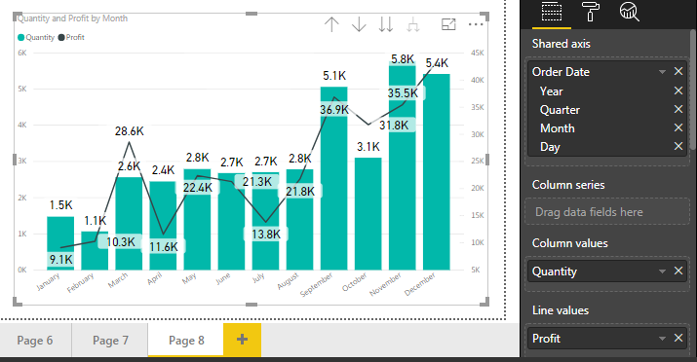

**When to use a Combo Chart**

Combo charts are a great choice

* When you have a line chart and a column chart with the same X axis.
* To compare multiple measures with different value ranges.
* To illustrate the correlation between two measures in one visualization.
* To check whether one measure meet the target which is defined by another measure
* To conserve canvas space.

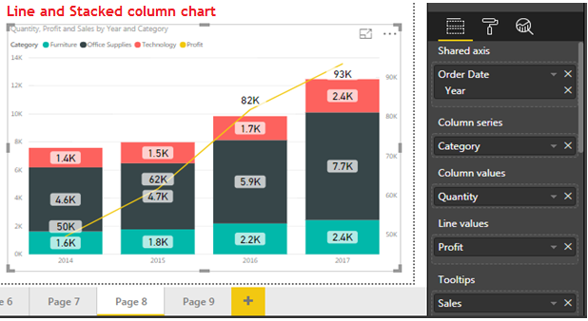

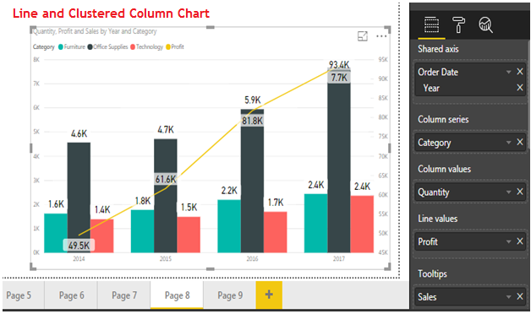

**Ribbon chart**

The Ribbon chart is similar to a column chart, but it has ribbons between the bars to highlight changes in the relative ranking of categorical items. The item with the highest value will be displayed on top. You can use ribbon charts in Power BI to visualize data, and quickly determine which category of data has the highest rank (largest value). Ribbon charts are effective at showing rank change, with the highest range (value) always displayed on top for each time period.

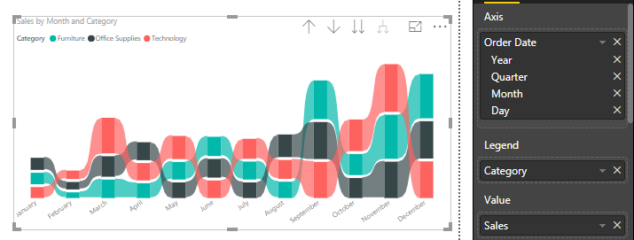

**The chart has four field wells**

**Axis** 🡪 One or more categorical columns.

**Legend** 🡪 You may use one categorical column.

**Value** 🡪 You can use one or more numerical fields in this well; if you use a legend, you can use one field only.

**Tooltips** 🡪 You may use one or more fields.

**Waterfall Chart**

A waterfall chart shows a running total as values are added or subtracted. It's useful for understanding how an initial value (for example, net income) is affected by a series of positive and negative changes.

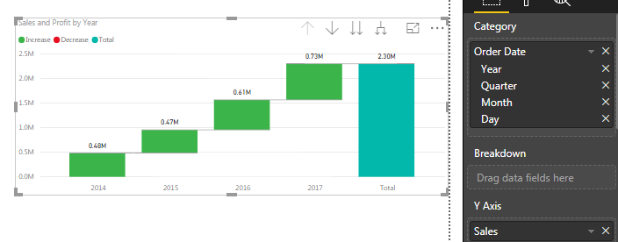

The columns are color coded so you can quickly tell increases and decreases. The initial and the final value columns often start on the horizontal axis, while the intermediate values are floating columns. Because of this "look", waterfall charts are also called bridge charts.

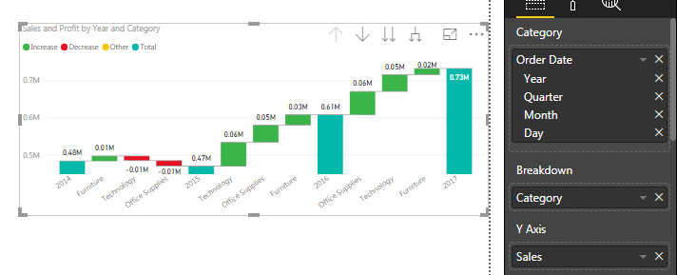

**Example:** Drag Order Date to Category field Well, Sales field to Y Axis field well and Category fied to Breakdown field well as shown in the above visual. You can see Year wise sales and contribution of each category for decay or growth of year wise sales.

**When to use a waterfall chart**

Waterfall charts are a great choice

* When you have changes for the measure across time series or different categories
* To audit the major changes contributing to the total value
* To plot your company's annual profit by showing various sources of revenue and arrive at the total profit (or loss).
* To illustrate the beginning and the ending headcount for your company in a year
* To visualize how much money, you make and spend each month, and the running balance for your account.

**The Funnel Chart**

Funnel chart, which looks similar to a bar chart with bars center-aligned. The Funnel Chart allows users to see the percentage difference between values. Normally, the highest value is at the top and the lowest is at the bottom, which gives the look of a funnel. Each stage of the funnel with tells the percentage difference between itself and the previous stage, as well as compared to the highest stage. With this type of design, it makes sense that the Funnel Chart is very effective when visualizing a linear process with at least three or four stages. Our data set does not have a process with multiple stages, but we can still create something that gives us value.

| **Category** | **Value** |
| --- | --- |
| Site Users | 1020 |
| Enquiries | 800 |
| Demo Attended | 200 |
| Registered | 150 |
| Placed | 100 |

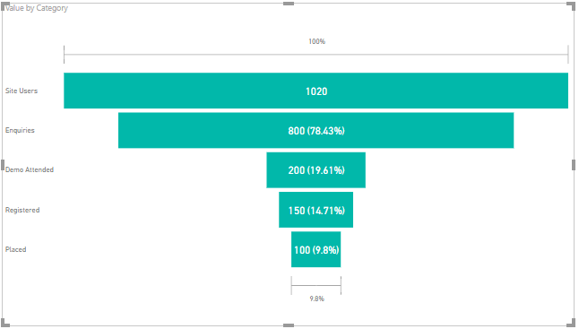

**The visual has four field wells**

* **Group** 🡪 You can use one or more categorical columns here.
* **Values** 🡪 You can only use a numerical field here.
* **Color saturation** 🡪 A numerical field may be used.
* **Tooltips** 🡪 One or more fields can be used here.

A funnel chart can be a proper choice for showing values by stages, for instance, by lead generation stages. The visual can also be used for revealing bottlenecks in a process or to track workflow.

In our example drag the Sub-category field to Group and Sales to Values.

The way we have set up this visual allows us to very easily identify which Sub-category make the most Sales and which make the least, but this is something we can achieve with many other visuals. What gives the Funnel Chart an edge is when we hover over one of the sections within the funnel and note the items that appear within the Tooltip. You will see when we hover over the section for Tables Subcategory that the tooltip lets us know how it compares to the section directly above it, as well as how it compares to the highest section, which is represented by the Phones.

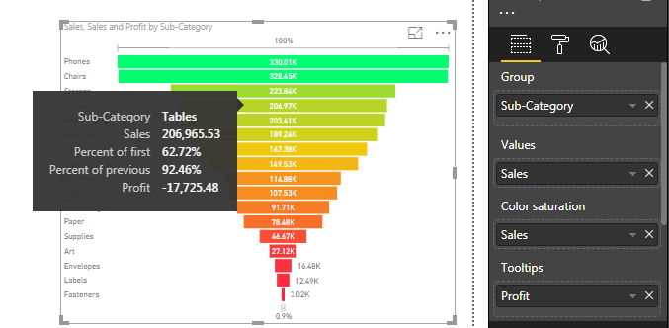

**Visualizing KPI Data**

KPI stands for Key Performance Indicator. It is a measurable value that demonstrates how well a company is achieving a certain objective. With Power BI, we have a couple of options to measure the progress being made towards a goal for operational processes. The strength of a KPI visual lies in its simplicity. It displays a single value and its progress toward a specific goal.

Key Performance Indicator is a measure for business to understand how they perform in specific area that is important and many times critical for their business. For example, they would like to see how the current year to date sales is going against what they estimated? Is it higher or lower? What is the trend? Is it going upward or downward?

**The Gauge visual**

The Gauge visual displays a single value within a circular arc and its progress towards a goal or target value that we specify. The Target Value is represented by a line within the arc. With our current data set, we do not have a measure that we can use to illustrate an accurate business goal, so we will have to create it. Before we set up this visual, we will need to create a new calculated measure.

Create a Measure with Name **Target** and assign a value of 500000

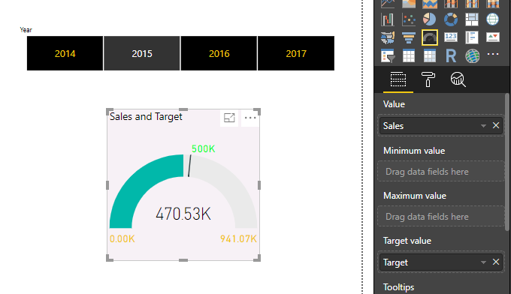

**When to use a radial gauge**

Radial gauges are a great choice to

* Show progress toward a goal.
* Represent a percentile measure, like a KPI.
* Show the health of a single measure.
* Display information that can be quickly scanned and understood.

**The KPI visual**

A Key Performance Indicator (KPI) is a visual cue that communicates the amount of progress made toward a measurable goal. Where the Gauge visual uses the circular arc to show the current progress, the KPI visual takes a more explicit approach and just shows the value in plain text, along with the goal. The only real visual elements that are in play with this visual occur when the indicator value is lower than the goal and the text is shown in red, and when it has surpassed the goal and the text is in green. This is definitely one of the more direct visuals and perfectly exemplifies what we want for a KPI.

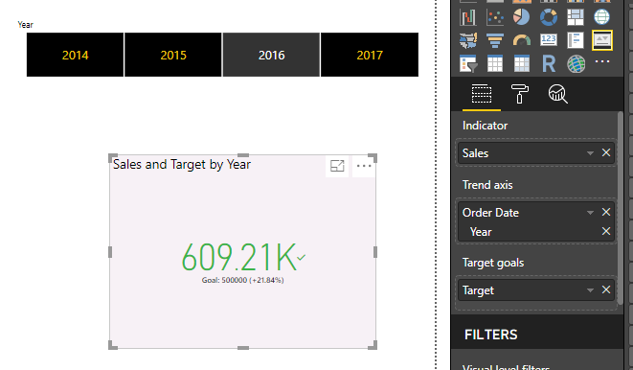

**When to use a KPI**

KPIs are a great choice

* To measure progress (what am I ahead or behind on?)
* To measure distance to a goal (how far ahead or behind am I?)

**Card Visualization**

Sometimes a single number is the most important thing you want to track in your Power BI dashboard, such as total sales, market share year over year, or total opportunities. You can create a big number tile in a Power BI report as shown below using Card Visualization.

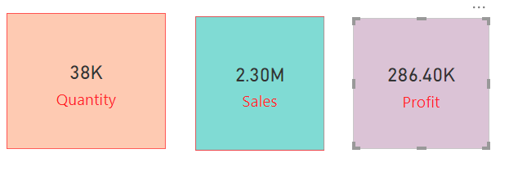

Sometimes instead of going and creating multiple Card Visualizations for multiple values that occupies more space in report page we will create a Multi Row Card and will place all the values in that Multi row card as shown below.

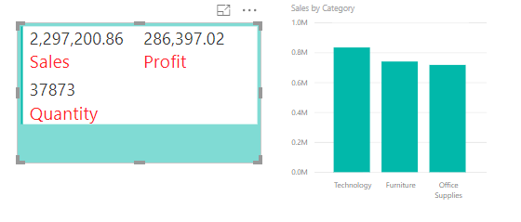

**Visualizing Geographical Data**

One of the most exciting ways to visualize data in Power BI is through the various map options that we have. All the maps serve the same purpose to illustrate data in relation to locations around the world, but there are some small differences between each of them. Power BI integrates with Bing Maps to provide default map coordinates (a process called geo-coding) so you can create maps. Together they use algorithms to identify the correct location, but sometimes it's a best guess. If Power BI tries can't create the map visualization on its own, it enlists the help of Bing Maps. All of the maps, except the Shape Map, have the option to provide the latitude and longitude coordinates, which will be the best way to ensure the appropriate location is being displayed. The reason for this is because the information that we provide the visual will be sent to Bing Maps to verify the positioning on the map. If we do not provide enough detail, then Bing may not return the desired results. For example, if we were to provide the map visual with a field that contains only the city name, which could result in some confusion because there may be multiple cities in the US with that name. In these scenarios, we will either want to supply some sort of geo-hierarchy to give better definition, or we can create new columns with more detailed information. Power BI also has a built-in feature when dealing with geographic data that allows users to help identify the type of data that is being provided, this is called Data Category.

Let's look at, setting up the example of Data Category

* Within the Fields Pane, expand the Geography table.
* The first field that we will categorize will be the City field. Highlight this field and then navigate to the Modeling ribbon. Once here, you will see the Data Category option.
* Inside of the drop-down menu, we will select the City option. Upon accomplishing this, you will see that there is now a globe icon next to the City field.
* Repeat the steps above for the State Name field, but choose the State or Province option for the data category dropdown.
* The final field that we need to perform these steps for is Country Name Field; Select the Country/Region option from the dropdown.
* Now that we have given a better description of our geographical data, we can proceed with using the various map visuals. One thing of note is that using any of these visuals does require internet access because we are going to send data to Bing Maps.

**Maps in Power BI**

Power BI has several options when it comes to visualizing geospatial data. In this section, we are going to review two map visuals, Map and Filled Map. You can use the following field wells.

**Location** 🡪 One or more categorical columns can be used.

**Legend** 🡪 You may use one categorical field here.

**Latitude** 🡪 You may use one field here.

**Longitude** 🡪 You may use one field here.

**Size** 🡪 You may use one numerical field (Map only).

**Color saturation** 🡪 You may use a numerical field here unless you use a Legend.

**Tooltips** 🡪 You may use one or more fields here.

**What is sent to Bing Maps?**

Power BI service and Power BI Desktop send Bing the geo data it needs to create the map visualization. This may include the data in the Location, Latitude, and Longitude buckets.

**The Map / Bubble Map** **visual**

The first visual we will use to illustrate geographical data is simply called the Map visual. This visual is also referred to as the Bubble Map because it plots the points of data with circles that can be set to change in size based off a supplied measure. If you are using a Legend, your bubbles will be turned into pie charts. If your Legend field well is empty, you can also use a numerical field for color saturation. Better to pass latitude and longitude values to the visuals as we may find same city name some times. If we do not have such detailed data of Latitude and Longitude, so we will need supply the necessary information through the Location section, which will be sent to Bing Maps.

If you use geographical hierarchies in the Location field well, you will be able to drill down into specific areas on your map.

When using a geo-hierarchy with a map, enabling the Drill Mode, which is signified by the down arrow in the upper right, can make this visual even more enjoyable. Remember this for any visual where we have a hierarchy selected; you should explore the different views it gives you.

**The Filled Map visual**

Unlike the traditional Map visual, that uses a bubble to indicate locations, the Filled Map visual uses shading in proportion across a geography or region to display the geographic data.

**Best Practices with Maps**

**Use latitude and longitude fields (if they exist)**

In Power BI, if the dataset you are using has fields for longitude and latitude 🡪 use them! Power BI has special buckets to help make the map data unambiguous. Just drag the field that contains your latitude data into the Visualizations > Latitude area. And do the same for your longitude data. When you do this, you also need to fill the Location field when creating your visualizations. Otherwise, the data is aggregated by default, so for example, the latitude and longitude would be paired at the state level, not the city level.

**Use geo-hierarchies so you can drill down to different "levels" of location**

When your dataset already has different levels of location data, you and your colleagues can use Power BI to create *geo-hierarchies*. To do this, drag more than one field into the **Location** bucket. Used together in this way, the fields become a geo-hierarchy. In the example below we have added geo fields for: Country/Region, State, and City. In Power BI you and your colleagues can drill up and down using this geo-hierarchy.

When drilling with geo-hierarchies, it is important to know how each drill button works and what gets sent to Bing Maps.

* The drill button on the far right, called Drill Mode  , allows you to select a map Location and drill down into that specific location one level at a time. For example, if you turn Drill Down on and click North America, you move down in the hierarchy to the next level -- states in North America. For geo-coding, Power BI sends Bing Maps country and state data for North America only.
* On the left there are 2 other drill options. The first option,  , drills to the next level of the hierarchy for all locations at once. For example, if you are currently looking at countries and then use this option to move to the next level, states, Power BI displays state data for all countries. For geo-coding, Power BI sends Bing Maps state data (no country data) for all locations. This option is useful if each level of your hierarchy is unrelated to the level above it.
* The second option,  , is similar to Drill Down, except that you don't need to click on the map. It expands down to the next level of the hierarchy remembering the current level’s context. For example, if you are currently looking at countries and select this icon, you move down in the hierarchy to the next level 🡪 states. For geo-coding, Power BI sends data for each state and its corresponding country to help Bing Maps geocode more accurately. In most maps, you will use either this option or the Drill Down option on the far right, so you can send Bing as much information as possible to get accurate location information.

**Visualizing Tabular Data**

We will see that there are many options within Power BI to visually represent data, but sometimes our users may want to see and compare detailed data and exact values. In these scenarios, by using the Table or Matrix visual ends up being our best choice. When leveraging either of these two visuals, it is important to take advantage of the Format area to ensure that users can easily interpret the detailed data that is being presented. One of the best ways to bring attention to values of importance with these visuals is by using Conditional Formatting. We will explore this option, as well as take advantage of the hierarchies to allow for drill downs within the visuals.

**The Table Visual**

The table visual is perfect for looking at many values (measures) for a category. To really make the table shine, we will also want to take advantage of the Conditional Formatting option that is available to us.

In the below table visual we use multiple dimensions and measures also we formatted the Profit column conditionally in such a way negative profits in Red color and Positive Profits in Green Color.

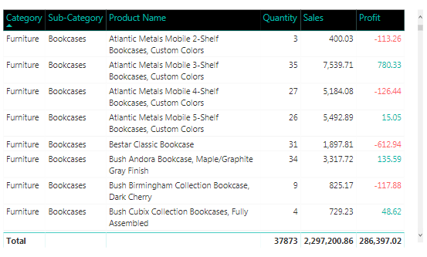

**Matrix Visualization**

A **Matrix** is similar to a table, but it has different category headers on the columns and rows. As with tables, numerical information will be automatically totaled along the bottom and right side of the matrix.

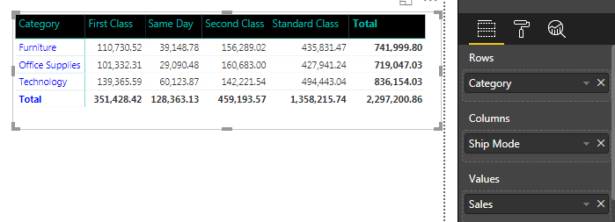

**Create Power BI visuals using R Script**

**Install R**

Power BI Desktop does not include, deploy, or install the R engine. To run R scripts in Power BI Desktop, you must separately install R on your local computer. You can download and install R for free from the below links.

<https://mran.revolutionanalytics.com/download>

<https://cran.r-project.org/bin/windows/base/>

**Enable R visuals**

To enable R visuals, select File 🡪 Options and settings 🡪 Options and in the Options page that appears, make sure your local R installation is specified in the R Scripting section of the Options window, as shown in the following image. In the following image, the path local installation of R is C:\Program Files\R\R-3.4.3 and that path is explicitly provided in the text box. Make sure the path it displays properly reflects the local R installation you want Power BI Desktop to use.

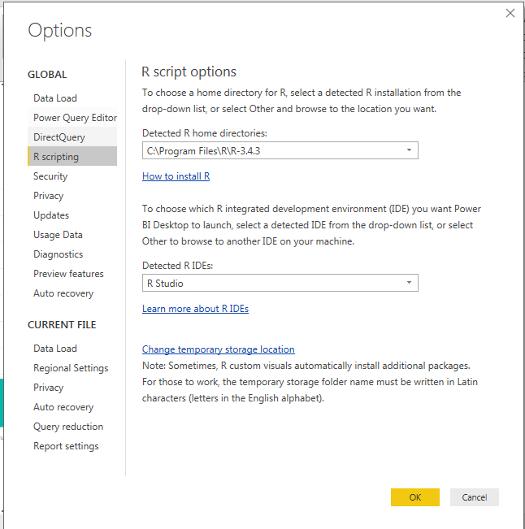

Once you specify your R installation, you’re ready to begin creating R visuals.

**Create R visuals in Power BI Desktop**

Select the R Visual icon in the Visualization pane, as shown in the following image, to add an R visual.

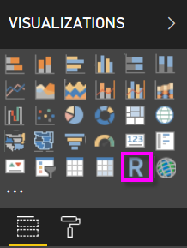

When you add an R visual to a report, Power BI Desktop does the following

* A placeholder R visual image appears on the report canvas.
* The R script editor appears along the bottom of the center pane.

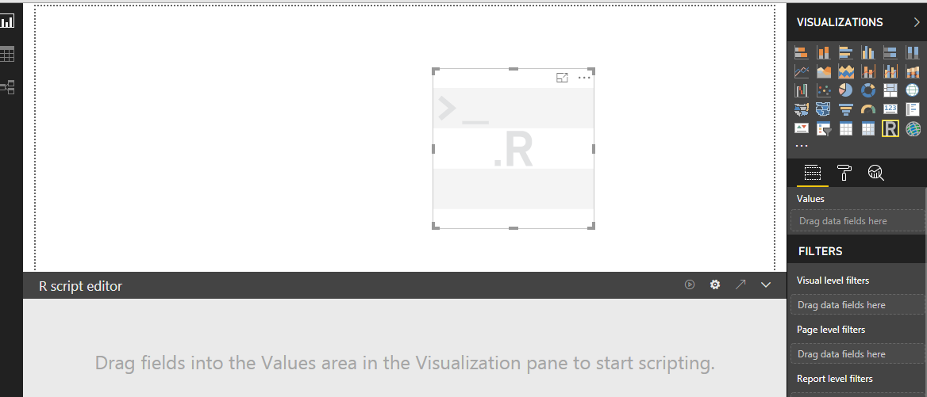

Next, add fields you want to consume in your R script to the Values section in the Fields well, just as you would with any other Power BI Desktop visual.

**Note:** The default aggregation type for R visuals is **do not** summarize.

Now you can use the data you selected to create a plot.

As you select fields, the R script editor generates supporting R script binding code based on your selections in the gray section along the top of the editor pane.

In the example shown in the following image, three fields were selected: Category, Sub-Category, and Sales. As a result of those selections, the R script editor generated the following binding code:

* A dataframe called dataset was created
* That dataframe is comprised of the different fields selected by the user
* The default aggregation is do not summarize
* Similar to table visuals, fields are grouped and duplicate rows only appear once

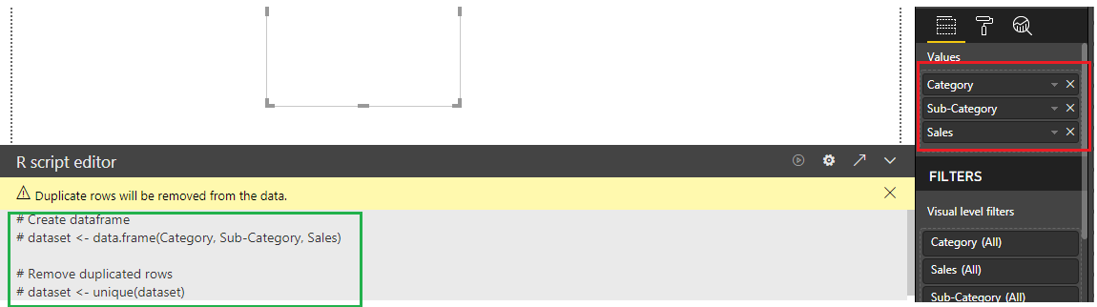

The generated dataframe is called a dataset, and you can access selected columns by their respective names. For example, access the Category field by writing dataset$Category in your R script. For fields with spaces or special characters, use single quotes (dataset$’Sub-Category’).

With the dataframe automatically generated by the fields you selected, you’re ready to write an R script those results in plotting to the R default device. When the script is complete, select Run from the R script editor title bar (Run is on the right side of the title bar).

**plot(dataset$State,dataset$Sales)**

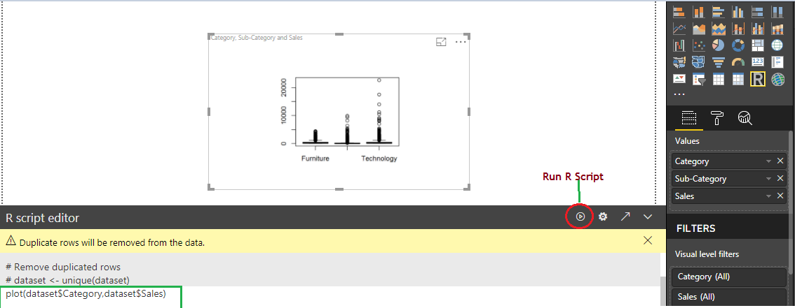

When you select Run, Power BI Desktop identifies the plot and presents it on the canvas. Since the process is executed on your local R installation, make sure the required packages are installed.

**Grouping and Binning**

When Power BI Desktop creates visuals, it aggregates your data into chunks (or groups) based on values found in the underlying data. Often that's fine, but there may be times when you want to refine how those chunks are presented. For example, you might want to place three categories of products in one larger category (one group). Or, you might want to see sales figures put into bin-sizes.

In Power BI Desktop, you can Group data points to help you more clearly view, analyze, and explore data and trends in your visuals. You can also define the Bin size, often called binning, to put values into equally sized groups that better enable you to visualized data in ways that are meaningful.

**Using grouping**

To use grouping, select two or more elements on a visual by using Ctrl+click to multi-select elements. Then, right-click one of the multi-select elements and select Group from the menu that appears.

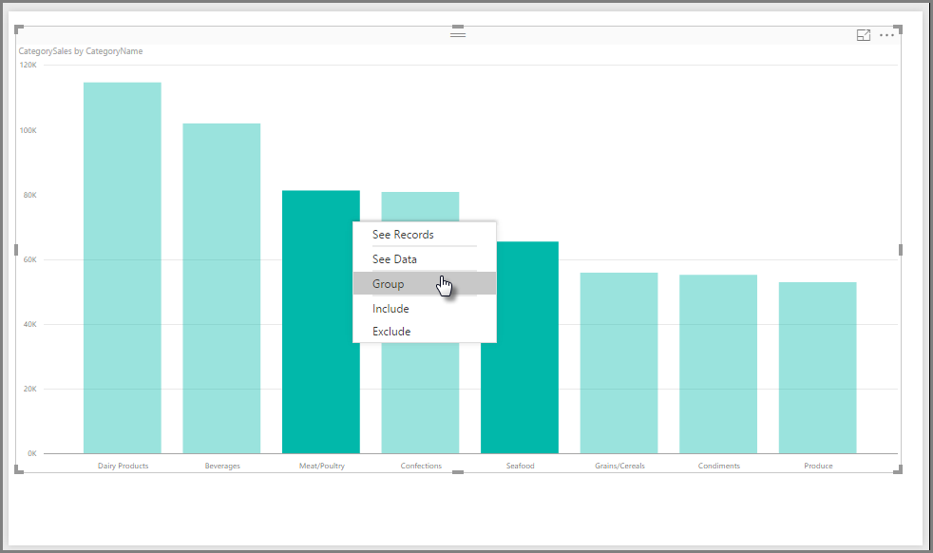

Once created, the group is added to the Legend bucket for the visual and it also appears in the Fields list.

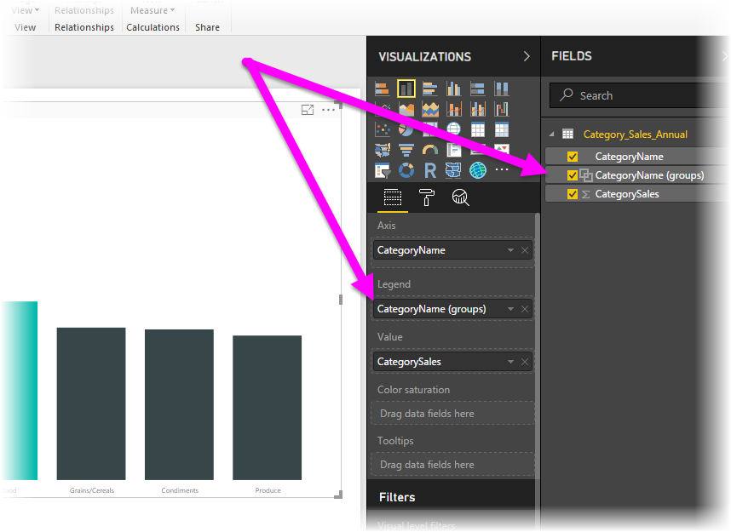

Once you have a group, you can easily edit the members of that group by right-clicking the field from the Legend bucket, or from the Fields list, and selecting Edit Groups.

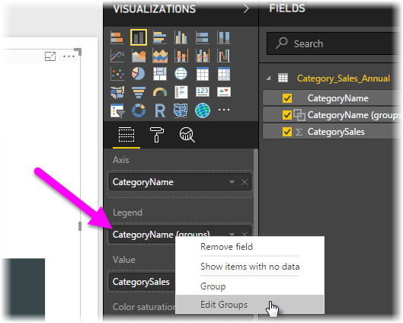

In the Groups window that appears, you can create new groups or modify existing groups. You can also rename any group by double-clicking on the group title in the Groups and members box and typing a new name.

There are all sorts of things you can do with groups like you can add items from the ungrouped values list into a new group or into one of the existing groups. To create a new group, select two or more items (using Ctrl+click) from the ungrouped values box, and then click the Group button below that box.

You can add an ungrouped value into an existing group, just select the ungrouped value, then select the existing group to which you want to add it, and click the Group button. To remove an item from a group, select it from the Groups and members box and then click Ungroup. You can also select whether ungrouped categories should be placed into the **Other** group, or should remain ungrouped.

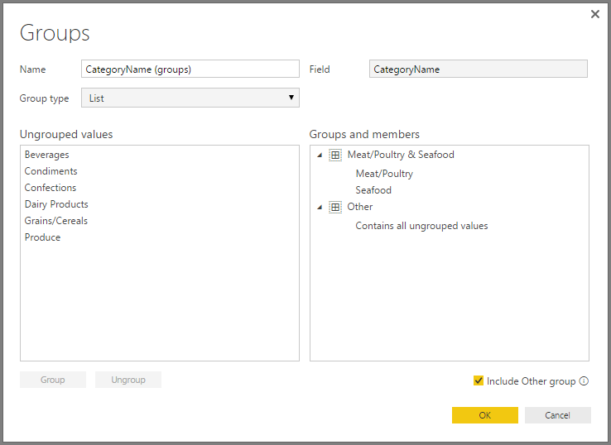

**Note**

You can create groups for any field in the Fields well, without having to multi-select from an existing visual. Just right-click the field and select New Group from the menu that appears.

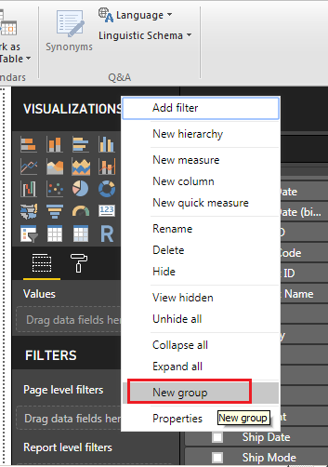

You can also create New Group and Edit Existing Groups from the Ribbon under Modeling Tab as shown below.

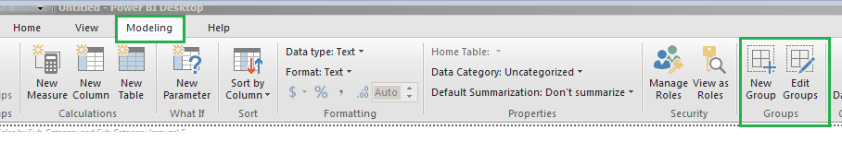

**Using binning**

You can set the bin size for numerical and time fields in Power BI Desktop. You can use binning to right-size the data that Power BI Desktop displays.

To apply a bin size, right-click a Field and select New Group.

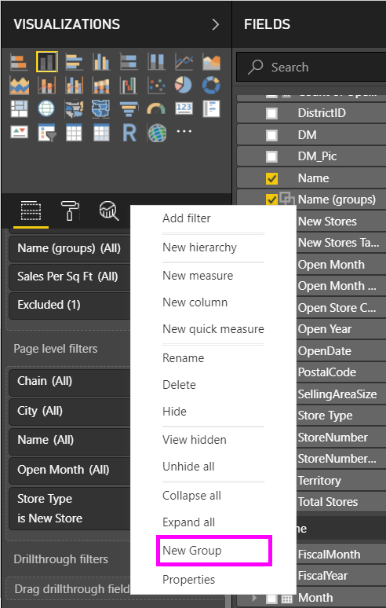

From the Groups window, set the Bin size to the size you want.

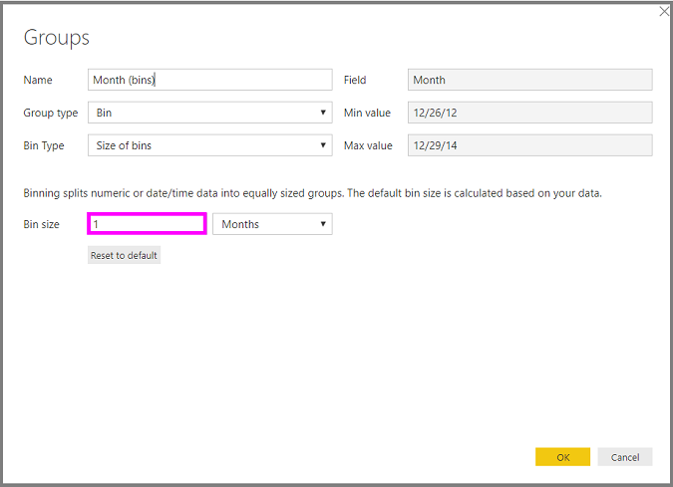

When you select OK, you'll notice that a new field appears in the Fields pane with (bins) appended. You can then drag that field onto the canvas to use the bin size in a visual.

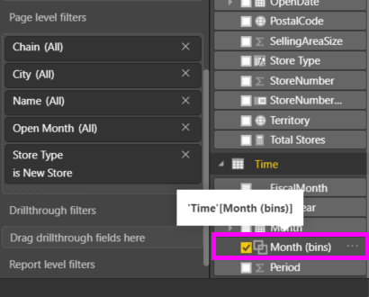

**Creating Bins on Number Column**

We have two columns Order Date and Ship Date, from those columns get the number of days taken for delivering the order using the below DAX formula by creating a New Column. Give the column Name as Delivered Days. In his column we will create the Bins to see how it works.

DATEDIFF(Orders[Order Date],Orders[Ship Date],DAY)

**Practice**

Create a visualization which show Sales by Sub-Category by Grouping Accessories, Appliances and Art into one group and all other Sub-Categories into another Group.

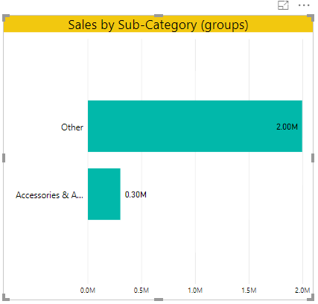

Create a Visualization which shows sales by “No of Days for Delivery” by creating bin on “No of Days for Delivery” field with bin size 2.

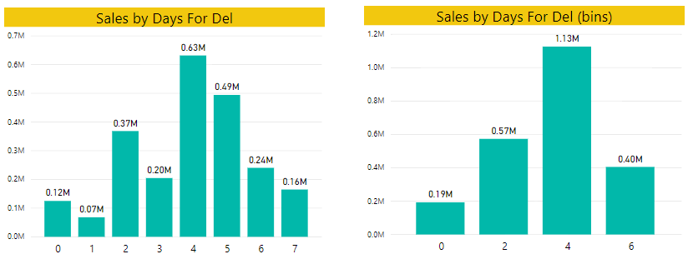

Create a visualization which show each 15 days sales as shown below.

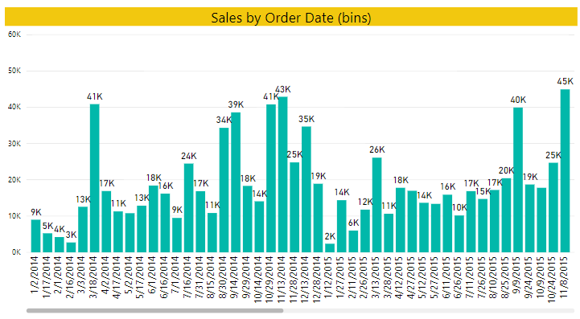

**Sorting Data in Visuals in Power BI Desktop**

In Power BI Desktop and the Power BI service, you can change how a visual look by sorting it by different data fields. By changing how you sort a visual, you can highlight the information you want to convey, and ensure the visual reflects that trend (or emphasis).

Whether you're using numeric data (such as sales figures) or text data (such as state names), you can sort your visualizations as desired, and make them look like you want them to. Power BI provides lots of flexibility for sorting, and quick menus for you to use. On any visual, select the ellipses menu (...) and then select the field by which you want to sort, as shown in the following image.

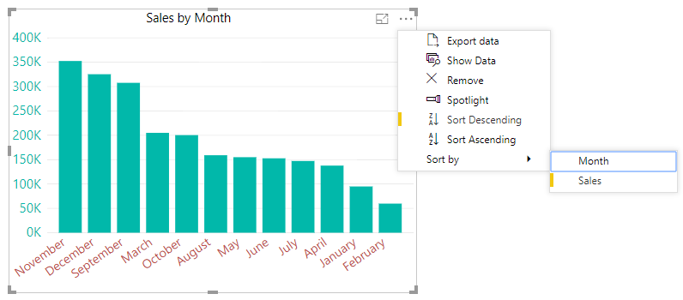

The below visualization shows Sales and Profit by Sub-Category. Here's the visualization as it looks before we do any further sorting.

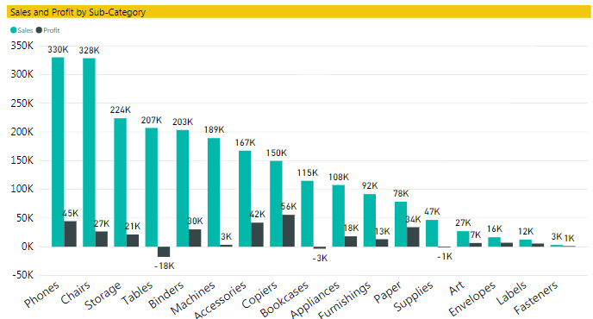

The visual is currently sorted by Sales - we can tell that by matching the color of the descending bars to the legend, but there's a better way to determine the current sort column, the ellipses menu (...) in the upper right corner of the visual. When we select the ellipses, we see the following.

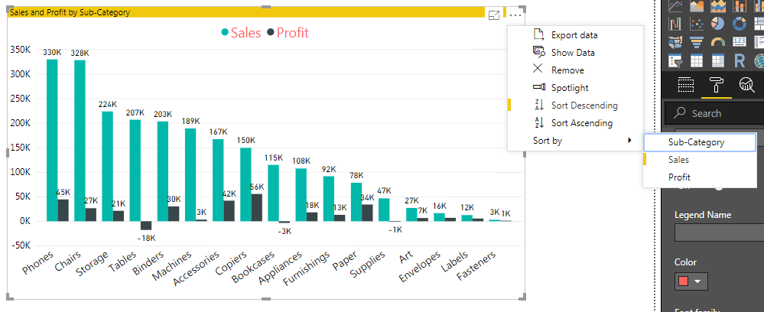

* The current sorting field is Sales, indicated by the facts that **Sort by** Sales has a yellow bar.
* The current sorting direction is largest to smallest, as shown by the little icon Z/A and a down arrow, indicated by the facts that Z/A Sort Descending has a yellow bar.

**Changing or selecting which column to use for sorting**

In the above Image you noticed the yellow bar beside **Sort by** Sales in the More Options menu, which indicates that the visual is sorted by the Sales column. Sorting by another column is easy - just select the ellipses to show the ellipsis menu, and then select another column.

In the following image, we selected Profit as the column by which we want to sort. Here's what it looks like after we select **Sort by** Profit.

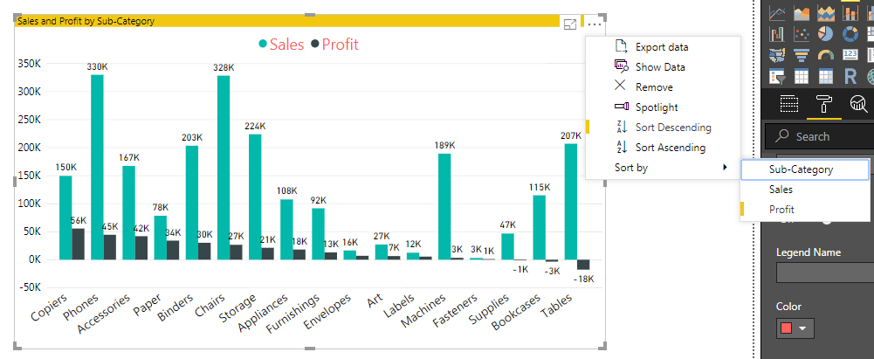

Notice how the visual has changed. The values now are ordered from highest Profit value, in this visual “Copiers”, down to “Tables” which has the lowest and Negative Value of Profit.

But what if we want to sort ascending, instead of descending?

**Selecting the sort order - smallest to largest, largest to smallest**

When “**Z/A Sort Descending**”, it means the visual is being sorted by the selected column in order of greatest value to smallest value. Want to change that? No problem - just select “**A/Z Sort Ascending**”, it means the visual is being sorted by the selected column in order of smallest to greatest value.

**NOTE**

Not all visuals can be sorted. For example, the following visuals cannot be sorted: Treemap, Map, Filled Map, Scatter, Gauge, Card, Multi Row Card, and Waterfall.

**Sort using the Sort by Column button**

You can even sort the Visualization using the column that is not used in the Visualization using Sort by Column option in The Ribbon under Modeling Tab.

Use the below DAX formulas to create Two New Columns for Getting Month_Name and Month_Number from “Order Date” Column. Or else add those two columns in Power Query.

MonthName = FORMAT (Orders [Order Date], "MMMM")

MonthNo = MONTH (Orders [Order Date])

There's another way to sort your data, and that's by using the Sort by Column button in the Modeling ribbon.

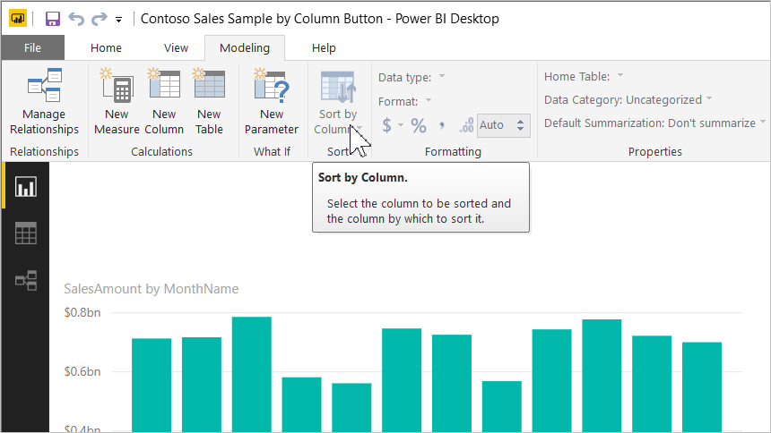

This approach to sorting requires that you select a column from the Fields pane, and then select the Sort by Column button to choose how (by which column) you want to sort your visual. You have to select the column (field) you want to sort from the Fields pane in order to enable the Sort by Column button - otherwise the button is inactive.

Let's look at a common example: you have data from each month of the year, and you want to sort it based on chronological order. The following steps show you how.

First, notice that when the visual is selected but no column is selected in the Fields pane, the Sort by Column button is inactive (grayed out).

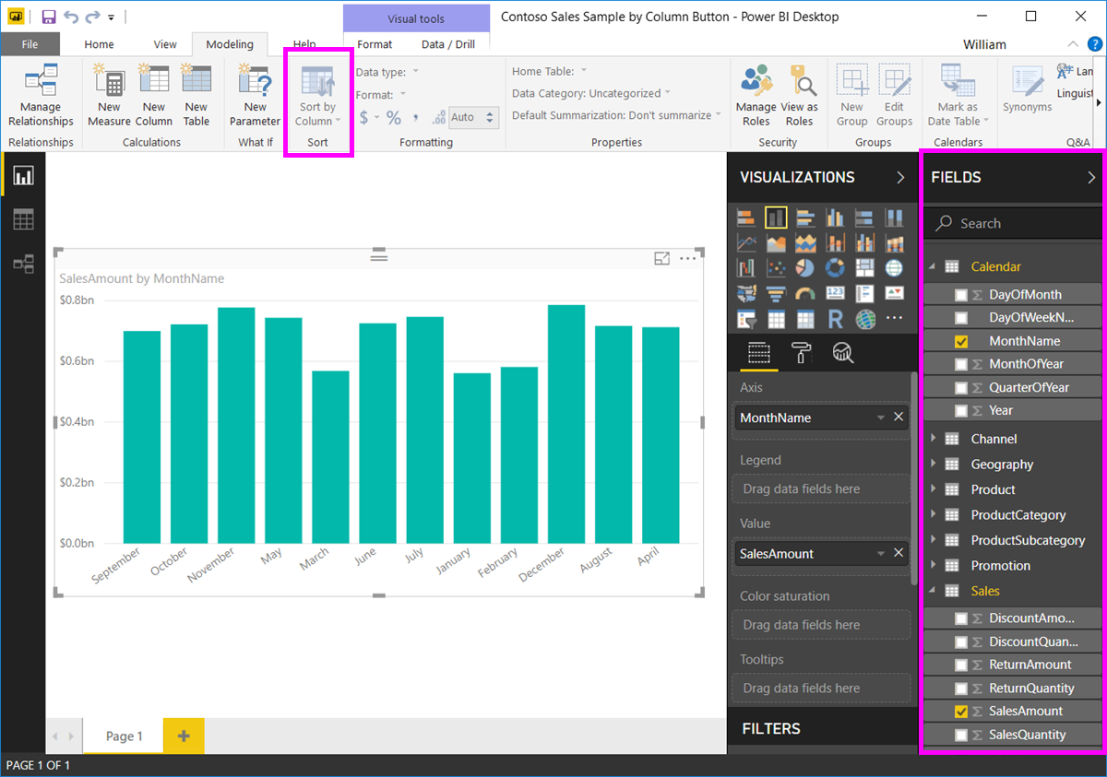

When we select the column by which we want to sort, in the Fields pane, the Sort by Column button becomes active.

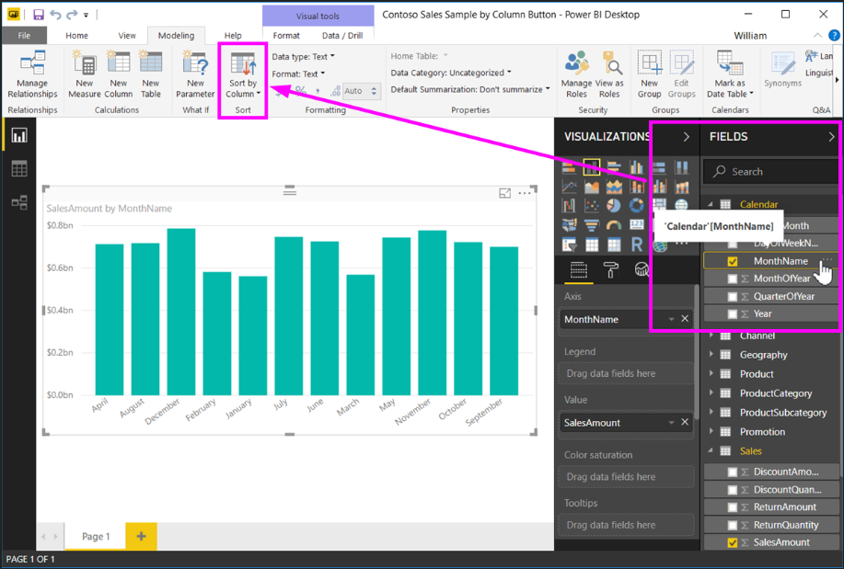Now, with the visual selected, we can select MonthOfYear, instead of the default (MonthName), and the visual now sorts in the order we want: by the month of the year.

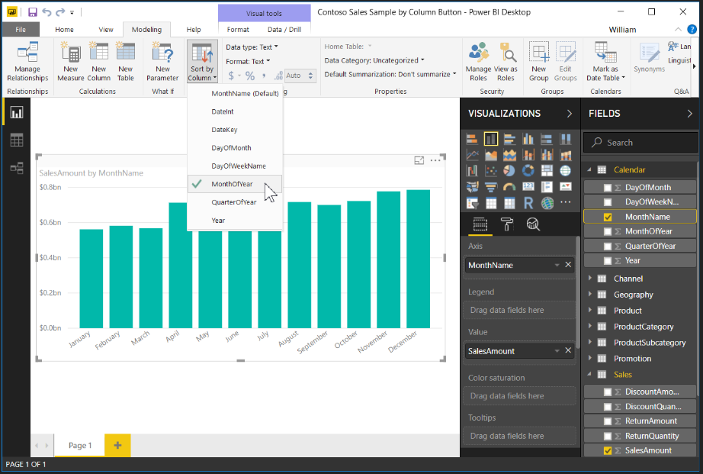

And that's it. Remember that you must select a column in the Fields pane for the Sort by Column button to become active.

**Create tooltips based on report pages in Power BI Desktop**

You can create visually rich report tooltips that appear when you hover over visuals, based on report pages you create in Power BI Desktop. By creating a report page that serves as your tooltip, your custom tooltips can include visuals, images, and any other collection of items you create in the report page.

You can create as many tooltip pages as you want. Each tooltip page can be associated with one or more fields in your report, so that when you hover over a visual that includes the selected field, the tooltip you created on your tooltip page appears when you hover over the visual, filtered by the data point over which your mouse is hovering.

**Create a report tooltip page**

Create a new report page by clicking the + button, found along the bottom of the Power BI Desktop canvas, in the page tabs area. The button is located beside the last page in the report.

Your tooltip can be any size, but keep in mind that tooltips hover over the report canvas, so you might want to keep them reasonably small. In the Format pane in the Page Size card, you can see a new page size template called Tooltip. This provides a report page canvas size that's ready for your tooltip.

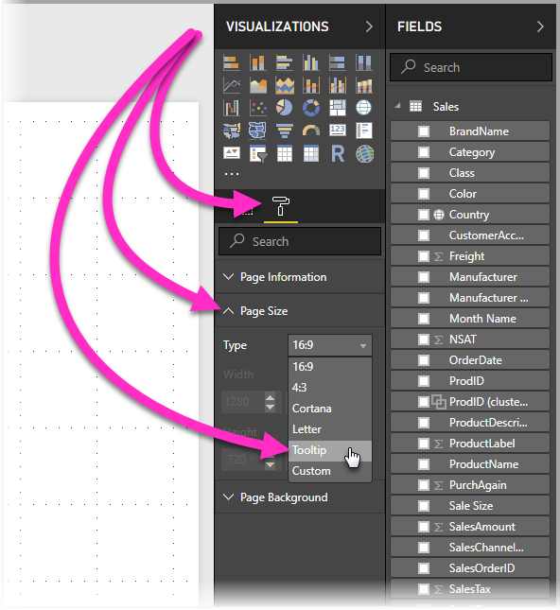

By default, Power BI Desktop fits your report canvas to the available space on the page. Often that's good, but not in the case of tooltips. To get a better sense and view of what your tooltip will look like when you're done, you can change the Page View to actual size.

To do that, select the View tab from the ribbon. From there, select Page View 🡪 Actual Size, as shown in the following image. Also name the report page (Tooltip1 or Year wise sales) so its purpose is clear.

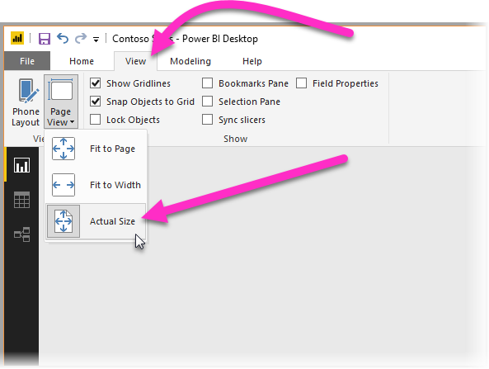

From there, you can create whatever visuals you would like to show up in your tooltip as shown below.

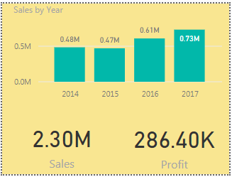

**Configure your tooltip report page**

Once you have the tooltip report page created, you need to configure the page in order for Power BI Desktop to register it as a tooltip, and to ensure it appears in over the right visuals.

To begin with, you need to turn the Tooltip slider to **ON**, in the Page Information card, to make the page a tooltip.

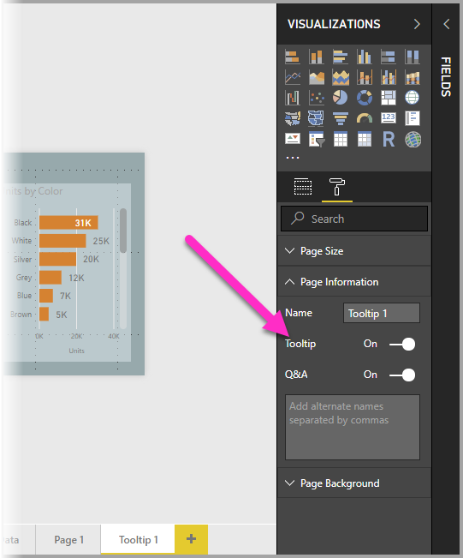

Once that slider is set to **ON**, you specify the fields for which you want the report tooltip to appear. For visuals in the report that include the field you specify, the tooltip will appear. You specify which field or fields apply by dragging them into the Tooltip fields bucket, found in the Fields section of the Visualizations pane. In the following image, the Category and Sub-Category fields has been dragged into the Tooltips fields bucket. You can include both categorical and numerical fields in the Tooltips fields bucket, including measures.

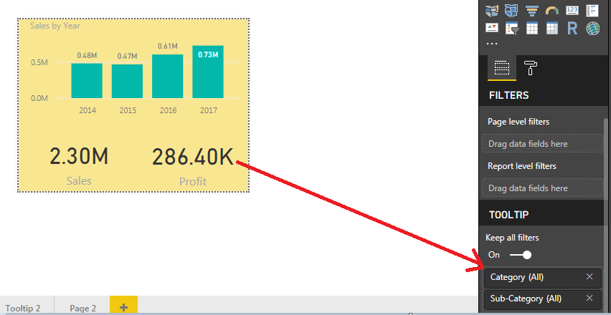

Once completed, the tooltip report page you created will be used as a tooltip in visuals in the report that use any fields you placed into the Tooltips fields bucket, replacing the default Power BI tooltip.

**Manually setting a report tooltip**

In addition to creating a tooltip that automatically appears when hovering over a visual that contains the specified field, you can manually set a tooltip.

Any visual that supports report tooltips now has a Tooltip card in its Formatting pane.

To set a tooltip manually, select the visual for which you want to specify the manual tooltip, then in the Visualizations pane, select the Format section and expand the Tooltip card.

Then, in the Page dropdown, select the tooltip page you want to use for the selected visual. Note, only report pages that are specified as Tooltip pages show up in the dialog box.

**Reverting to default tooltips**

If you create a manual tooltip for a visual but decide you want the default tooltip instead, you can always return to the default tooltip that Power BI provides. To do so, when a visual is selected and the Tooltip card is expanded, just select Auto from the Page dropdown to go back to the default.

**Modern Visual Tooltips**

Modern Visual Tooltips includes Data Point Drill Actions (Drill Down and Drill Up, Drill Through) and updated styling to match your Report Theme.

When you enable these new tooltips

* You can Drill Down and Drill Up the visual without using the Drill Actions in the header for the visual.

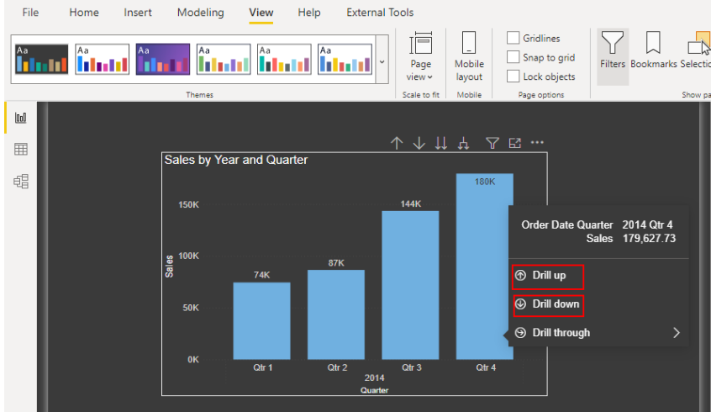

* You can Drill Through on a Data Point without having to use the right-click menu.

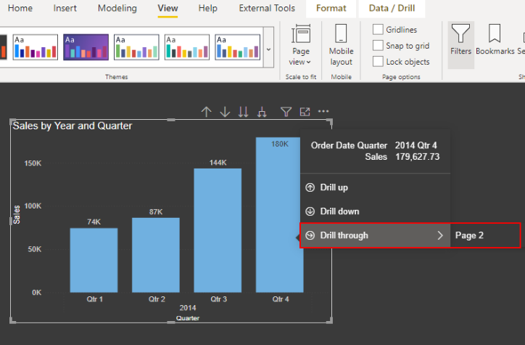

**Bookmarks, Selection Pane & Buttons**

**Bookmarks**

Bookmark saves the state of the Page, exactly as it is at the time of creating it.

That means you can then select the Bookmark and see the Page with the state that you have saved it.

Once you have a list of bookmarks, you can use those in several ways like organizing presentations of your report, creating report navigation, creating an Index page in report and more.

When you add a bookmark to your report, it will include the following

* The current page
* Filters
* Slicers
* Sort order
* Drill location
* Visibility
* Any of the “focus” modes

You can Open Bookmarks Pane by opening the Show panes, which can be found under the View tab.

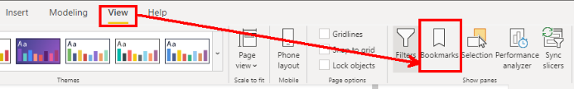

Once you Open Bookmarks Pane we can the add Bookmarks. Set up your report to look how you want, with all the filters properly set, and click the Add button under Bookmarks.

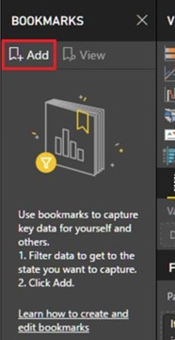

This will add a bookmark to pane, which you can rename and go back to whenever you want. You can continue adding as many bookmarks as you want.

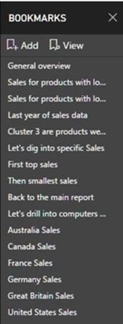

If you want to use your bookmarks as a story or in a presentation, you can use the View option to enter into a view mode for bookmarks.

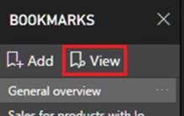

When in this mode, there is a title bar for each bookmark that includes the bookmark name and navigation arrows. At this point, you can close the bookmarking pane if you want.

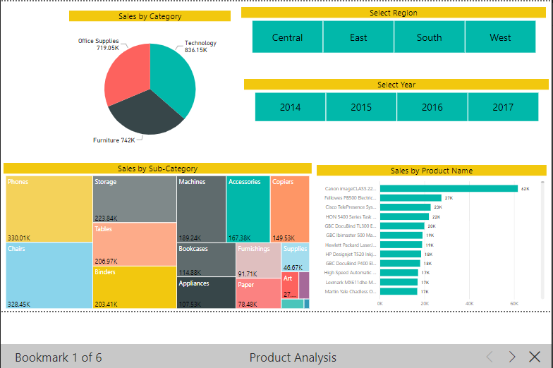

**Bookmark links for buttons, shapes and images**

You can link buttons, shapes and images to bookmarks. This is a great feature for creating custom navigation in your reports or creating buttons that perform different actions across your report.

You’ll find the option in the formatting pane under the Action. You can pick either Back or Bookmark as your Action type. If you pick bookmark, you’ll have a dropdown to pick one of the bookmarks you currently have in your report.

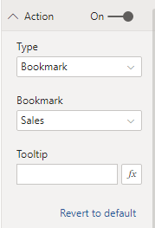

Just like the back button, you can activate bookmark buttons by pressing “**ctrl + click”** while in editing mode or just clicking in reading mode.

**Selection Pane**

You can hide or unhide visuals in a Power BI report through the selection pane. There is an eye icon besides every visual, which gives you the control over visibility of that visual on the report page.

**Buttons**

Buttons are action objects in Power BI. You can create a button (or even an image or shape), and then set the action of that to be; back, Q&A, or bookmark. In this post, we are only talking about the bookmark action feature.

Changing the Chart Type Dynamically

**Data Transformation with Power Query / Query Editor**

**Data Transformation**

Data transformation is the process of converting data or information from one format to another, usually from the format of a source system into the required format of a new destination system.

**Data Transformation – Why?**

When existing Business model is hard to understand we use power query to Shape or Transform the data, and build a model that will be easily understandable for a Report User.

If existing Business model contains too many tables and many relationships between tables makes a reporting query very slow and not efficient. Here we use Power Query to Shape and Transform the data to build a star or snow flake schema by creating dimension tables and fact table, which is more comfortable for report development.

Transactional databases are not best option for reporting purpose because

* The model is hard to understand for a Report User.
* Too many tables and many relationships between tables makes a reporting query (that might use 20 of these tables at once) very slow and not efficient.
* Also we don't need all the transactional data to be loaded into Reporting Tools we just load whatever data we need for reports into our reporting tools.

**Shape or Transform Data using Power Query**

With Power BI Desktop or Query Editor or Power Query, you can connect different types of data sources, and then shape the data to meet your reporting needs.

In Power Query or Query Editor we will transform or shape the data using built-in GUI transformations in the ribbon or using M language code.

**Benefits of Data Transformation**

Data transformation ensures that data that enters your enterprise is usable and manageable.

It facilitates cost-efficient storage, ease of analysis for greater business intelligence, and operational efficiency.

On the flip side, storing data that has not been transformed wastes resources and creates the possibility of compliance risk because the data cannot be managed under the organization’s data governance rules.

**Overview of Power Query / Query Editor**

* Power Query is a Data Extraction, Transformation and Loading Engine.
* The Engine comes with a Graphical Tool and a Formula Language (M Language).
* Power Query can connect to set of data sources and read data from them for data preparation.
* Once connected to any data source, then Queries (one for each table, or entity) are listed and available for selection, viewing, and shaping.
* The Graphical Tool has list of Transformations that can be applied on a data set or Queries, and it also supports different data sources.
* Power Query graphical interface is so easy to work with that even business analyst or a power user can work with it, on the other hand Power Query M language is so powerful that can be used for complex real world challenges of data transformations.
* However, the Power Query formula language (M Language) is much more powerful than the GUI. Actually there are some features in Power Query engine that not yet has been implemented through GUI, but they are available through M Language.
* Power Query can load the result set into Power Pivot for data modeling.
* M is the formula language behind the scenes of Power Query. Everything you do in the Query Editor will be translated to an M script. M contains full list of functions that you can use. So the powerful side of Power Query is actually M. M is a functional language and it has a simple structure.
* Every data preparation steps or applied steps on Queries will be recorded and displayed in Query Editor under Applied Steps Section.

**Query Editor User Interface**

You can open Power Query Editor in three different ways

1. From Home Tab you can find Edit Queries.

2. In the Table Level Options you can find Edit Query.

3. While loading the table edit option that takes you to the Edit Queries.

To get into Query Editor, select Edit Queries from the Home tab of Power BI Desktop.

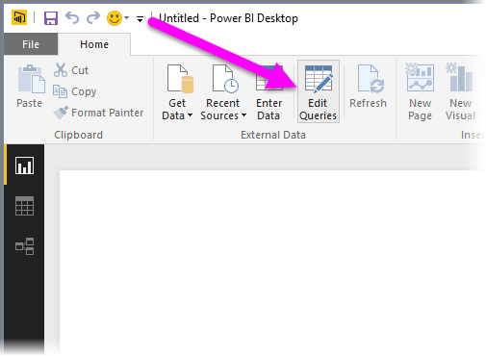

Other way to get or open Query Editor is, go to Table Level Options you can find Edit Query.

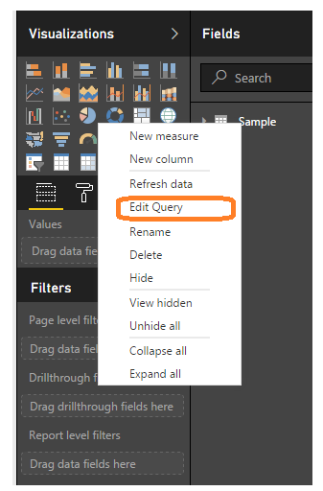

Third way is while loading the table “Edit” option that takes you to the Edit Queries.

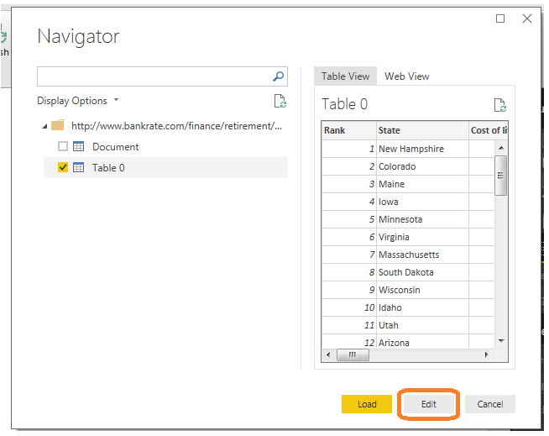

With no data connections, Query Editor appears as a blank pane, ready for data as shown below.

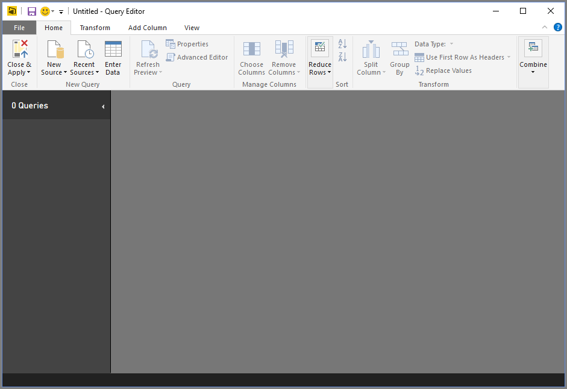

**How to establish connection to the source?**

Home Tab 🡪New Source 🡪 Get Data window🡪Select the Source Type 🡪 Select the Source 🡪 Ok

Once Query Editor is loaded with data that's ready for you to shape, you see a handful of sections. Here’s how Query Editor appears once a data connection is established.

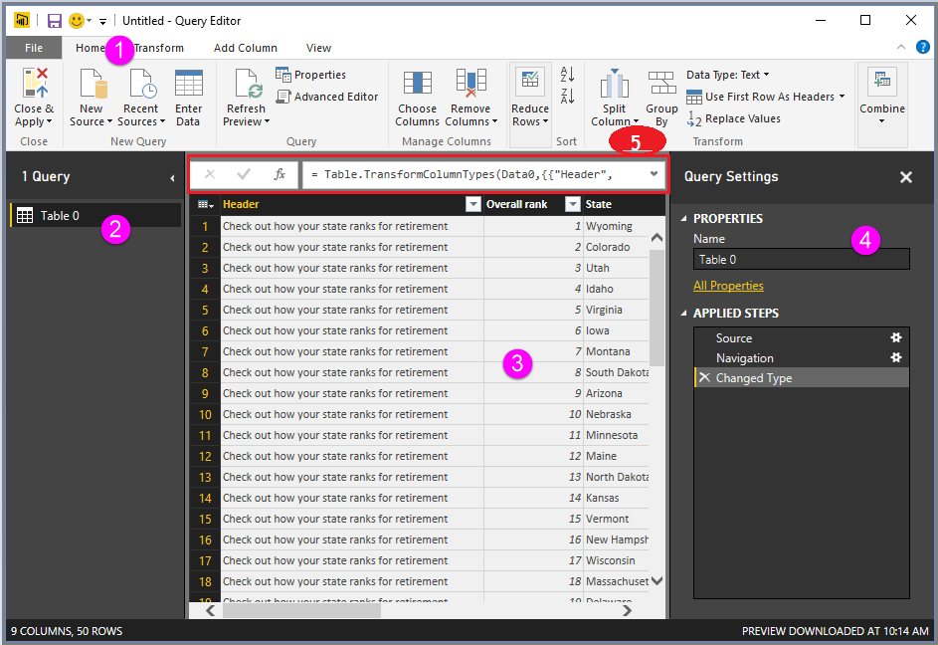

* In the ribbon, many buttons are now active to interact with the data in the query for data preparation.
* In the left pane or queries pane, queries (one for each table, or entity) are listed and available for selection, viewing, and shaping.
* In the center pane or Results Pane, data from the selected query is displayed and available for shaping.
* The Query Settings window appears, listing the query’s properties and applied steps.
* The Formula bar is the place where you can see and edit the M code of the current transformation step.

We’ll look at each of these four areas

* The ribbon
* The queries pane
* The data view / Results Pane
* The Query Settings pane
* Formula Bar

**The Query Ribbon**

The ribbon in Query Editor consists of four tabs – Home, Transform, Add Column, and View.

**Home Tab**

The Home tab contains the **common query tasks**, including the first step in any query, which is Get Data. The following image shows the Home ribbon.

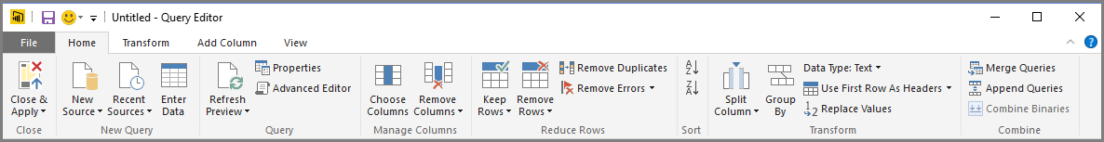

**Transform Tab**

The Transform tab provides access to common **data transformation tasks**, such as adding or removing columns, changing data types, splitting columns, and other data-driven tasks. The following image shows the Transform tab.

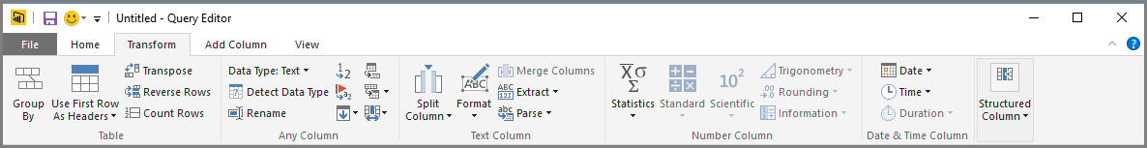

**Add Column Tab**

The Add Column tab provides additional tasks associated with **adding a column, formatting column data, and adding custom columns.** The following image shows the Add Column tab.

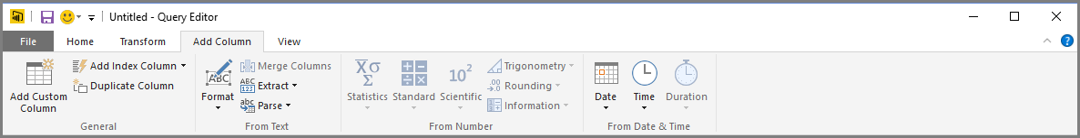

The Difference between the **Transform** and **Add Column** Tabs

The bulk of all transformations available in power query can be accessed through either the Transform tab or the Add Column tab.

You might think there is a lot of duplication between these two tabs. For example, both tabs contain a form Text section with a lot of the same commands. It’s not really the case, there is a subtle difference!

When you use a command from the Add Column tab that is found in both tabs, it will create a new column with the transformed data and the original column will stay intact. Whereas using the equivalent command from the Transform tab will change the original column and no new column is created. This is a critical point to be aware of!

**View Tab**

The View tab on the ribbon is used to toggle whether certain panes or windows are displayed. It’s also used to display the Advanced Editor. The following image shows the View tab.

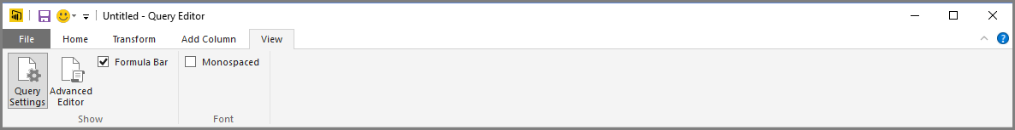

It’s useful to know that many of the tasks available from the ribbon are also available by right-clicking a column, or other data, in the center pane.

**The Left Pane / Queries Pane**

The left pane displays the number of active queries, as well as the name of the query. When you select a query from the left pane, its data is displayed in the center pane, where you can shape and transform the data to meet your needs. The following image shows the left pane with multiple queries.

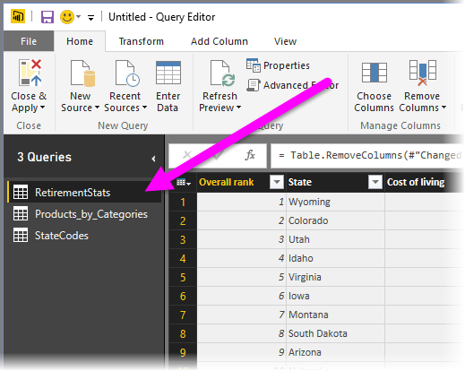

**The Center (Data) Pane / Results Pane**

In the center pane, or Data pane, data from the selected query is displayed. This is where much of the work of the Query view is accomplished.

Notice that many of these right-click menu items are the same as buttons in the ribbon tabs.

When you select a right-click menu item (or a ribbon button), Query applies the step to the data, and saves it as part of the query itself. The steps are recorded in the Query Settings pane in sequential order, as described in the next section.

**The Query Settings Pane**

The Query Settings pane is where all steps associated with a query are displayed. For example, in the following image, the Applied Steps section of the Query Settings pane reflects the fact that we just changed the type of the Overall score column.

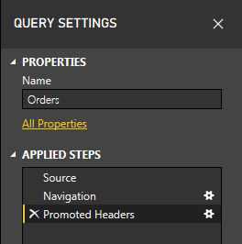

As additional shaping steps are applied to the query, they are captured in the **Applied Steps** section.

It’s important to know that the underlying data is not changed rather Query Editor adjusts and shapes its view of the data, and any interaction with the underlying data occurs based on Query Editor’s shaped and modified view of that data.

In the Query Settings pane, you can rename steps, delete steps, or reorder the steps as you see fit. To do so, right-click the step in the Applied Steps section, and choose from the menu that appears. All query steps are carried out in the order they appear in the Applied Steps pane.

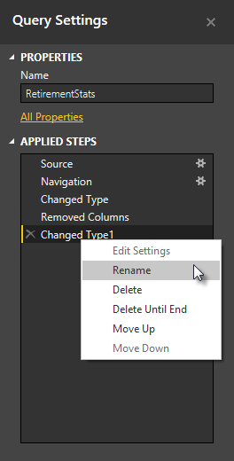

**Formula Bar**

This is where you can see and edit the M code of the current transformation step. Each transformation you make on your data is recorded and appears as a step in the applied steps area.

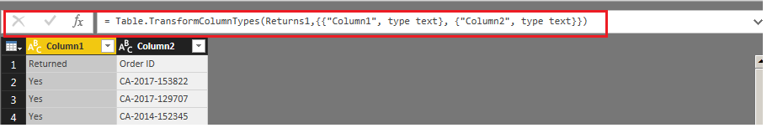

**The Advanced Editor**

If you want to see the code that Query Editor is creating with each step, or want to create your own shaping code, you can use the Advanced Editor. To launch the advanced editor, select View from the ribbon, then select Advanced Editor.

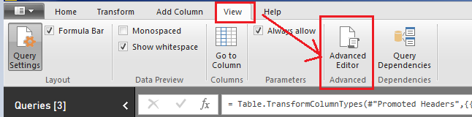

A window appears, showing the existing Query code. You can directly edit the code in the Advanced Editor window. To close the window, select the done or Cancel button.

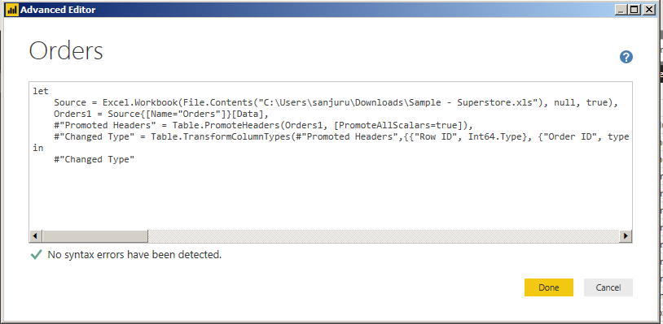

**Saving Your Work**

When your query is where you want it, you can have Query Editor apply the changes to the data model into Power BI Desktop, and close Query Editor. To do that, select Close & Apply from Query Editor's File menu as shown below.

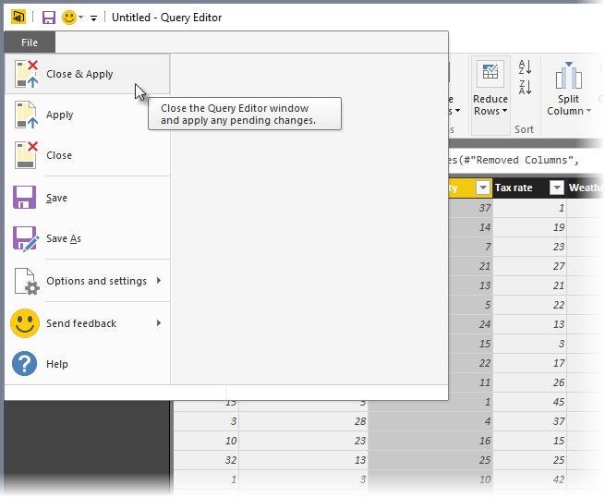

Once you have your query where you want it, or if you just want to make sure your work is saved, Power BI Desktop can save your work in the form of **“. pbix”** file.

To save your work, select File > Save (or File > Save As), as shown in the following image.

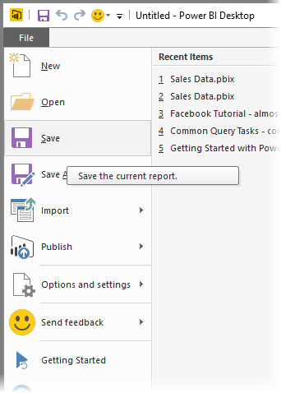

In below diagram you can see a high level diagram of Power Query conceptually

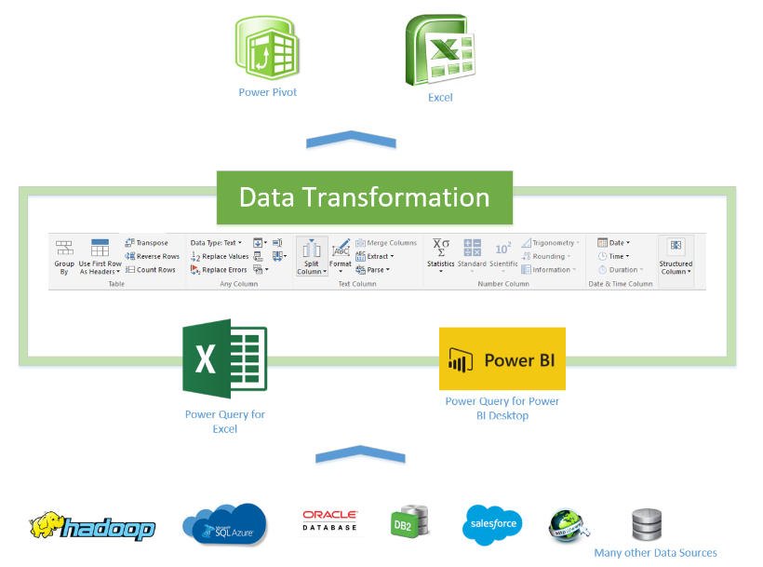

**Data Type**

Data Type represents the type of information stored in the memory location or Column. Each column should have only one Data Type.

**Change Data Type of a Column in Power BI**

When you import or load a table from any data source, Power BI will automatically detect the data type of a column. However, there may be some situations where Power BI might get them wrong. For example, it may consider amounts, values, or even dates as the text. Now we will see how to Change Data Types of a Column in Power BI with example. Changing data type of the column is important as DAX functions have special data type requirements and also filtering options will change based on data type of the column.

In Query Editor or Power Query you can change the Data Type of a column in different ways.

**Approach 1**

In the below image for Units Sold Column, Power BI identified it as string column. But actually we have Decimal Numbers as that column values.

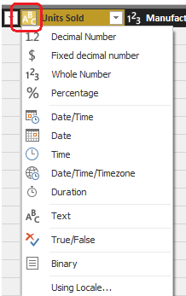

So to change the data type, select the Column for which you want to change the data type. Next, click on the left corner of the column header which is marked in Red Box. Then select the data type which is appropriate, here Decimal Number.

Changing data type of a column will open the following pop up window. You can Choose “Replace Current” to update current step or also you can choose “Add new step” to add a new transformation step to the Query.

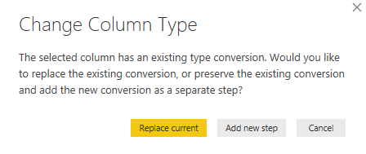

**Approach 2**

Select the Column name that you want to alter the data type, and click on the Data Type button under the Home tab in Power Query Ribbon.

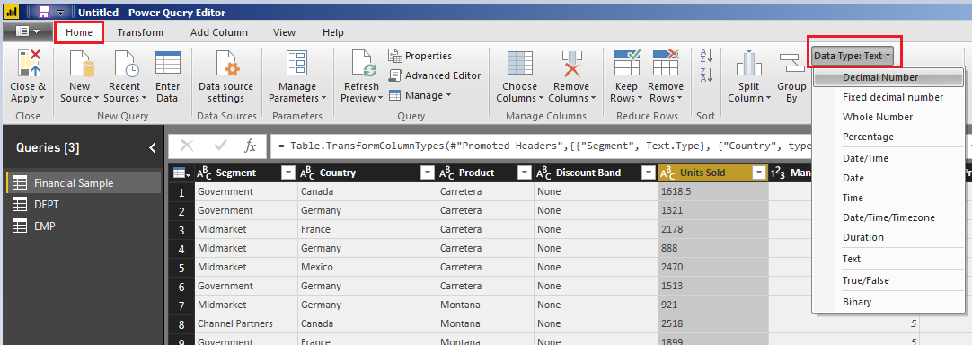

**Approach 3**

Select the Column that you want to change the data type and right-click on it will open the context menu. Select the Change Type and then select the data type from the list. For now, we are selecting the Decimal Number.

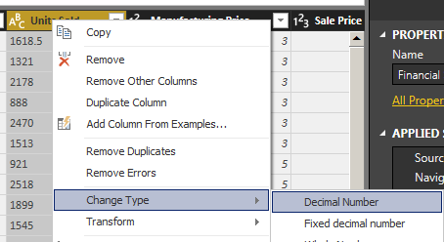

**Filtering select Rows in Power Query / Filters in Power Query**

Data Type of column has impact on filtering options available. Filter options changes with respect to data types. Before going to filter rows check the data types of the columns.

“Text Filtering Options Are Case Sensitive”.

**Filter a column using an Auto Filter / Basic Filtering**

* Select the column that you need to filter.
* Click the down arrow (  ).
* Uncheck the Select All box to deselect all Column Values.
* Select the column values you want to include in your table.
* Click OK.

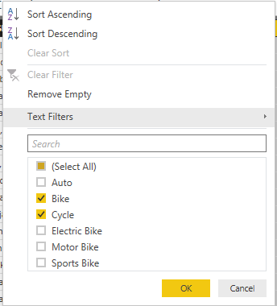

“Search Bar is Case Insensitive”.

**Note:**

Be careful if you are filtering the rows using Search Bar. Always look at the M code return by Power Query and cross check it is filtering as expected.

Basic Filtering is good only if you want to do equity filtering for values that exists in the current data set, however it won’t work correctly if you want to check ranges, or contains or things that is not an exact equity filter. Advanced Filtering is the correct way of filtering in Power Query, and there are advanced filters for all types of data types; Numbers, Text, Date…

When you filter a column, only the top 1,000 distinct values in the column will load into the filter list. If there are 1,000 or more values in the column in Query Editor that you are filtering, a message will appears indicating that the list of values in the filter list may be incomplete, and the Load more link is shown. Click the Load more link to load another 1,000 distinct values.

If exactly 1,000 distinct values are found again, the list is displayed with a message stating that the list could still be incomplete.

If less than 1,000 distinct values are found, the full list of values is shown.

**Filter a Column using Text Filters**

In addition to the “Auto Filters” or Basic Filtering, you can filter a Text values using the Text Filters context menu.

Click the down arrow (  ) of the column containing a Text values you want to filter on.

Click Text Filters and select the filter option required from Context Menu.

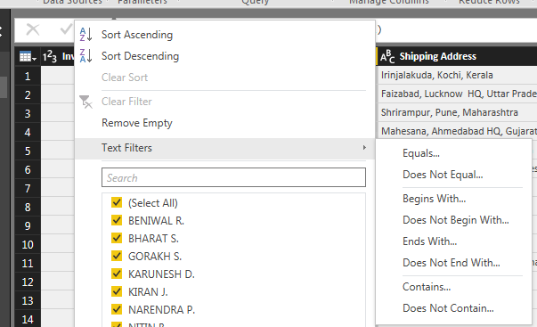

**Filter a Column using Number Filters**

In addition to the “Auto Filters”, you can filter Number values using the Number Filters Context Menu.

To filter a column using Number Filters, Click the down arrow (  ) of the column containing a Number values you want to filter on.

Click Number Filters, and select the filter option required from Context Menu.

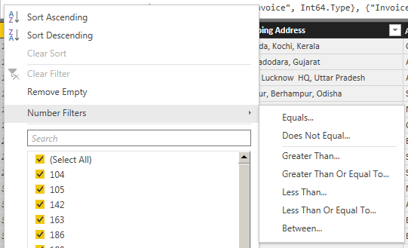

**Filter a Column using Date Filters**

In addition to the “Auto Filters”, you can filter Date values using the Date Filters Context Menu.

To filter a column values using Date Filters, Click the down arrow (  ) of the column containing Date values you want to filter on.

Click Date Filters, and select the filter option required from Context Menu.

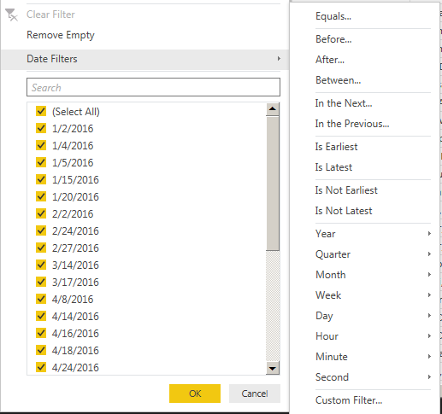

**Filter Multiple Columns**

To filter multiple columns, select an additional column, and repeat one of the column filter steps. **AND** Operation will be performed between the columns if you apply filters on multiple columns individually.

Other way is by Using **Advanced** option in Filter Rows you can apply filters on multiple columns at a time. Here you can select **And / Or** operation between columns.

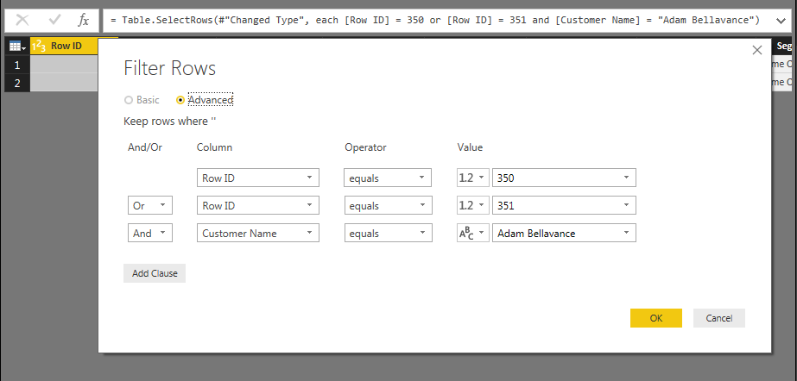

In below image we applied filters on Row ID and Customer Name Column and you can see M Language Code.

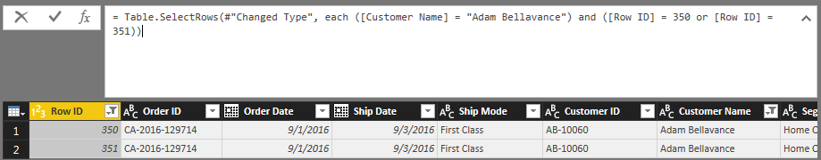

**Inbuilt Column Transformations**

* Remove Columns / Remove Other Columns
* Name / Rename a Column
* Reorder Columns or Sort Columns
* Add Column / Custom Column
* Split Columns
* Merge Columns
* Pivot, Unpivot Columns
* Transpose Columns

**Remove Columns / Remove Other Columns**

If you want to remove unwanted columns which are not necessary in your data model for the data source in your query, you can use Remove Columns / Remove Other Columns option as shown in the below image.

If you want remove selected columns

Select the columns you want to remove 🡪 Right Click 🡪 Remove Columns

If you want to remove all other columns other than selected

Select the columns you want to keep 🡪 Right Click 🡪 Remove Other Columns

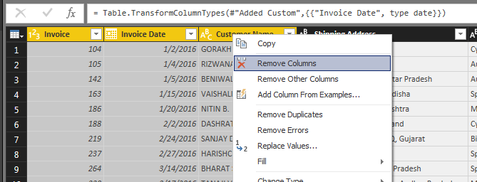

You can also remove columns from **Manage Columns** Section in **Home** Tab in **Query Editor** Ribbon.

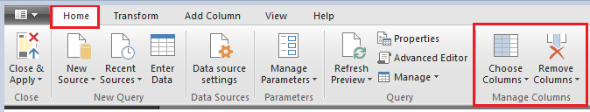

**Name or Rename a Column**

When you want give a meaningful name for a column that needs in Report, you can do it by renaming a column. To rename a column

Right click a column 🡪 Rename 🡪 Enter a meaningful Name

(OR)

Double click the column 🡪that will allow you to edit Name 🡪 Enter a meaningful Name

**Reorder Columns or Sort Columns in Power BI**

One way is drag the required column and Drop at the position you want to place.

Second way, right-click on the column name that you want to move will open the context menu. Select the **Move** and then select **Right**, **Left**, **To End**, or **To Beginning** options.

**Add Column / Add Custom Column**

In Query Editor you can create custom formulas that operate on multiple columns in your table, and then place the results of such formulas into a new (custom) column. Query Editor makes it easy to create custom columns.

In Query Editor, select Custom Column from the Add Column tab on the ribbon.

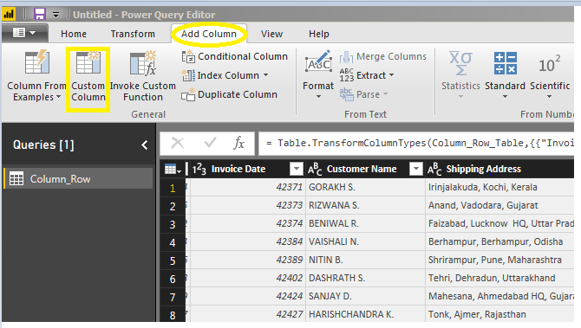

Once we select custom column a Custom Column window opens as below where we can provide New column name and Custom column formula.

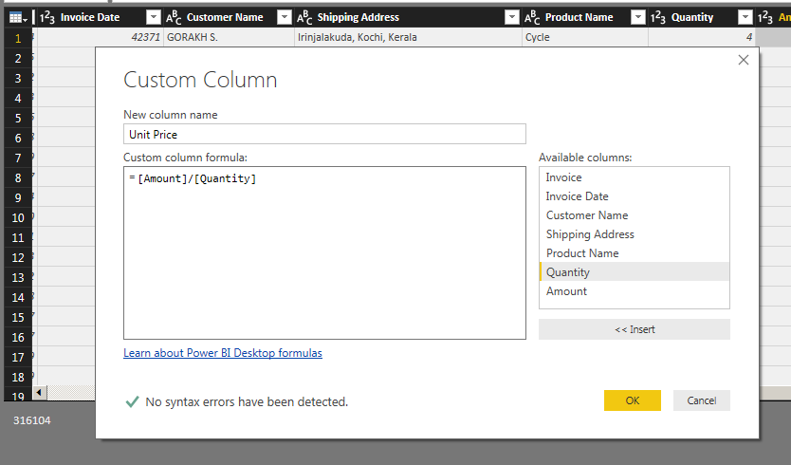

**Split Columns**

Sometimes you will get merged columns (one column with too much information). In that situation, you can use Power BI Split Columns option to split that column into multiple columns.

We have two options here to split columns as shown in below image.

* By Delimiter
* By Number of Characters

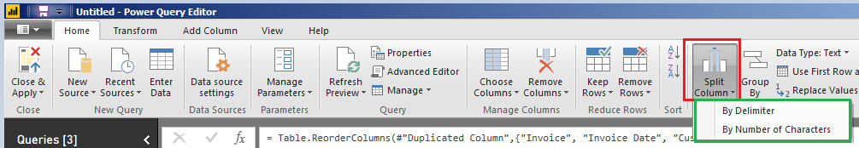

In order to split the columns in a table, right-click on the column that you want to split will open the context menu. Select the Split Columns and then select “**By Delimiter”** option.

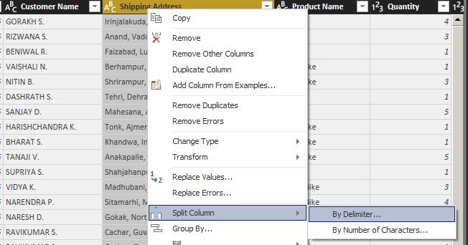

Selecting the “By Delimiter” option will open the following window.

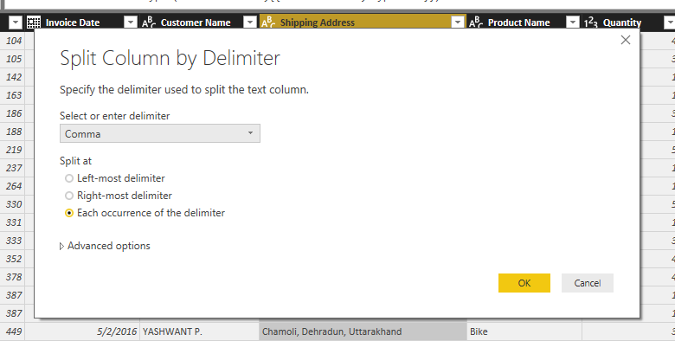

**Select or enter delimiter**

Please select the delimiter that you want to use as the split character from the drop down list. If it is not there in the list, then select Custom option in the drop down and specify that custom character.

**Left most delimiter**

This option will split the left most string before first delimiter.

**Right most delimiter**

This option will split right most string after the last delimiter.

**Each Occurrence of the delimiter**

Text will split at each occurrence of a delimiter.

**Split Columns by Number of Characters**

Right-click on the column that you want to split will open the context menu. Please select the Split Columns and then select “By Number of Characters” option.

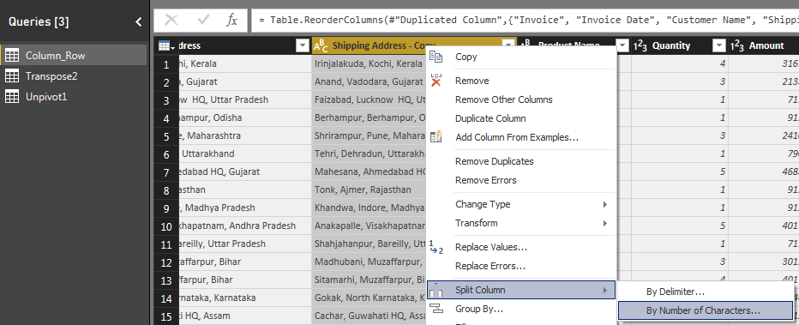

Selecting the “By Number of Characters” option will open the Split Column by Number of Characters window.

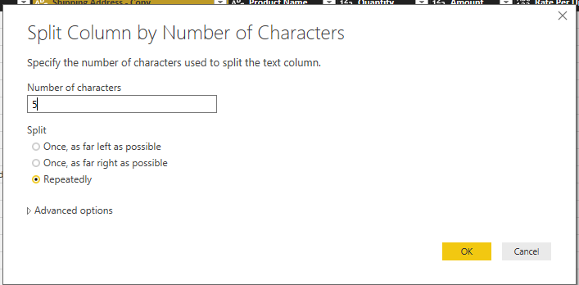

**Number of Characters**

Please specify the number of characters used to split the column. Let us give as 5.

**Once, as far left as possible**

This option will split the given string into two strings first string with first 5 Characters and second string with remaining characters.

**Once, as far right as possible**

This option will split the given string into two strings first string with all the characters except last 5 Characters and second string will be last 5 characters.

**Repeatedly**

Text will split for every 5 characters.

**Merge Columns**

With Power Query, you can merge two or more columns in your query. You can merge columns to replace them with a merged column, or create a new merged column alongside the columns that are merged.

**Merge columns to replace existing columns**

Select two or more columns that you need to merge. Press the CTRL key, and then click on the column headers to select each of the columns that you'll include in the merge.

**NOTE:** The order in which you select the columns sets the order of the values in the merged column.

Right-click the columns and click Merge Columns.

In the Merge Columns popup window, specify the separator that is in use between each of the column values. You can select from predefined separator values, or specify a custom separator value. Give a meaningful Name in “**New column name”** section.

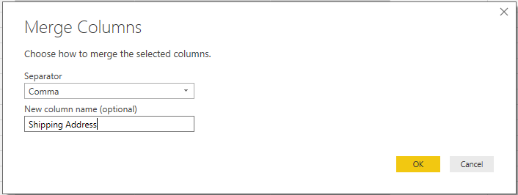

Click OK to create a merge column that replaces the columns selected for the merge operation.

**Merge Columns to create a new column**

Perform all the above steps in **Add Column** Tab in **Query Ribbon** to create a new column for all the merged columns.

**PIVOT and UNPIVOT with Power BI**

Turning columns to rows, or rows to columns is easy with Power Query and Power BI.

**UNPIVOT** 🡪 Converting Columns to Rows

**PIVOT** 🡪 Converting Rows to Columns

**Transpose**

This is used to reverse the rows and column of a table. Once you select the column and click on transpose option the rows becomes columns and column becomes rows. For using it click on Transpose option of Transform tab as below.

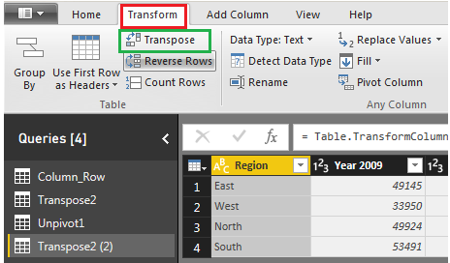

Region values are in Rows and Year Values are in columns in the below Query and we will use this for Transpose.

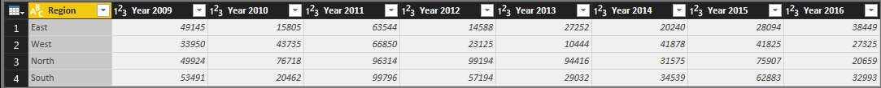

Once after Transpose the result will looks like below. Year values in rows and Region values in columns.

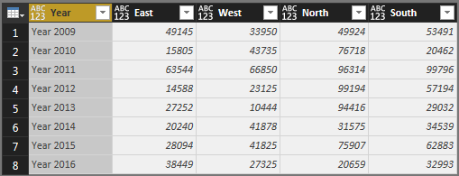

**In built Row Transformations**

* Header Row or Use First Row as Headers
* Keep Top Rows
* Keep Bottom Rows
* Keep Range of Rows
* Keep Duplicates
* Keep Errors
* Remove Top Rows
* Remove Bottom Rows
* Remove Alternative Rows
* Remove Duplicates
* Remove Blank Rows
* Remove Errors
* Group Rows

**Use First Row as Header**

When power bi is not able to identify headers automatically, you can manually do that using “**Use First Row as Header”**.

**Reduce Rows**

In case you want to filter the data you are importing, you have two options: either by keeping the specific rows or removing rows. Both options can be found by clicking **Home** 🡪 **Reduce Rows**.

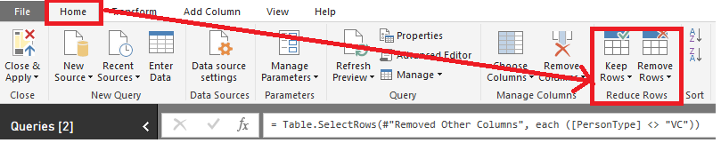

Under **Keep Rows**, you have the following options

**Keep Top Rows** 🡪 where you specify the number of top rows to keep.

**Keep Bottom Rows** 🡪 for which you pick the number of bottom rows to keep.

**Keep Range of Rows** 🡪 which skips a specified number of top rows and then keeps the chosen number of rows.

In addition to the first three options, which work on whole tables, you have **Keep Duplicates** and **Keep Errors**, both of which can work on either the whole table or the selected columns only. For example, if you select the whole table and choose Keep Duplicates, you will only see the rows that are complete duplicates of each other. However, if you choose only one column and click Keep Duplicates, you will get the rows where the values in the selected column are duplicates, regardless of other columns’ values.

Under **Remove Rows**, you have six options

**Remove Top Rows** 🡪 Removes a specified number of top rows. Works on the whole table only.

**Remove Bottom Rows** 🡪 Removes a specified number of bottom rows. Works on the whole table only.

**Remove Alternate Rows** 🡪 Removes rows following a user-supplied pattern: it starts with a specified row, then alternates between removing the selected number of rows and keeping the chosen number of rows. Works on the whole table only.

**Remove Duplicates** 🡪 Removes rows that are duplicates of other rows. Works on either the whole table or the selected columns only.

**Remove Blank Rows** 🡪 Removes rows that completely consist of either empty strings or nulls; if you need to remove blank values from one column, you can click on the arrow to the right of a column’s name and click **Remove Empty**. Remove Blank Rows Works on the whole table only.

**Remove Errors** 🡪 Removes rows that contain errors. Works on either the whole table or the selected columns only.

In case of Remove Duplicates and Remove Errors, there is a difference between applying these options to all selected columns or the whole table. In the first case, if you have new columns added to your query, the functions will not work on the new columns, because selecting all columns keeps their names in the code. To remove duplicates or errors from the whole table, select the table icon above row numbers and choose either Remove Duplicates or Remove Errors.

**Group rows / Group By**

In Query Editor, you can group the values in multiple rows into a single value. This can be useful when summarizing the number of products offered, the total sales, or the count of students or total salary paid for each department.

Let’s summarize our EMP table by Deptno and Job wise 🡪 TotSal, MinSal, MaxSal, AvgSal, CountOfEmp.

To do that, you can select Deptno and Job first, then click **Home** 🡪 **Transform** 🡪 Group By (**Or) Transform 🡪 Table 🡪 Group By**. The **Group By** window then opens; you’ll see a radio button to switch between Basic and Advanced settings. Specify one or more columns to group by and how to aggregate data. To group by more than one column, switch to Advanced settings, or you could have pre-selected multiple columns before clicking **Group By**.

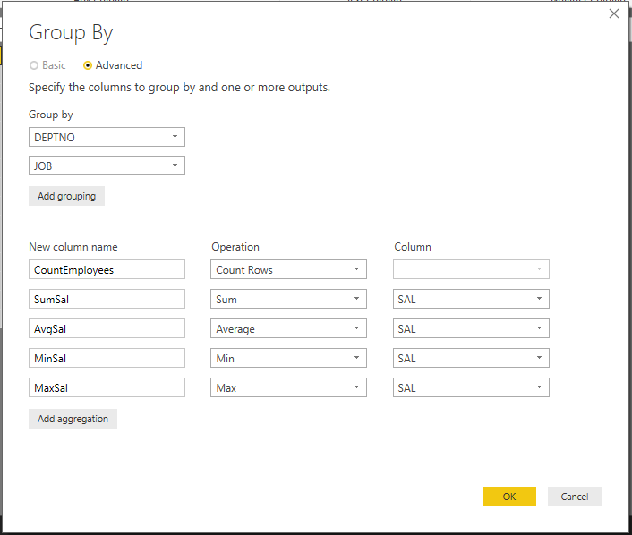

**Combine Queries**

Combining more than one queries either horizontal or vertical we call it as Combine Queries. Result of a combine operation on one or more queries will be only one query. You can find **Append Queries** or **Merge Queries** in the Combine Queries section of the Query Editor in Power BI. Append Queries will combine the queries data vertically. Merge Queries will combine the queries data horizontally.

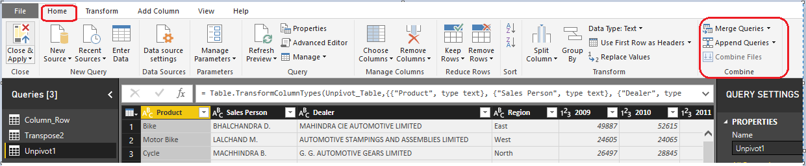

**Append Queries**

Append Queries means results of two (or more) queries will be combined vertically into one query in the below way

Rows will be appended after each other. (For example appending a query with 50 rows with another query with 100 rows, will return a result set of 150 rows)

Each Query should contain same number of columns and same datatype for columns for better outputs. (For example col1, col2… col10 in first query, after appending with same columns in the second query will result into one query with single set of col1, col2… col10)

**Append 2 files individually with different queries**

Consider two sample data sets, one for each month sales,

**Sales for April Month**

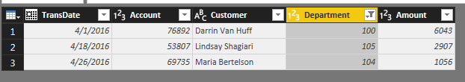

**Sales for May Month**

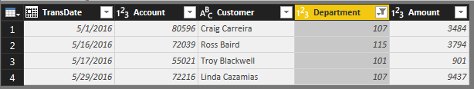

To append these queries, click on one of them and select Append Queries from the **Combine** section of **Home** tab in Query Editor.

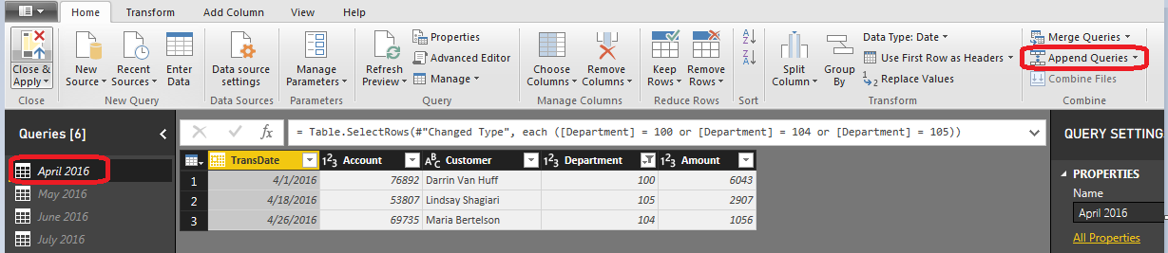

If you want to keep the existing query result as it is, and create a new query with the appended result choose Append Queries as New, otherwise just select Append Queries. In this example I’ll do Append Queries as New, because I want to keep existing queries intact.

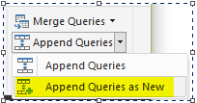

You can choose what is the primary table (normally this is the query that you have selected before clicking on Append Queries), and the table to append. In the append query result you will see primary table values first and others next.

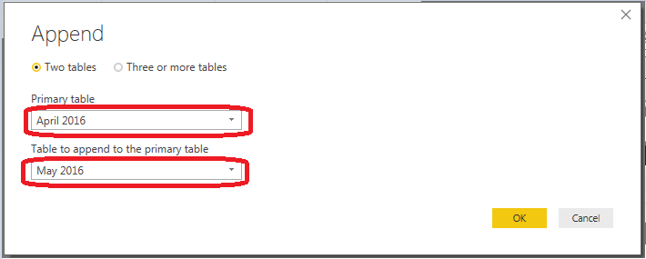

For this example, I have only two tables, so I’ll continue with above configuration. Append Queries simply append rows after each other, and because column names are exactly similar in both queries, the result set will have same columns.

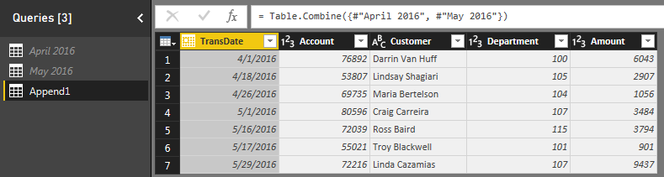

Result of Append as simple as below. Append is similar to UNION ALL in T-SQL.

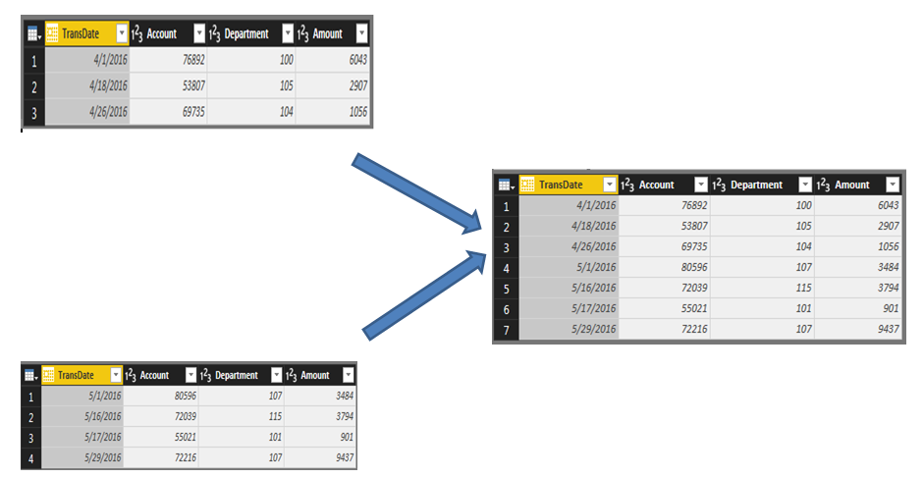

**What if files contain duplicates?**

Append Queries will NOT remove duplicates. You have to use Group By or Remove Duplicate Rows to get rid of duplicates.

**What if the Columns in the query are not matched exactly?**

Append requires columns to be exactly similar to work in best condition. If columns in source queries are different, append still works, but will create one column in the output per each new column, if one of the sources doesn’t have that column the cell value of that column for those rows will be null.

**Append 3 or more files individually with different queries**

Open Edit Queries as shown below.

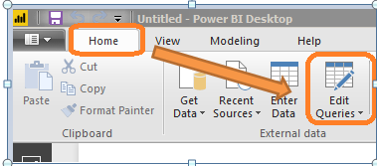

Query Editor Will opens 🡪 From Home Tab 🡪 selects **New Source** 🡪 Select the type of source for example **Text/CSV** as shown below **🡪** Browse for the file location 🡪 Select the file 🡪 Open.

Apply all steps above for each file to get multiple files into Query Editor for Appending.

Now all the three files are there in Query Editor as shown below. Now we will see how to append them.

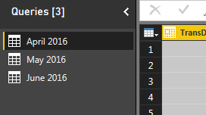

Select Append Queries 🡪 Under select **Append Queries as New**

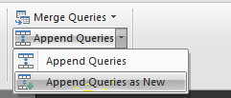

Select three or more tables 🡪 Add tables from **Available tables** section to **Tables to append** section

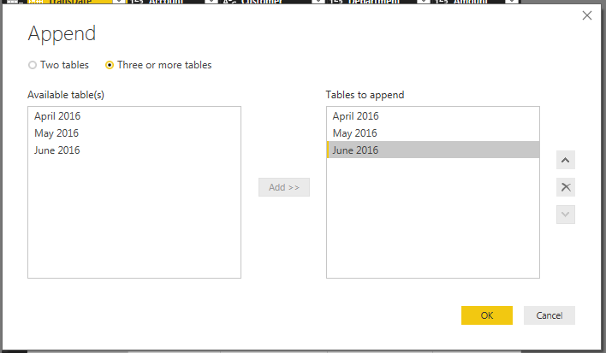

Change the order using up and down button as shown in above image, the way you are expecting the data in append query result🡪 Ok. Now you will see an Append Query with the data from all the three files we selected in the same order as we placed in **Tables to append section** as shown below.

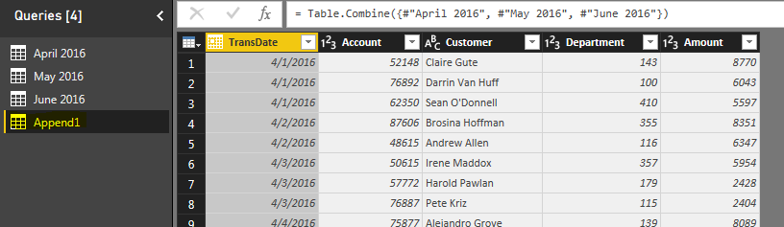

**Appending multiple files of same type from a folder using single query**

In the above example we append April, May and June files. Tomorrow let us assume we get a file for July Month. In the above process you need to import it manually and need to append all the four files. It’s a manual and lengthy process. Let’s see how we can automate it by a single refresh and how to import and append with single query.

Open Query Editor 🡪 Home 🡪 New Source 🡪 More...

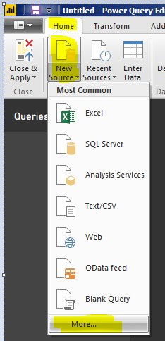

Select **Folder** 🡪 Connect 🡪 Enter the folder Path where files are located

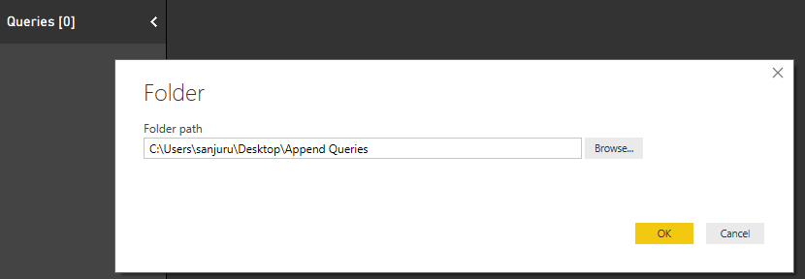

Select Ok 🡪 Edit 🡪 Perform Transformation Steps as shown below.

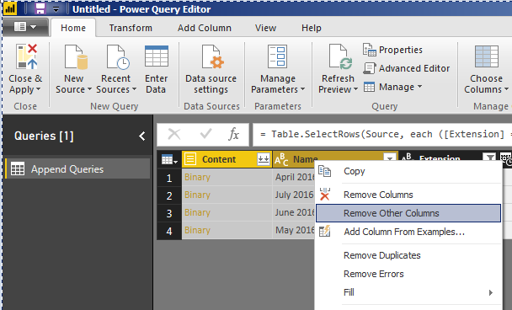

Select two down arrows to combine files as shown in below image

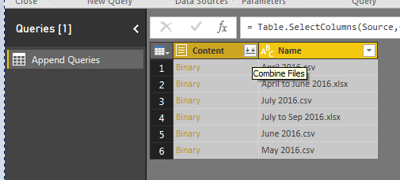

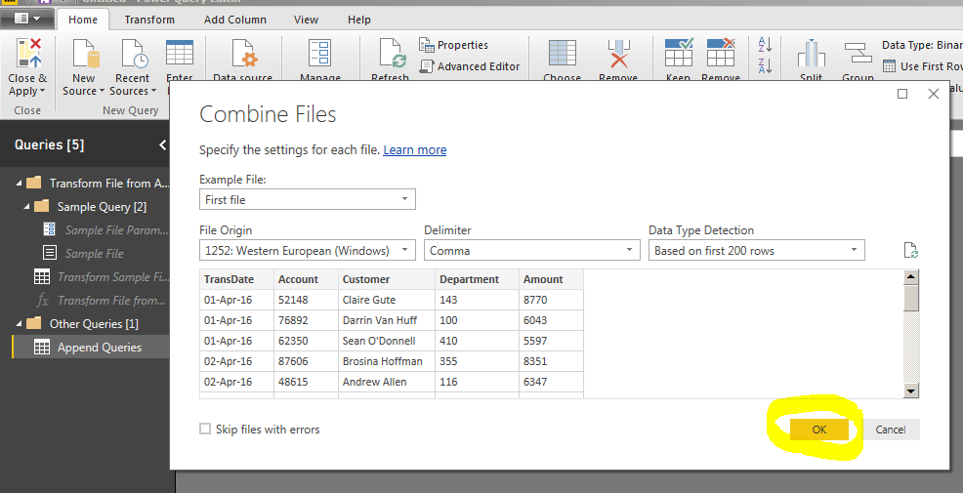

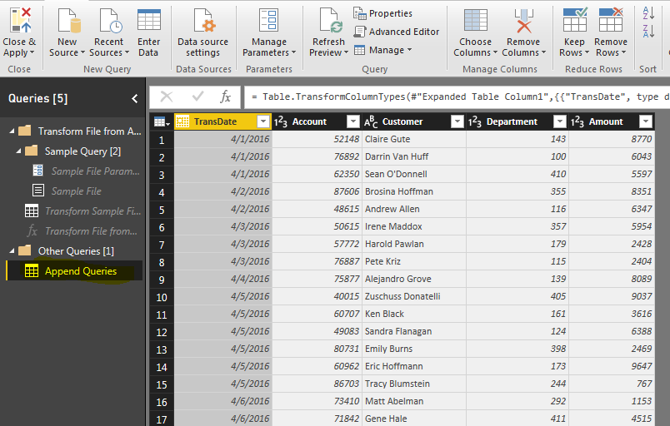

Tomorrow when you get a new file, place it in the folder and simply refresh in Query Editor. You will find updated data in Append Queries section.

**Task**

Append the data from multiple excel sheets in an excel workbook and multiple workbooks or files in folder with a single query.

Add a Custom Column with the below formulae to read the content from excel workbook.

Excel.Workbook([Content])

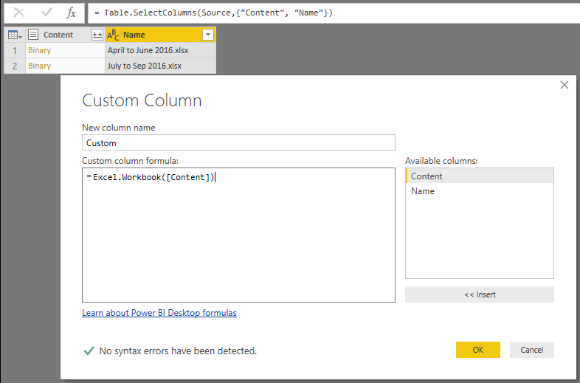

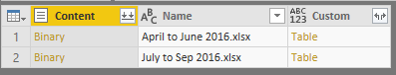

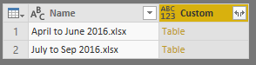

**Right-click options of a Query**

When you right-click on the name of a query (in the left-most pane of Power Query's window) you will see list of options a show below. We will discuss each of them now.

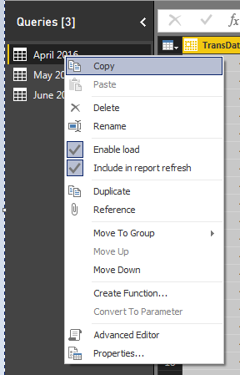

**Copy**

Copy option will copy the query and you can paste the query where ever you needed.

**Paste**

Paste is used to paste the copied query under the queries section.

**Delete**

Delete is used to delete a particular Query.

**Rename**

Rename will help you to rename a query.

**Enable Load**

Always remember that Query Editor is your ETL (Extract, Transform, and Load) engine. It will apply all transformations before loading the data into the model, but once you finished the transformation all queries will be loaded into the model and they take memory. By default, all queries are enabled to Load into the model. Simply change that for queries that are not required in the model by disabling the option “Enable Load”.

"Enable Load" means query results are available for report builder. Otherwise you may use it in your other queries (for example to merge data), but it is not shown in the report builder.

**Include in report refresh**

"Include in Report Refresh" means query is automatically refreshed when you press "Refresh" button on the ribbon. Disable this option for the static tables to improve the performance of report refresh.

**Duplicate Query**

Duplicate will duplicate the code of the query. Duplicate is generally used when you would like to create a similar query and you do not want to type the same code. Once you created a duplicate query from source query then duplicate query is independent of source query. You can make changes to this duplicate query.

**Reference Query**

Reference Query means you would like to use that Query results in some other queries where your original query remains as a base Query. Once you created a reference query from source query then reference query is dependent of source query. When you make changes to source query those will reflect in reference query. You can make additional changes to this reference query.

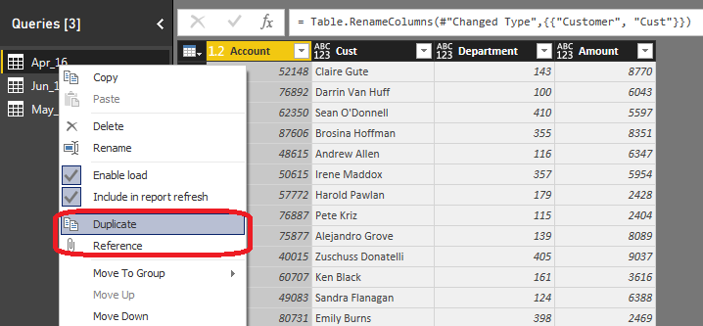

**Merge Queries**

Merge Queries are used when we need to add one or more columns to a Query from another Query. Merge is similar to JOINS in T-SQL or Other Databases.

Now we will see how to merge queries with an example. Take the EMP and DEPT Queries as shown below.

**EMP**

|  |  |  |  |  |  |
| --- | --- | --- | --- | --- | --- |
| **EMPNO** | **ENAME** | **JOB** | **MGR** | **SAL** | **DEPTNO** |
| 7369 | SMITH | CLERK | 1001 | 800 | 20 |
| 7499 | ALLEN | SALESMAN | 7566 | 1600 | 30 |
| 7521 | WARD | SALESMAN | 7566 | 1250 | 30 |
| 7566 | JONES | MANAGER | 7839 | 2975 | 20 |
| 7788 | SCOTT | ANALYST | 7839 | 3000 | 20 |
| 7839 | KING | PRESIDENT |  | 5000 | 10 |
| 7934 | MILLER | CLERK | 1001 | 1300 | 10 |
| 1001 | SUNIL | TRAINER | 7839 | 10000 | 50 |

**DEPT**

|  |  |  |
| --- | --- | --- |
| **DEPTNO** | **DNAME** | **LOC** |
| 10 | ACCOUNTING | NEW YORK |
| 20 | RESEARCH | DALLAS |
| 30 | SALES | CHICAGO |
| 40 | OPERATIONS | BOSTON |

If you want to see employee details along with the department details in the same query then you need to merge EMP, DEPT Queries. Now we will see how to merge both of them.

Get both the Queries (EMP, DEPT) into Power Query. Select EMP Query first, and then select Merge Queries (Merge Queries as New) from the Home tab on the ribbon as shown below.

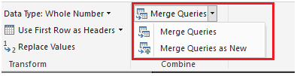

Next the Merge window appears prompting us to select the tables, matching columns and **Join Kind** to create a merged table as shown below. We will discuss more about Join Kind later.

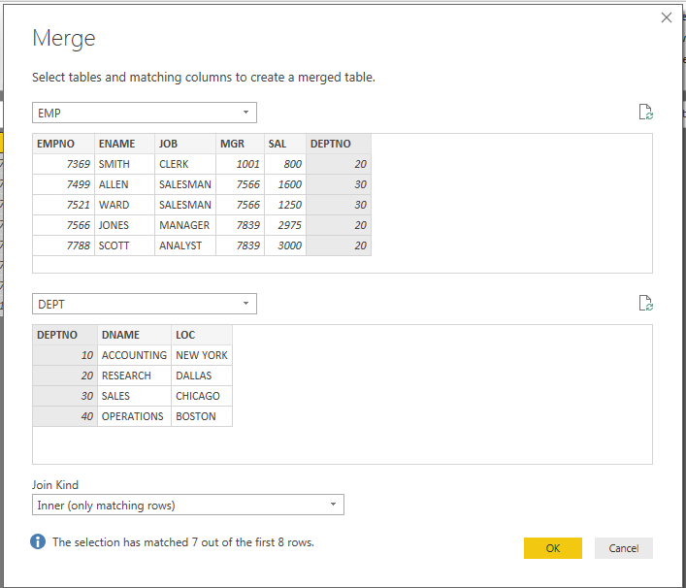

Once you selecttables, matching columns and Join Kind Then Ok button enabled. Once you press **OK**, a NewColumn is created at the end of the query as shown below. The NewColumn is the contents of the table (query) that was merged with the existing query. All columns from the merged query are condensed into the NewColumn.

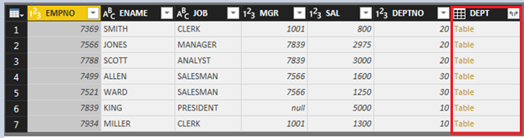

To Expand the merged table, and select which columns to include, select the expand icon (). The **Expand** window appears as shown below.

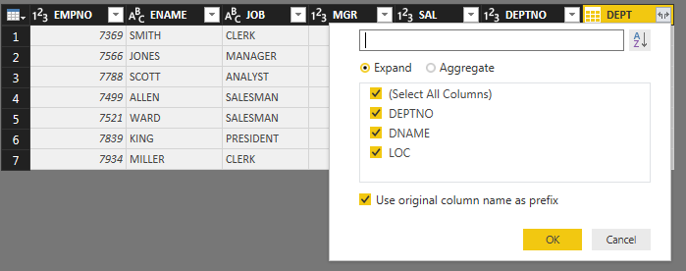

In this case, we only want the DNAME and LOC columns, so we select only that columns and then select OK. We clear the checkbox from Use original column name as prefix because we don’t need or want that, if we leave that selected, the merged column would be named **DEPT.DNAME, DEPT.LOC** (the original column name, or NewColumn, then a dot, then the name of the column being brought into the query).

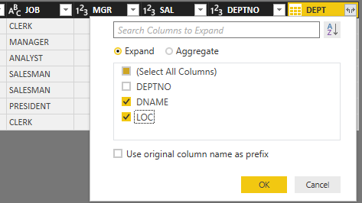

Select OK to see the merged query output as shown below.

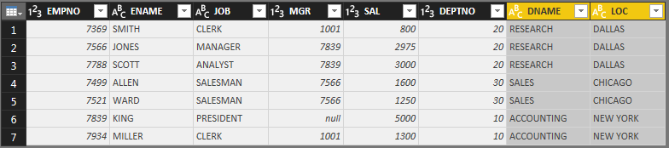

You can easily use multiple columns in join condition for merging two data sets. Just select them in an order with holding Ctrl key of the keyboard.

**Types of Joins / Join Kinds / Merge Type**

There are 6 types of joins you can perform for merging the queries by default as shown below. Each of these joins gives you different results in merge query output. Default Join Kind is Left Outer. Let’s see what their difference is.

1. Left Outer (all from first, matching from second)
2. Right Outer (all from second, matching from first)
3. Full Outer (all rows from both)
4. Inner (only matching rows)
5. Left Anti (rows only in first)
6. Right Anti (rows only in second)

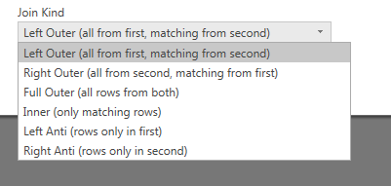

We use below EMP and DEPT Tables to illustrate these Join Types

**EMP**

|  |  |  |  |  |  |
| --- | --- | --- | --- | --- | --- |
| **EMPNO** | **ENAME** | **JOB** | **MGR** | **SAL** | **DEPTNO** |
| 7369 | SMITH | CLERK | 1001 | 800 | 20 |
| 7499 | ALLEN | SALESMAN | 7566 | 1600 | 30 |
| 7521 | WARD | SALESMAN | 7566 | 1250 | 30 |
| 7566 | JONES | MANAGER | 7839 | 2975 | 20 |
| 7788 | SCOTT | ANALYST | 7839 | 3000 | 20 |
| 7839 | KING | PRESIDENT |  | 5000 | 10 |
| 7934 | MILLER | CLERK | 1001 | 1300 | 10 |
| 1001 | SUNIL | TRAINER | 7839 | 10000 | 50 |

**DEPT**

|  |  |  |
| --- | --- | --- |
| **DEPTNO** | **DNAME** | **LOC** |
| 10 | ACCOUNTING | NEW YORK |
| 20 | RESEARCH | DALLAS |
| 30 | SALES | CHICAGO |
| 40 | OPERATIONS | BOSTON |

**Left and Right**

To start, you need to know the concept of Left and Right tables (or queries). When you merge two data sets with each other, the first query is considered as LEFT and the second as RIGHT.

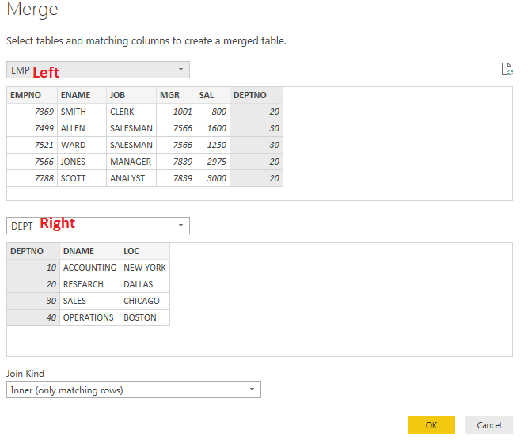

In the above example EMP is Left and First and DEPT is Right and Second. Understanding this is important, because most of Join Kinds works with the concept of left or right or both.

**Left Outer (All from first, matching from second)**

The first type of Join/Merge is Left Outer. All records from this query (LEFT or FIRST) will be showed in the result set plus their matching rows in the right (or second Query). This type of join is the default type. If you don’t specify the Join Kind, it will be always Left Outer. The result set of EMP and DEPT with Join Kind Left Outer is shown below. We can see that all the Rows from EMP table are shown in the result. We don’t have the DEPTNO=50 in DEPT table still it is showing in the merged query result as we select **Left Outer** Join Kind.

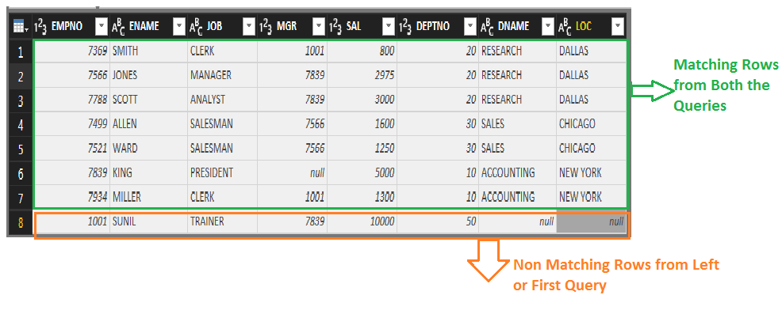

**Right Outer (all rows from second, matching from first)**

With this type of Join, you get all rows from the RIGHT (or second) Query, with their matching rows from left (or first Query). We can see that all the Rows from DEPT Query are shown in the result along with matching rows from Both the Queries.

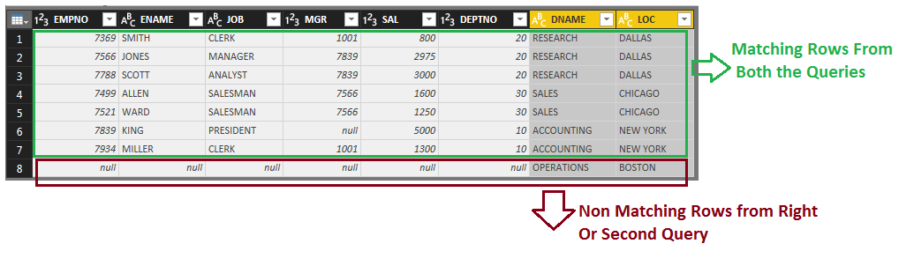

**Full Outer (all rows from both)**

This Join Kind will return all rows from both Queries (matching and non-matching). You will have all non-matching rows from first Query, and all non-matching rows from the second Query, and all matching rows from both the Queries. In the below image you can see Matching Rows from both the Queries in Green Box, Non matching rows from First or Left Query in Red Box and Non matching rows from Second or Right Query in Blue Box.

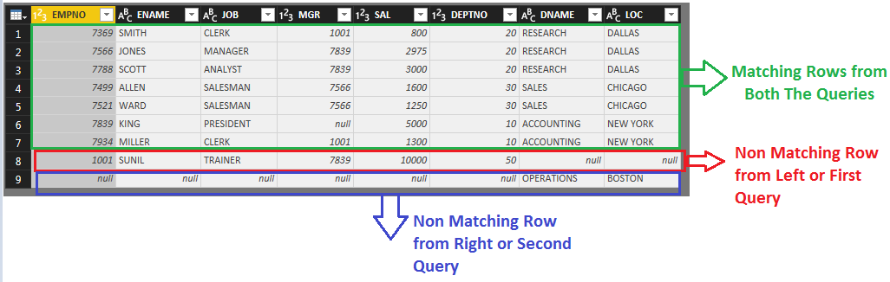

**Inner (only matching rows)**

This Join Kind will only return matching rows as shown below. You will not have any record with null values (because these records generate as a result of not matching).

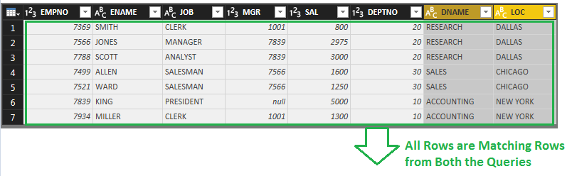

**Let Anti (rows only in first)**

If you are only interested in rows from the LEFT (first) Query, then this is the option to select. This means rows that are in the First or Left Query and DO NOT match with the Second or Right Query. So this Join Kind returns only non-matching rows from the first or Left Query. With Anti options you always get null for the second data set, because these rows don’t exist there. Anti-options are good for finding rows that exists in one Query but not in the other one.

This Join Kind will find the only one row that exists in the EMP Query and does not match with any of rows in the DEPT Query.

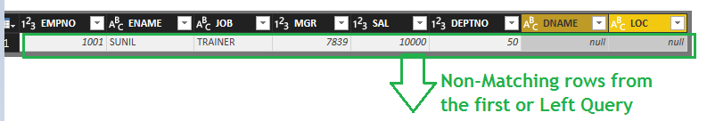

**Right Anti (rows only in second)**

This Join Kind will give you only non-matching rows, this time from the Second (Right) Query. You can find out what rows in the Right or Second Query are not matching with the Left or First Query.

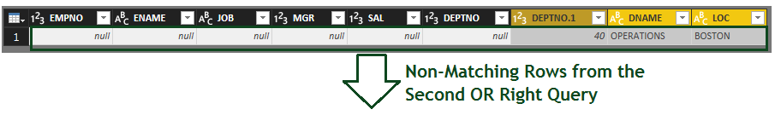

**Cartesian Join or Cross Join**

By Default, in Power BI we have 6 types of joins and in that we don’t have on more type of join that is Cross Join or Cartesian Join. To get the cross join output we have a work around that we need to add a custom column for both the queries and populate that column with a unique value.

**Data Modelling:**

**Power Pivot**

Power Pivot is an In-Memory Columnar Database.

We used Power Pivot to Store the Data that is required for Analysis Purpose.

**In-Memory** Vs. **Traditional Databases / Relational Databases**

In Traditional Databases / Relational Databases Data will be Stored in Disk and accessed from the Disk.

In In-Memory Databases the Data will be stored in RAM and accessed from the RAM.

In Traditional Databases / Relational Databases Data will be Stored in Row Format.

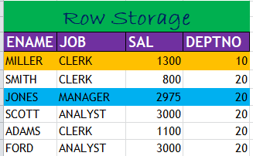



In In-Memory Databases the Data will be stored in Columnar Format.

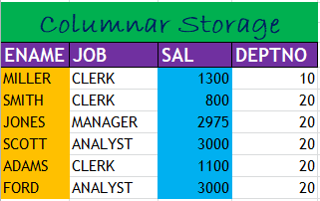



Columnar Storage makes it possible to read data faster, which is crucial for analytical queries.

Columnar storage also takes up less disk space, because each block contains the same type of data, meaning it can be compressed into a specific format.

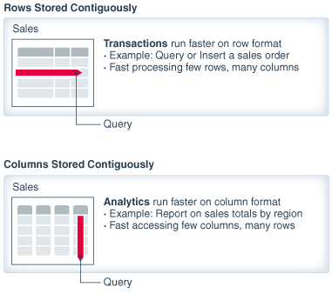

**Advantages of In-Memory Columnar Databases**

1. When you create Reports or Visuals on Power Pivot You Can See the Data in Reports or Visuals Faster as you access the Data from RAM.
2. Data is Highly Compressed in Power Pivot (Approximately 1/10th Source Data).
3. When You Perform the Aggregate Calculations on Power Pivot they are Much Faster.

**Power BI Modeling**

In this section, we will learn about Modeling Data, relationships, their definition, use, and how to create relationships, different types of relationships in Power BI. After this, we will learn how to manage relationships in Power BI. Managing relationships means adding, editing, and deleting relationships as well as making these active or inactive.

Below image explains different steps involved in Power BI Desktop.

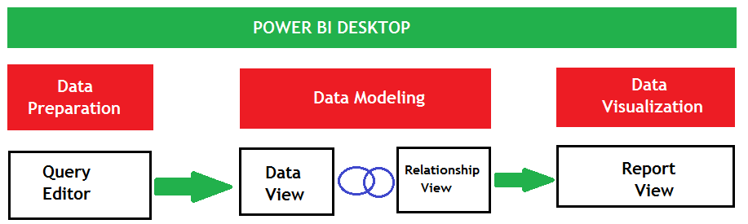

**Power BI Desktop Steps**

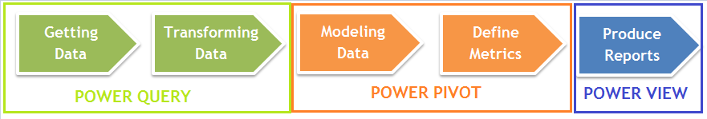

Power BI can connect to different data source, Transform or Prepare the Data using Power Query or Query Editor and then Load the transformed data into Power Pivot, to perform data modeling.

**Data Modeling**

Establishing the Relationships Between the Tables we call as Data Modeling.

Modeling is to create a connection between different tables, for that you create a relationship.

Often, you'll will use fields from more than one Tables to create your Visualizations, and you'll need all of that data to work together. Modeling is how you get it there.

Usually in OLAP systems we stores discriptive information in Dimension Tables and Numeric information that is helpful for Analyzing the business will be stored in Fact Table. We always use the dimension table along with fact table to build reports or visualizations.

**Relationship**

As the name suggests, Relationship in Power BI is used to define the connections or the relation between two or more tables. The relationship is used when we want to perform an analysis based on multiple tables. Relationship helps us to display the data and correct information between multiple tables. It is used to calculate the accurate results also.

A relationship between data sources enables Power BI to know how those tables relate to one another, allowing you to create interesting visuals and reports.

**Need of Relationship**

If we don’t have relationship between two tables which are using in the same visualization for analysis, throws error as shown below or else it will show wrong results.

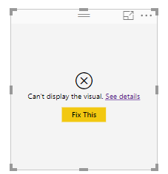

When you Click the **See details** hyperlink, you will be getting the message as shown in below image.

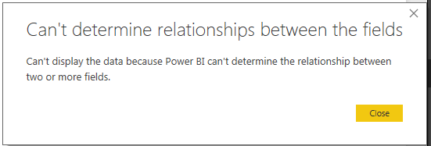

When you Load the Tables into Power Piviot, Majority of the Data Modeling Work Will be Done By the Power BI itself.

Power BI Desktop will create the relationships for you automatically. It is important to verify these relationships Created by Power BI to ensure accuracy.

Below are the Options which help to Create the Relationships by Power BI.

Go to File Menu – Options & Setting – Options - Data Load

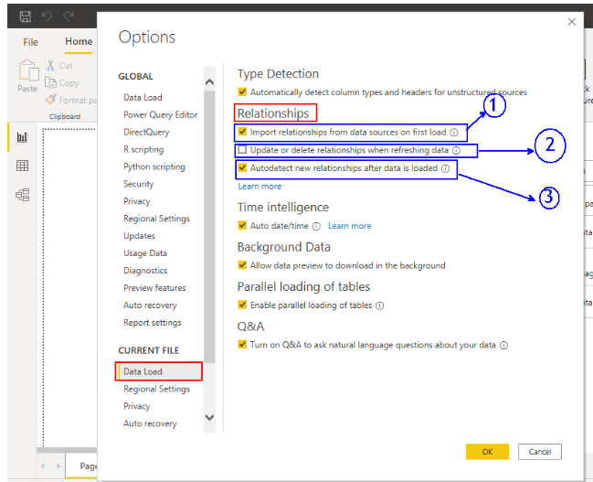

**Relationship Types / Cardinality in General**

There are three types of relationships or Cardinality betweeen tables

* One-to-One
* One-to-Many (or Many-to-One)
* Many-to-Many

**One-to-One**

A row in table **A** can have only one matching row in table **B**, and vice versa.

Ex: Person and Passport Table

**One-to-Many (or Many-to-One)**

This is the most common relationship type. In this type of relationship, a row in table **A** can have many matching rows in table **B**, but a row in table **B** can have only one matching row in table **A**.

One-to-Many relationships can also be viewed as Many-to-One relationships, depending on which way you look at it.

Ex: Customer and Sales Table

Sales table is the “many” and the Customer table is the “one”. Customer Table will have customer record only onces but a Sales table will have multiple sales values for the same customer. When you see from Sales table to Customer Table it is Many-to-One relationship similarly when you see from Customer Table to Sales Table it is One-to-Many relationship.

**Many-to-Many**

In a many-to-many relationship, a row in table **A** can have many matching rows in table **B**, and vice versa. Coustomer can buy many products and a Product can be purchased by many Customers.

Ex: Customers and Products

Relationships cannot be built directly between tables that have a many-to-many relationship in Power BI.

A many-to-many relationship could be thought of as two one-to-many relationships, linked by an intermediary table.

The intermediary table is typically referred to as a “junction table” (also as a “cross-reference table”). This table is used to link the other two tables together. It does this by having two fields that reference the primary key of each of the other two tables.

The first thing you should do after importing data is to verify that all auto-detected relationships have been created correctly. From the modeling ribbon, select Manage Relationships.

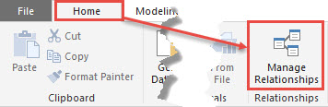

This will open up the Manage Relationships editor. The relationship editor is where you will go to create new relationships, Autodetect Relationship and edit or delete existing relationships. The relationship editor will be used to verify the relationships that were automatically created by Power BI Desktop.

Let's take a look at the Manage Relationships editor, in which you can manage or perform the following.

1. Current relationships in the data model
2. Create a new relationship
3. Edit existing relationships
4. Delete a relationship
5. Autodetect the relationship

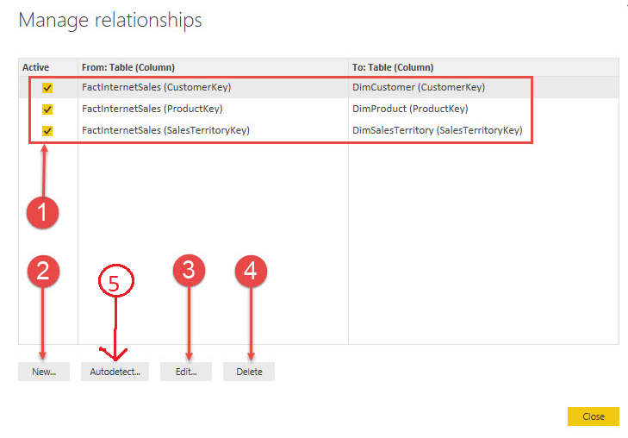

First, you need to verify auto-detected relationships. The top half of the relationship editor gives you a quick and easy way to see what tables have relationships between them, what columns the relationships have been created on, and if the relationship is an active relationship.

**To create the new relationship**

You can select Autodetect option in Manage relatioship window to identify the relationships exists between the tables automatically by Power BI or else you can create manually using below steps.

* Click Manage Relationships. In Manage Relationships Window, click New. This opens the Create Relationship dialog / Window, where we can select the tables, columns, and any additional settings we want for our relationship.
* For the first table, select SALES_DATA, then select the CustomerKey column in SALES_DATA table. This is the many side of our relationship.
* For the second table, select CUSTOMERS_DATA, then select the CustomerKey column. This is the one side of our relationship.
* Go ahead and click OK in the Create Relationship dialog and the Manage Relationships dialog Cick on close.

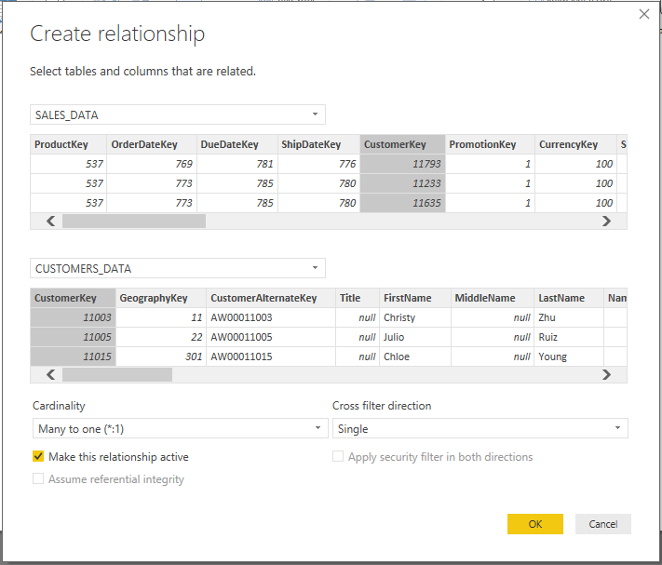

**Editing relationships**

Now, let's take a look at how to edit an existing relationship. In this example, you will edit the relationship between FactInternetSales and DimCustomer. To edit an existing relationship, select that relationship and then click on Edit.

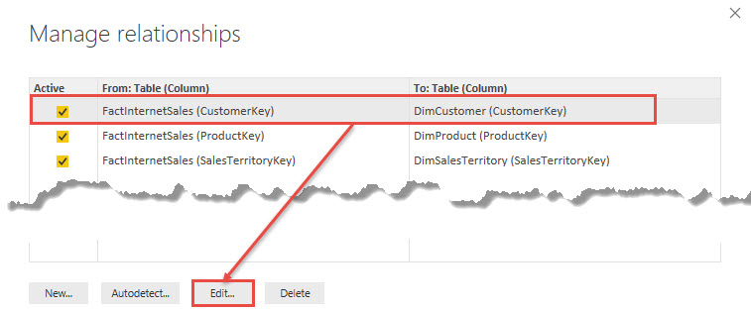

Once you select Edit... you will receive a new dialog box, this is the Edit Relationship editor. In this view, you will see how to change an existing relationship, how to change a relationship to active or inactive, and the cardinality of the current relationship, this is also where you can change the cross filter direction if required.

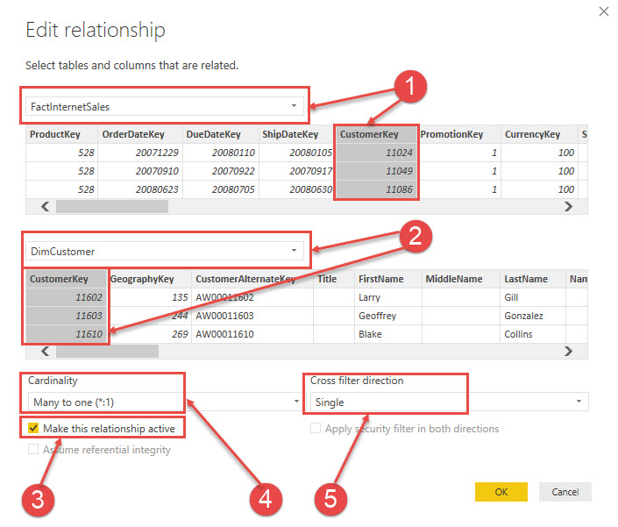

There are five things we want to look at in the edit relationship window

1. This identifies the FactInternetSales table and the column that the relationship was built on.
2. This identifies the DimCustomer table and the column that the relationship was built on.
3. This checkbox identifies whether the relationship is active or inactive.
4. This is the current cardinality or relationship type between the two tables. Here we see that there is a many-to-one relationship between FactInternetSales and DimCustomer. Power BI does an excellent job of identifying the correct cardinality, but it is important to always verify that the cardinality is correct.
5. The cross filter direction can be single or both. *The one side of a relationship always filters the many side of the relationship, and this is the default behavior in Power BI.* If you filter values in dimension table corresponding values in fact table will be shown. The cross filter option allows you to change this behavior. Cross filtering will be discussed later in this chapter.

**Assume referential integrity settings in Power BI Desktop**

When connecting to a data source using **DirectQuery**, you can use the Assume Referential Integrity selection to enable running more efficient queries against your data source. When we are using **DirectQuery**, every time when we drag the fields to visualizations, Power BI will run Queries on top of Source Databases. This feature has a few requirements of the underlying data, and it is only available when using **DirectQuery**.

Setting Assume referential integrity enables queries on the data source to use **INNER JOIN** statements rather than **OUTER JOIN**, which improves query efficiency.

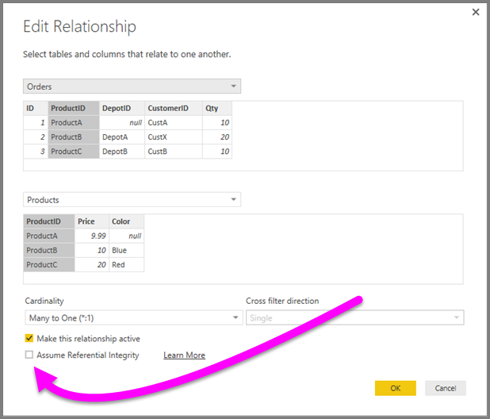

**Requirements for using Assume referential integrity to Give Correct Values**

This is an advanced setting, and is only enabled when connecting to data using **DirectQuery**. The following requirements are necessary for Assume referential integrity to work properly.

* Data in the **From** column in the relationship is never Null or blank.
* For each value in the **From** column, there is a corresponding value in the **To** column.
* In this context, the **From** column is the Many in a One-to-Many relationship, or it is the column in the first table in a One-to-One relationship.

**Example of using Assume referential integrity**

The following example demonstrates how Assume referential integrity behaves when used in data connections. The example connects to a data source that includes an Orders table, a Products table, and a Depots table.

1. In the following image that shows the Orders table and the Products table, note that referential integrity exists between Orders[ProductID] and Products[ProductID]. The [ProductID] column in the Orders table is never Null, and every value also appears in the Products table. As such, Assume Referential Integrity should be set to get more efficient queries (using this setting does not change the values shown in visuals).

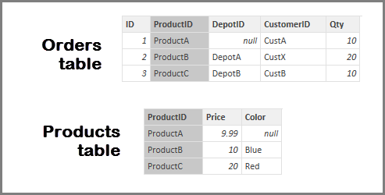

1. In the next image, notice that no referential integrity exists between Orders[DepotID] and Depots[DepotID], because the DepotID is Null for some Orders. As such, Assume Referential Integrity should not be set.

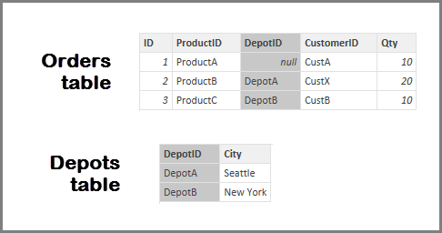

1. Finally, no referential integrity exists between Orders[CustomerID] and Customers[CustID] in the following tables, the CustomerID contains some values (in this case, CustX) that do not exist in the Customers table. As such, Assume Referential Integrity should not be set.

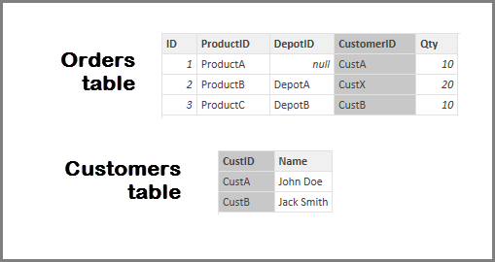

**Setting Assume referential integrity**

To enable this feature, select the checkbox next to Assume Referential Integrity as shown in the following image.



When selected, the setting is validated against the data to ensure there are *no Null or mismatched rows*. However, for cases with a very large number of values, the validation is not a guarantee that there are no referential integrity issues.

In addition, the validation occurs at the time of editing the relationship, and does not reflect any subsequent changes to the data.

**What happens if you incorrectly set Assume referential integrity?**

If you set Assume Referential Integrity when there are referential integrity issues in the data, this will not result in errors. However, it will result in apparent inconsistencies in the data. For example, in the case of the relationship to the Depots table described above, it would result in the following.

A visual showing the total Order Qty would show a value of 40

A visual showing the total Order Qty by Depot would show a total value of only 30, because it would not include Order ID 1, where DepotID is Null.

**Many-to-many relationships in Power BI Desktop - Preview July2018**

With the Many-to-many relationship feature in Power BI Desktop you can join tables using a cardinality of Many to Many, and create data models that contain multiple data sources easier and more intuitively.

**Enabling the many-to-many relationships preview feature**

The many-to-many relationships feature is part of the composite models capabilities and is in Preview, and must be enabled in Power BI Desktop. To enable composite models, select File 🡪 Options and Settings 🡪 Options 🡪 Preview Features, then select the composite models checkbox.

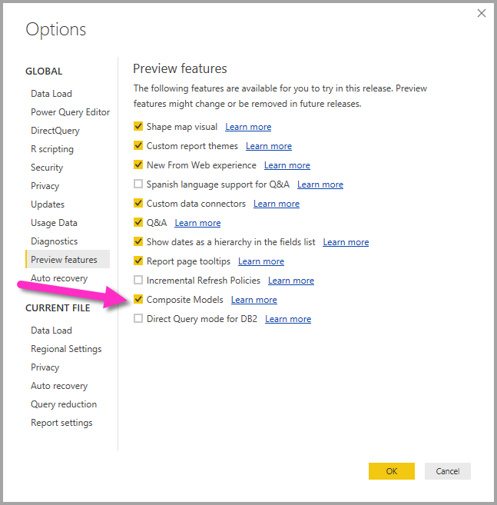

You'll need to restart Power BI Desktop for the feature to be enabled.

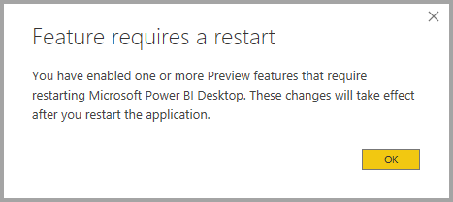

**What many-to-many relationships solves**

Prior to availability of many-to-many relationships, when defining a relationship between two tables in Power BI, at least one of the columns involved in the relationship had to contain unique values. In many circumstances though, no column in the table contained unique values.

For example, two tables may have a column containing the Country, but the values of Country were not unique in either table. To join between such tables, it was necessary to create a workaround such as introducing additional tables into the model that contained the necessary unique values. The feature many-to-many relationships provides an alternative approach, allowing such tables to be joined directly using a relationship with a cardinality of Many-to-many.

**DAX (DATA ANALYSIS EXPRESSION)**

**Introduction to DAX**

**What is DAX?**

**DAX** stands for **Data Analysis eXpressions**, and it is the formula language used in **Power BI**. **DAX** is also found in other offerings from **Microsoft**, such as **Power Pivot** and **SSAS Tabular**.

DAX is a functional language, which means the full executed code is contained inside a function.

There are two primary calculations you can create using DAX

* Calculated Columns
* Measures

DAX is a collection of **Functions**, **Operators**, and **Constants** that can be used in a formula, or expression, to calculate and return one or more values. Stated more simply, DAX helps you create new information from data already in your model.

**DAX Table and Column Name syntax**

Whether you're creating a New Column or Measure, it's important to know the general format of table names in DAX.

**'Table Name'[ColumnName]**

If there are spaces in the table name (as shown above), the single quotes around the table name are mandatory. If the table name has no spaces, the single quotes can be omitted, so the syntax looks like the following. Column names must always include the square brackets.

**TableName[ColumnName]**

**Creating Calculated Columns**

Calculated Columns are useful when you want a calculation for every row in your table.

You can create Calculated Columns in Power BI Desktop by selecting New Column from the Modeling tab. It's best to be in Data view (rather than Report or Relationships view), since you can see the **New Column** created and the Formula Bar is populated and ready for your DAX formula.

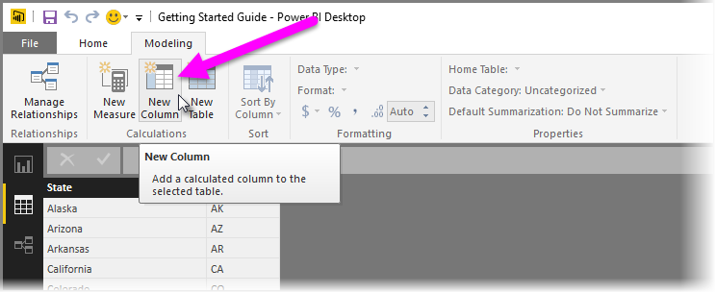

Once you select the New Column button, the Formula Bar is populated with a basic column name (which you change to suit your formula, of course) and the = operator, and the new column appears in the data grid, as shown in the following image.

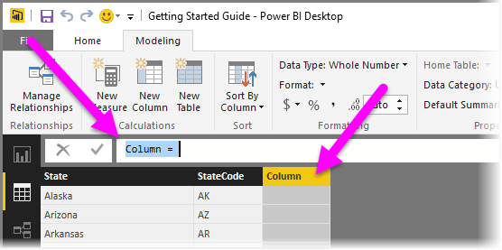

The required elements for a calculated column are the following

* A new column name
* At least one function or expression

**Calculated Columns Examples**

1. Load the Orders table into Power BI

2. Create the following Calculated Columns

a) Unit Price = Sales / Quantity

b) Cost Price = Sale – Profit

C) Quantity Type = IF (Orders [Quantity] = 1, "Single Item”, "Multiple Items")

d) State and Country = CONCATENATE (Orders [State], CONCATENATE (", ", Orders [Country]))

**Creating Measures**

Use a calculated measure when you are calculating percentages or ratios, or you need complex aggregations. To create a measure using a DAX formula, select the New Measure button from the Modeling tab. Again, it's best to be in the Data view of Power BI Desktop since it shows the Formula Bar and makes it easy to write your DAX formula.

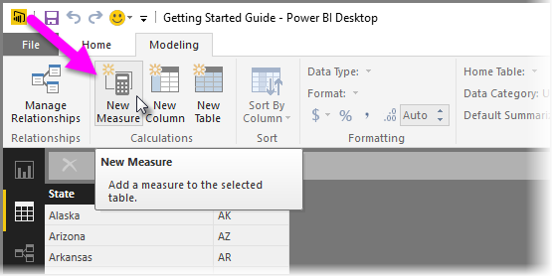

With measures, you see a new measure icon appear in the Fields pane with the name of the measure. The Formula Bar is again populated with the name of your DAX formula (this time, with your measure).

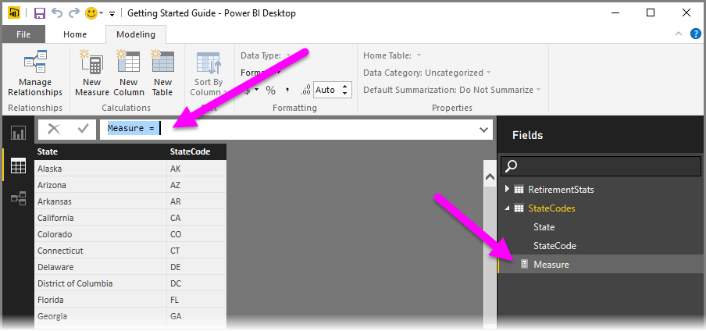

The required elements for a calculated measure are the same as they are for a calculated column

* A new measure name
* At least one function or expression

**Calculated Measures Examples**

* Total Sales = SUM(Orders[Sales])
* Total Profit = SUM(Orders[Profit])
* Average Sales = AVERAGE(Orders[Sales])

**Implicit Vs Explicit Measures**

Implicit Measures are created when you drag raw numerical fields (like Sales, Profit, Quantity) into the values field well of a visual and manually select the aggregation mode (Sum, Average, Min/Max, etc.).

Explicit measures are created by actually entering DAX functions like below

* Sum Of Sales = SUM(Orders[Sales])

Implicit measures are only accessible within the specific visualization in which it was created, and cannot be referenced elsewhere.

Explicit measures can be used anywhere in the report and referenced with other DAX calculations.

* Sum Of Sales = SUM (Orders[Sales])
* % Sales = **[Sum Of Sales]/**CALCULATE(**[Sum Of Sales],**ALL(Orders))

**Calculated Columns / New Column Vs New Measures**

|  |  |
| --- | --- |
| **Calculated Columns / New Column** | **New Measures** |
| For Each Row when you need a Value | To Calculate Aggregates and Percentages. (OR)  For Group of Rows if you need one Value |
| Values are calculated based on information for each row of a Table. Row Context. | Values are calculated based on information from any filters in the report or the fields used in the visualizations. Filter Context. |
| Appends Static values to each row in a table and stores them in the model which increases the file size | Does not create new data in the tables which doesn't increases the file size |
| Recalculate on data source refresh or when changes are made to component columns which are used to derive Calculated Columns | Recalculate in response to any change to filters within the report or when we Add / Remove another dimension to the visualization. |
| New Column Name Should be unique at Table Level | Measure Name Should be unique thought the Model |

**DAX Syntax & Operators**

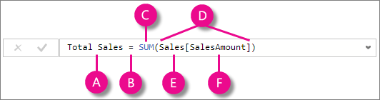

This formula includes the following syntax elements

A) The measure name Total Sales.

B) The equals sign operator (=) indicates the beginning of the formula. When calculated, it will return a result.

C) The DAX function SUM adds up all of the numbers in the Sales [SalesAmount] column. You’ll learn more about functions later.

D) Parenthesis () surround an expression containing one or more arguments. All functions require at least one argument. An argument passes a value to a function.

E) The referenced table Sales.

F) The referenced column [SalesAmount] in the Sales table. With this argument, the SUM function knows on which column to aggregate a SUM.

**DAX Operators**

The Data Analysis Expression (DAX) language uses operators to create expressions that compare values, perform arithmetic calculations, or work with strings.

**Types of Operators**

There are four different types of operators 🡪 arithmetic, comparison, text concatenation, and logical.

**Arithmetic Operators**

To perform basic mathematical operations such as addition, subtraction, or multiplication, combine numbers, and produce numeric results, use the following arithmetic operators.

|  |  |  |
| --- | --- | --- |
| **Arithmetic operator** | **Meaning** | **Example** |
| + (plus sign) | Addition | 3+3 |
| – (minus sign) | Subtraction or sign | 3–1 |
| * (asterisk) | Multiplication | 3*3 |
| / (forward slash) | Division | 39/3 |
| ^ (caret) | Exponentiation | 16^4 |

**Comparison Operators**

You can compare two values with the following operators. When two values are compared by using these operators, the result is a logical value, either TRUE or FALSE.

|  |  |  |
| --- | --- | --- |
| **Comparison operator** | **Meaning** | **Example** |
| = | Equal to | [Region] = "USA" |
| > | Greater than | [Sales Date] > "Jan 1 2009" |
| < | Less than | [Sales Date] < "Jan 1 2009" |
| >= | Greater than or equal to | [Amount] >= 20000 |
| <= | Less than or equal to | [Amount] <= 100 |
| <> | Not equal to | [Region] <> "USA" |

**Text Concatenation Operator**

Use the ampersand (&) to join, or concatenate, two or more text strings to produce a single piece of text.

|  |  |  |
| --- | --- | --- |
| **Text operator** | **Meaning** | **Example** |
| & (ampersand) | Connects, or concatenates, two values to produce one continuous text value | [State] & ", " & [Country] |

**EX:** State and Country = CONCATENATE (Orders [State], CONCATENATE (", ", Orders [Country]))

**Or**

State and Country = Orders [State] & ", " & Orders [Country]

**Logical Operators**

Use logical operators (&&) and (||) to combine expressions to produce a single result.

|  |  |  |
| --- | --- | --- |
| **Logical operator** | **Meaning** | **Example** |
| && (double ampersand) | Creates an AND condition between two expressions that each have a Boolean result. If both expressions return TRUE, the combination of the expressions also returns TRUE; otherwise the combination returns FALSE. | ([Region] = "France") && ([BikeBuyer] = "yes")) |
| || (double pipe symbol) | Creates an OR condition between two logical expressions. If either expression returns TRUE, the result is TRUE; only when both expressions are FALSE is the result FALSE. | (([Region] = "France") || ([BikeBuyer] = "yes")) |
| IN | Creates a logical OR condition between each row being compared to a table. Note: the table constructor syntax uses curly braces. | 'Product'[Color] IN { "Red", "Blue", "Black" } |

**1.DAX Functions Date _Time Functions**

**Functions in DAX / DAX Functions Categories**

DAX provides the following types or Categories of functions which we mostly used.

* Date and Time Functions
* Logical Functions
* Text Functions
* Math & Statistical Functions
* Filter Functions
* Time Intelligence Functions

**Basic Date & Time Functions**

Mostly we used Date and Time functions to create Calculated Columns / New Columns. Let’s us discuss about below date functions.

* YEAR
* MONTH
* DAY
* WEEKDAY
* WEEKNUM
* FORMAT (Text Function) 🡪 Month Name, Weekday Name
* DATE
* TODAY
* NOW
* HOUR
* MINUTE
* SECOND
* TIME
* DATEDIFF
* CALENDAR
* EOMONTH
* STARTOFMONTH

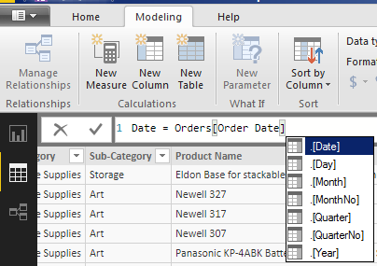

**Creating Calculated Columns form Date Fields**

Here we will create fields for Year, Month and Day.

a) Year = Year (Orders [Order Date])

b) Month = Month (Orders [Order Date])

c) Day = Day (Orders [Order Date])

d) Week Day = Weekday (Orders [Order Date])

e) WeekNum = WEEKNUM (Orders [Order Date])

**Create the Month Name field**

Month Name = Format (Orders [Order Date],"MMMM") 🡪 Gives full Month Name

Month Name = Format (Orders [Order Date],"MMM") 🡪 Gives Month Name abbreviations

**Create a Weekday Name field**

Weekday Name = FORMAT (Orders [Order Date],"DDDD") 🡪 Gives Full Weekday Name

Weekday Name = FORMAT (Orders [Order Date],"DDD") 🡪 Gives Weekday Name abbreviations

**DATEDIFF**

No of Days = DATEDIFF (Orders [Order Date], Orders [Ship Date], DAY)

(Select don’t summarize for No of Days to get correct results)

**Calculated Tables**

In a calculated table, the table values are generated by Data Analysis Expression (DAX) and the values are stored in the Power BI model. Usually using Calculated Tables, we will create Date Dimension table and use this table in the model for time series analysis.

**Date Dimension Table**

Every Time creating this date fields for different data sets is difficult, so what we do is we create a Date Dimension Table which contains all these fields and use it.

**DAX CALENDAR Function**

The calendar function returns a table with a single column that contains a continuous set of dates. The start and end date range will be supplied as parameters.

The following formula returns a calculated table **Date_Dim** with dates between January 1st, 2011 and December 31st, 2020.

Date_Dim = CALENDAR (DATE (2011, 1, 1), DATE (2020, 12, 31))

From the above **Date** Column, we will be deriving below columns.

* Day = DAY(Date_Dim[Date])
* WeekDay = WEEKDAY(Date_Dim[Date])
* WeekDayName = FORMAT(Date_Dim[Date],"DDDD")
* Month = MONTH(Date_Dim[Date])
* MonthName = FORMAT(Date_Dim[Date],"MMMM")
* Quarter = ROUNDUP((Date_Dim[Month]/3),0)
* Quarter = IF (Month Number<4,"Qtr 1”, IF (Month Number<7,"Qtr 2”, IF (Month Number<10,"Qtr 3","Qtr 4")))
* QuarterName = "Qtr" & Date_Dim[Quarter]
* QuarterName = CONCATENATE ("Qtr", Date_Dim[Quarter])
* Year = YEAR(Date_Dim[Date])
* WeekNumber = WEEKNUM(Date_Dim[Date])
* WeekNumMonth = 1 + WEEKNUM (Dim_Date[Date]) - WEEKNUM(STARTOFMONTH(Dim_Date[Date]))
* WeekNameMonth = "Week" & " " & Date_Dim[WeekNumMonth]

**Week of Month**

The week number of the month is, one plus the difference between the weeknum for the date and the weeknum of the first of the month.

WeekOfMonth =1+ WEEKNUM (Dim_Date[Date]) - WEEKNUM(STARTOFMONTH(Dim_Date[Date]))

**EOMONTH**

EOMONTH Returns the date in datetime format of the last day of the month, before or after a specified number of months. Use EOMONTH to calculate maturity dates or due dates that fall on the last day of the month.

**Syntax**

EOMONTH (<start_date>, <months>)

**Example**

1. If customer taken a loan for 12 months, to find when the loan will complete use below syntax.

EOM = EOMONTH (Orders [Order Date], 12)

1. Based on Order Date filed in Orders table, get the Number of Days in that month.

No of Days in Month = DAY ((EOMONTH (Orders [Order Date], 12)))

**2. DAX Logical Functions**

Microsoft Power BI DAX provides various **Logical Functions** as shown below

* IF
* TRUE
* FALSE
* NOT
* OR
* IN
* AND
* IFERROR
* SWITCH

Now we will see how to use Power BI DAX Logical Functions with examples.

**IF Function**

The DAX **IF** function is used to check the given expression is True or False. The basic syntax of the Power BI DAX If Function is as shown below

**Syntax**

IF (LogicalTest, ResultIfTrue, [ResultIfFalse])

IF (Expression, True_Info, False_Info)

As you can see from the above syntax, this function accepts three arguments. First argument is the Boolean expression (which return true or false). If the expression results TRUE then second argument will return otherwise, third argument will return.

Syntax in Square Brackets is optional. If you are not providing third argument, then if the condition is not satisfied it will return NULL values.

**Examples**

If Example = IF(Orders[Quantity]>1,"Multiple Products", "Single Product")

**Nested IF Function**

In Power BI DAX, you can use the Nested If concept, One If statement inside another. Below statement will check whether the Sales amount of each column is less than 100 or not. If true then column will return “Low Sales” otherwise, it will enter into Nested If.

**Examples**

Nested If Example = IF(Orders[Sales]<100,"Low Sales", IF(Orders[Sales]>300, "High Sales", "Avg Sales"))

**DAX TRUE & False Function**

The DAX **TRUE** function will return a logical value **True**. The DAX **FALSE** function will return logical **False**.

True and False Example = IF(Orders[Sales]>100, TRUE (), FALSE ())

**DAX NOT Function**

The DAX **NOT** function will convert True to False, and False to True. I mean, it returns opposite result. The syntax of the Power BI DAX NOT Function is as shown below

NOT(Condition)

NOT(<logical>)

**Example**

NOT example = NOT(IF(Orders[Sales]>100, TRUE (), FALSE ()))

**DAX OR Function**

The DAX OR function is like either or statement in English, which is used to check multiple expressions. The syntax of the Power BI DAX OR Function is as shown below.

OR (Condition 1, Condition 2)

OR (Logical1, Logical2)

**Example**

Weekday = WEEKDAY (Orders [Order Date])

Weekend = IF(OR(Orders[Weekday]=1, Orders[Weekday]=7),"Weekend", "Weekday")

Weekend = IF(Orders[Weekday]=1 || Orders[Weekday]=7,"Weekend", "Weekday")

**DAX IN Function**

IN Example = IF(Orders[Weekday] **IN** {2,3,4,5,6}," Weekday ", Weekend"")

**DAX AND Function**

The DAX AND function is used to check multiple expressions. The syntax of the Power BI DAX AND Function is as shown below

AND (Condition 1, Condition 2)

AND (Logical1, Logical2)

As you can see from the above syntax, DAX **AND** function accepts two arguments. If both the conditions are True then it will return True otherwise, it return False.

**Examples**

And Example = IF(AND(Orders[Category]="Office Supplies", Orders[Sub-Category] = "Storage"), TRUE (), FALSE ())

And example = IF(Orders[Category]="Office Supplies" && Orders[Sub-Category] = "Storage", TRUE(), FALSE())

**DAX IFERROR Function**

The DAX IFERROR function is very useful to handle the arithmetic overflow, or any other errors. It simply performs calculation and return the result, if there is an error then it will return the value inside the second argument. The syntax of the DAX IFERROR Function is as shown below.

IFERROR (Calculation, Value_If_Error_Occurs)

Below statement will return 100 if error occurs. Indeed, all the records will throw error because we are dividing them 0. If there is no error, it will give calculation or expression value.

Error Example = IFERROR(Orders[Sales]/0, 100)

**DAX SWITCH Function**

The DAX SWITCH function helps you to return multiple options. For example, **IF** statement will return either True or false. However, you can use this switch case to multiple results. The syntax of the DAX SWITCH Function is as shown below.

SWITCH (Expression, Option 1, Result 1, Option 2, Result 2, ...., Else Result)

If Month of Order Date is 1 then below statement will return January, 2 means February, 3 means March, 4 means April, 5 means May, 12 means December otherwise, Unknown.

Switch Example = SWITCH (MONTH (Orders [Order Date]), 1, "January", 2, "February", 3, "March", 4, "April", 5, "May", 12, "December", "Unknown")

Switch Example = SWITCH (TRUE (), Orders [Sales]<100, "Low Sales”, Orders[Sales]>300,"High Sales”, “Medium Sales")

SWITCH () always test for equivalence. SWITCH () is still testing for equivalence! By providing the first argument as TRUE (), now each subsequent “test” is going to be checking for TRUE (). And since each of our inequality tests results in either TRUE () or FALSE () as a value, the test case that evaluate to TRUE () is the one that gets matched, and therefore the one that gets used. For instance, if [Measure] <1 evaluates to TRUE (), then expr1 gets returned.

**3. Text Functions in DAX**

**LEN**

LEN function will Returns the Number of characters in string.

**Syntax**

LEN (<Text>)

**Example**

Length = LEN (Orders [Customer Name])

**CONCATENATE (&)**

CONCATENATE function joins two text strings into one text string.

**Syntax**

CONCATENATE (<Text1>, <Text2>)

**Example**

Concat = CONCATENATE (Orders [Category], CONCATENATE (" - ", Orders [Sub-Category]))

Concatenate = Orders [Category] & " - " & Orders [Sub-Category]

**LEFT**

LEFT Function Returns the specified number of characters from the start of a text string.

**Syntax**

LEFT (<text>, <num_chars>)

num_chars optional, if omitted, 1.

**Example**

Left = LEFT (Orders [Country], 5)

**RIGHT**

RIGHT function returns the last character or characters in a text string, based on the number of characters you specify.

**Syntax**

RIGHT (<text>, <num_chars>)

num_chars optional, if omitted, 1.

**Example**

Right = RIGHT (Orders [Country], 5)

**MID**

MID Function Returns a string of characters from the middle of a text string, given a starting position and length.

**Syntax**

MID (<text>, <start_num>, <num_chars>)

**Example**

Mid = MID (Orders [Country], 8, 5)

**UPPER**

UPPER Function Converts a text string to all uppercase letters

**Syntax**

UPPER (<text>)

**Example**

Upper = UPPER (Orders [Country])

**LOWER**

Lower Function Converts all letters in a text string to lowercase.

**Syntax**

LOWER (<text>)

**Example**

Lower = LOWER (Orders [Country])

**TRIM**

TRIM Function Removes all spaces from text except for single spaces between words.

**Syntax**

TRIM (<text>)

**Example**

Trim = TRIM (Orders [Customer Name])

**SUBSTITUTE**

SUBSTITUTE Function Replaces existing text with new text in a text string.

**Syntax**

SUBSTITUTE (<text>, <old_text>, <new_text>, <instance_num>)

instance_num optional, if omitted, every instance of old_text is replaced with new_text.

**Example**

Substitute = SUBSTITUTE (Orders [Country], "t", "T") – Replace existing text with new text for all occurrences

Substitute = SUBSTITUTE (Orders [Country], "t", "T", 2) - Replace existing text with new text for second occurrence only.

**BLANK**

Returns a blank.

**Syntax**

BLANK ()

**Example**

The following example illustrates how you can work with blanks in formulas. The formula calculates unit price. However, before attempting to calculate the ratio the denominator should be checked for zero values. If the denominator is zero then a blank value should be returned, otherwise, the ratio is calculated.

Blank = IF (Orders[Quantity] = 0, BLANK (), Orders[Sales]/ Orders[Quantity])

**Usage**

Avoids ‘Divide by zero’ error.

**4. Math and Statistical Functions**

**INT**

INT Rounds a number down to the nearest integer.

**Syntax**

INT (<number>)

**Example**

INT Example = INT (Orders [Sales])

12.34 =12 12.78 = 12 12.55=12

**ROUND**

Round function will Rounds a number to the given number of digits.

**Syntax**

ROUND (<number>, <num_digits>)

**Example**

Round Example = ROUND (Orders [Sales], 0)

12.34 =12 12.78 = 13 12.55=13

Round Example = ROUND (Orders [Sales], 1)

12.34 =12.3 12.78 = 12.8 12.55=12.6

**ROUNDUP**

Roundup will Rounds a number to next integer value if num_digits = 0.

**Syntax**

ROUNDUP (<number>, <num_digits>)

**Example**

ROUNDUP Example = ROUNDUP (Orders [Sales], 0)

12.34 =13 12.78 = 13 12.55=13

ROUNDUP Example = ROUNDUP (Orders [Sales], 1)

12.34 =12.4 12.78 = 12.8 12.55=12.6

**ROUNDDOWN**

ROUNDDOWN Rounds a number down, toward zero.

**Syntax**

ROUNDDOWN (<number>, <num_digits>)

**Example**

ROUNDDOWN Example = ROUNDDOWN (Orders [Sales], 0)

12.34 =12 12.78 = 12 12.55=12

ROUNDDOWN Example = ROUNDDOWN (Orders [Sales], 1)

12.34 =12.3 12.78 = 12.7 12.55=12.5

**DIVIDE**

Performs division and returns alternate result or BLANK () on division by 0.

**Syntax**

DIVIDE (<numerator>, <denominator>, [<alternateresult>])

**Example**

Divide Example = DIVIDE (Orders [Sales], Orders [Quantity], 0)

Divide Example = DIVIDE (200,4,0) = 50

Divide Example = DIVIDE (100,0, -1) = -1

**EVEN**

Returns number **rounded up** to the nearest even integer.

**Syntax**

EVEN (number)

**Example**

Even Example = EVEN (Orders [Sales])

12.34 =14 12.78 = 14 12.55=14

13.34 =14 13.78 = 14 13.55=14

**ODD**

Returns number **rounded up** to the nearest odd integer.

**Syntax**

ODD (number)

**Example**

Odd Example = ODD (Orders [Sales])

12.34 =13 12.78 = 13 12.55=13

13.34 =15 13.78 = 15 13.55=15

**POWER**

Returns the result of a number raised to a power.

**Syntax**

POWER (<number>, <power>)

**Example**

Power Example = POWER (Orders [Quantity], Orders [Quantity])

Power Example = POWER (Orders [Quantity],2)

Power Example = POWER (4,2) 🡪16

Power Example = POWER (3,3) 🡪27

**SIGN**

SIGN determines the sign of a number, the result of a calculation, or a value in a column. The function returns 1 if the number is positive, 0 (zero) if the number is zero, or -1 if the number is negative.

**Syntax**

SIGN (<number>)

**Example**

Sign Example = SIGN (Orders [Sales])

**SQRT**

SQRT returns the square root of a number. If the number is negative, the SQRT function returns an error.

**Syntax**

SQRT (<number>)

**Example**

SQRT Example = SQRT (Orders [Quantity])

SQRT Example = ROUND (SQRT (Orders [Quantity]), 2)

**FACT**

Returns the factorial of a number, equal to the series 1*2*3*..., ending in the given number.

**Syntax**

FACT (<number>)

**Example**

FACT Example = FACT (Orders [Quantity])

**SUM**

SUM Function Adds all the numbers in a column.

**Syntax**

SUM (<column>)

**Example**

Sum of Sal = SUM (EMP [SAL])

**SUMX**

Returns the sum of an expression evaluated for each row in a table.

**Syntax**

SUMX (<table>, <expression>)

SUMX of Sal = SUMX (EMP, EMP [SAL] +EMP [COMM])

**MIN**

Returns the smallest numeric value in a column.

**Syntax**

MIN (<column>)

**Example**

Min of Sal = MIN(EMP[SAL])

**MINX**

Returns the smallest numeric value that results from evaluating an expression for each row of a table.

**Syntax**

MINX (<table>, <expression>)

**Example**

MINX of Sal = MINX (EMP, EMP [SAL]+ EMP [COMM])

**MAX**

Returns the largest numeric value in a column.

**Syntax**

MAX (<column>)

**Example**

MAX of Sal = MAX(EMP[SAL])

**MAXX**

Evaluates an expression for each row of a table and returns the largest numeric value.

**Syntax**

MAXX (<table>, <expression>)

**Example**

MAXX of Sal = MAXX (EMP, EMP [SAL]+ EMP [COMM])

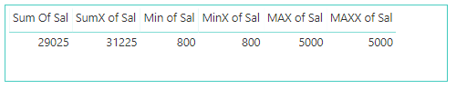

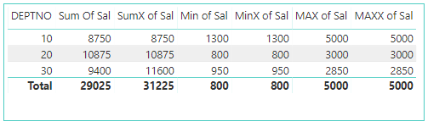

**COUNT**

Counts the number of cells in a column that contain numbers.

**Syntax**

COUNT (<column>)

**Example**

COUNT Example = COUNT(EMP[SAL])

Count Example1 = COUNT (EMP [COMM])

**COUNTX**

Counts the number of rows that contain a number or an expression that evaluates to a number, when evaluating an expression over a table.

**Syntax**

COUNTX (<table>, <expression>)

**Example**

COUNTX Example = COUNTX (EMP, EMP[SAL]+EMP[COMM])

**AVERAGE**

AVERAGE Function Will Returns the average of all the numbers in a column.

**Syntax**

AVERAGE (<column>)

**Example**

Average Example = AVERAGE(EMP[SAL])

Average of COMM = AVERAGE(EMP[COMM])

**AVERAGEX**

Calculates the average of a set of expressions evaluated over a table.

**Syntax**

AVERAGEX (<table>, <expression>)

**Example**

AVERAGEX Example = AVERAGEX (EMP, EMP[SAL]+EMP[COMM])

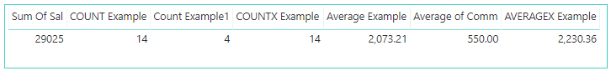

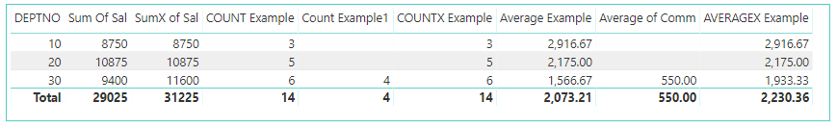

**COUNTROWS**

Counts the number of rows in the specified table, or in a table defined by an expression.

**Syntax**

COUNTROWS (<table>)

**Example**

COUNTROWS Example = COUNTROWS(EMP)

**COUNTBLANK**

Counts the number of blank cells in a column.

**Syntax**

COUNTBLANK (<column>)

**Example**

COUNTBLANK Example = COUNTBLANK(EMP[COMM])

**RANKX**

The RANKX function is used in DAX to create rankings.

Ranks allow you to easily compare products, salespeople or anything else that you want to evaluate the performance.

RANKX is a scalar function and it is also an iterator. The RANKX function can optionally take a Value argument that represents a scalar value whose rank is to be found. The optional Order argument specifies how to rank Value, descending (0) or ascending (1). The optional Ties argument defines how to determine ranking when there are ties (Same Ranks). Skip (default) will use the next rank value after a tie, and Dense will use the next rank value (i.e. there will be no gaps in the rank numbers).

Optional arguments might be skipped by placing an empty comma (,) in the argument list, i.e. RANKX = RANKX (EMP, EMP[SAL],,,Dense)

**Syntax**

RANKX (TABLE, EXPRESSION [, VALUE] [, ORDER] [, TIES]…)

Dense – will not Skip Between Rank Numbers

**Examples**

RANKX = RANKX (EMP, EMP[SAL])

Category Rank =

-- STEP 3. Rank my expression against the sorted list from 2.

RANKX (

-- STEP 1. Loop the rows in this table

ALL(EMP[DEPTNO]),

-- STEP 2. Run this expression for each loop

CALCULATE (

SUM(EMP[SAL])

)

)

**SUMMARIZE**

Summarize Functions Returns a "summary table or Aggregate Table" for the requested totals over a set of groups.

DeptJobSAL = SUMMARIZE(emp,Dept[DEPTNO],Emp[JOB],"CountOfEmp",COUNT(Emp[EMPNO]),"SumOfSal",SUM(Emp[SAL]))

**6. DAX Functions - Filter Functions**

**CALCULATE**

**CALCULATE** Functionevaluates a given expression or formula under a set of defined filters. We Know that in many visualizations, we want to show only a sub set of data instead of creating visualizations and filtering we will filter the measure value using **CALCULATE** Function.

**Syntax**

CALCULATE (<expression>, <filter1>, <filter2>…)

**Examples**

SumOfSales = SUM (Orders [Sales])

EastRegionSales = CALCULATE ([SumOfSales], Orders [Region] ="East")

EastCentralSales=

CALCULATE ([SumOfSales], Orders [Region] ="East" || Orders [Region] ="Central")

EastTechSales=

CALCULATE ([SumOfSales], Orders [Region] ="East", Orders [Category] ="Technology")

Between each filter condition it will use AND operation.

**ALL**

**ALL** Function returns all the rows in a table, or all the values in a column, ignoring any filters that might have been applied.

This function is useful for clearing filters and creating calculations on all the rows in a table or column.

**Syntax**

ALL ({**<table> | <column>** [, <column> [, <column> […]]]})

**<Table> | <column>**

The “table or column” that you want to clear filter on. If you want you can add multiple columns to clear filter.

**Examples**

%Sales = [SumOfSales] /CALCULATE ([SumOfSales], ALL (Orders [Category]))

% Sales = [SumOfSales] /CALCULATE ([SumOfSales], ALL (Orders))

Achieving %Sales is a reasonably easy task using simple implicit measures in Power BI as shown in below.

Drag Category, Sales twice into Visuals. The Visual will give Below Output.

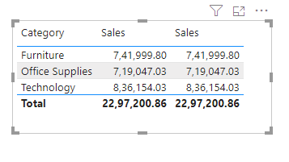

To get %Sales Go to the Field wells and Click on Expand button as shown below.

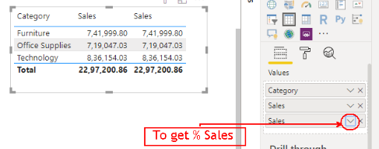

By Default as shown in below image “**Show Value as**” Selected as “No Calculation”, so that it will result Default “Sum of Sales”.

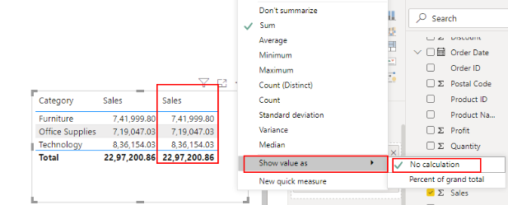

Change “**Show Value as**” to “**Percent of grand total”** to get expected **% Sales** results

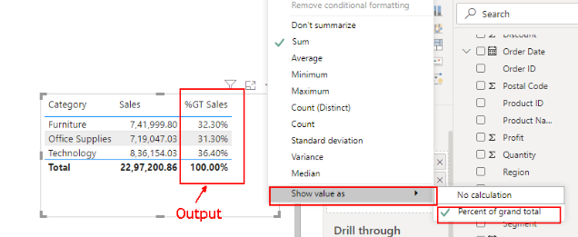

**ALLSELECTED**

**ALLSELECTED** willreturns all the rows in a table, or all the values in a column, ignoring any filters that might have been applied inside the query or Visualization, but keeping filters that come from outside slicer.

%Sales = [SumOfSales]/CALCULATE ([SumOfSales], ALL (Orders))

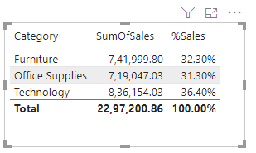

When You Filter the Visual using the Slicer based on Region Column, you will see the below results.

%Sales = [SumOfSales]/CALCULATE ([SumOfSales], ALL (Orders))

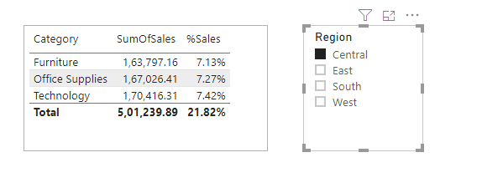

%SalesAllSelected =

[SumOfSales]/CALCULATE (SUM (Orders [Sales]), ALLSELECTED (Orders))

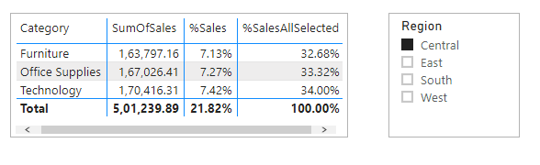

**ALLEXCEPT**

Removes all context filters in the table except filters that have been applied to the specified columns.

1. Calculate Category wise %Sales

%Sales = [SumOfSales]/CALCULATE ([SumOfSales], ALL (Orders))

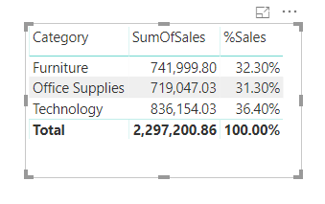

1. Calculate Category wise %Sales for each Region

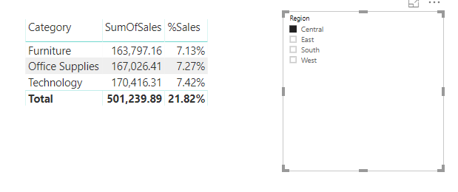

%Sales = [SumOfSales]/CALCULATE ([SumOfSales], ALLEXCEPT (Orders, Orders [Region]))

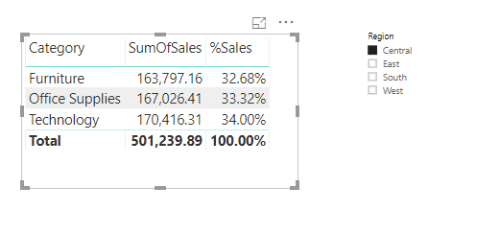

**RELATED**

Returns a related value from another table.

The RELATED function requires that a relationship exists between the current table and the table with related information. You specify the column that contains the data that you want, and the function follows an existing **many-to-one** relationship to fetch the value from the specified column in the related table. If a relationship does not exist, you must create a relationship.

**Syntax**

RELATED (<column>)

**Example**

Person = RELATED(People[Person])

**\*\*\*USERELATIONSHIP**

Specifies the relationship to be used in a specific calculation as the one that exists between columnName1 and columnName2.

Sum of Sales Ship Date = CALCULATE(SUM(Orders[Sales]), USERELATIONSHIP(Dim_Date[Date], Orders [Ship Date]))

**NATURALINNERJOIN**

**NATURALLEFTOUTERJOIN**

**CROSSJOIN**

**CALCULATETABLE**

**RELATEDTABLE**

**LOOKUPVALUE**

LOOKUPVALUE Function will Returns the value in result_columnName for the row that meets all criteria specified by search_columnName and search_value.

**Syntax**

LOOKUPVALUE (<result_columnName>, <search_columnName>, <search_value> [, <search_columnName>, <search_value>]… [, <alternateResult>])

DName = LOOKUPVALUE (Dept [DNAME], Dept [DEPTNO], Emp [DEPTNO])

The value will return for result_column for the Rows where all pairs of search_column and search_value have a match.

If there is no match a BLANK will return when You Don’t Supply Alternative Result, if supplied Alternative Result will be returned.

If multiple rows match the search values and in all cases result_column values are identical then that value is returned.

However, if result_column returns different values an error or alternateResult, if supplied, is returned.

To get Related Value using LOOKUPVALUE function we no need to Have Relationship B/W Tables.

In LOOKUPVALUE function we can write Multiple Conditions

QtySold = LOOKUPVALUE(Sales[QtySold],Sales[Category],Product[Category],Sales[ProductCode],Product[ProductCode])

CALCULATE

CALCULATE Function Evaluates an expression in a context modified by filters.

CALCULATETABLE

Evaluates a table expression in a context modified by filters.

FILTER

Returns a table that has been filtered.

**FILTER**

The FILTER function is used to return a subset of a table or expression.

CentralOrders = FILTER(Orders,Orders[Region]="Central")

Above Formula will create a New table with only Central Region Orders.

In many cases you can use the CALCULATE function instead of the FILTER function to produce the same results (the resulting formula is usually easier to understand, too).

Filter = CALCULATE(SUM(Orders[Sales]), FILTER (orders, Orders[Region]="South" || Orders[Segment]="Home Office"))

**7. DAX Functions - Time Intelligence Functions**

**Time Intelligence**

What is Time Intelligence?

Time Intelligence means doing calculations over periods of time or dates. All the Time Intelligence Functions will need a **date column** to perform the calculations, and this date column should contain **unique**, **no null** and **contiguous** date values to get the accurate results.

Time Intelligence simply means doing BI calculations over periods of time, or over dates. For example, a common request in many reports is to show a value, such as Sales, aggregated month-by-month, from the beginning of each year, so that you know, in this case, what were the total sales, in that year, up to the given month. DAX, Data Analysis Expressions, the language of Power BI, includes many predeﬁned time intelligence functions, including **TOTALYTD**, which is exactly the function you need to use in this particular scenario.

Many data analysts prefer to create their own date tables, which is fine. In Power BI Desktop, you can specify the table you want your model to use as its date table, and subsequently create date-related visuals, tables, measures, and so on, using that table's date data. When you specify your own date table, you control the date hierarchies created in your model, and use them in measures and other operations that use your model's date table.

To make DAX Time Intelligence functions work properly set date dimension table as “**Mark as date table”.**

**Setting your own date table**

To set a date table select the table you want to use as a date table in the Fields pane, then right-click the table and select Mark as date table 🡪 Mark as date table in the menu that appears, as shown in the following image.

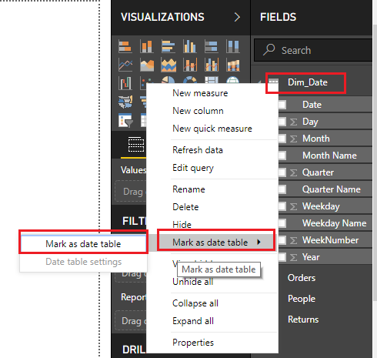

You can also select the table and then select **Mark as Date Table** from the **Modeling ribbon**, shown here.

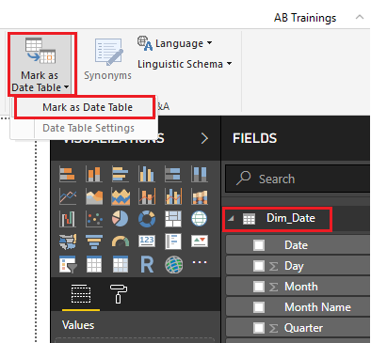

When you specify your own date table, Power BI Desktop performs the following validations of that column and its data, to ensure that the data

* contains unique values
* contains no null values
* contains contiguous date values (from beginning to end)
* if it is a Date/Time data type, it has the same timestamp across each value

Once you specify a date table, you can select which column in that table is the date column. You can specify which column to use by selecting the table in the Fields pane, then right-click the table and select Mark as date table 🡪 Date table settings. The following window appears, where you can select the column to use as the date table from the drop-down box.

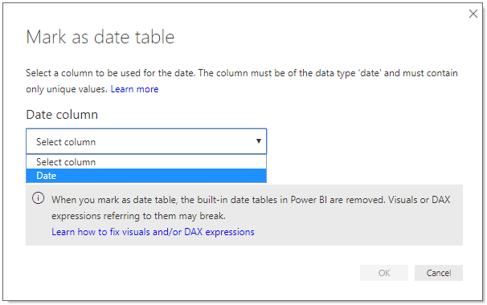

**DAX Time Intelligence Functions**

All the Time Intelligence Functions will need a **date column** to perform the calculations, and this date column should contain **unique**, **no null** and **contiguous** date values to get the accurate results.

**TOTALMTD**

Evaluates the value of the expression for the month to date, in the current context. TOTALMTD will give Running Totals or cumulative sum for each Month.

**Example**

Total MTD = TOTALMTD(SUM(Orders[Sales]), Dim_Date[Date])

**TOTALQTD**

Evaluates the value of the expression for the dates in the quarter to date, in the current context. TOTALQTD will give Running Totals or cumulative sum for each Quarter.

**Example**

Total QTD = TOTALQTD(SUM(Orders[Sales]), Dim_Date[Date])

**TOTALYTD**

Evaluates the year-to-date value of the expression in the current context. TOTALYTD will give Running Totals or cumulative sum for each year.

**Example**

Total YTD = TOTALYTD(SUM(Orders[Sales]), Dim_Date[Date])

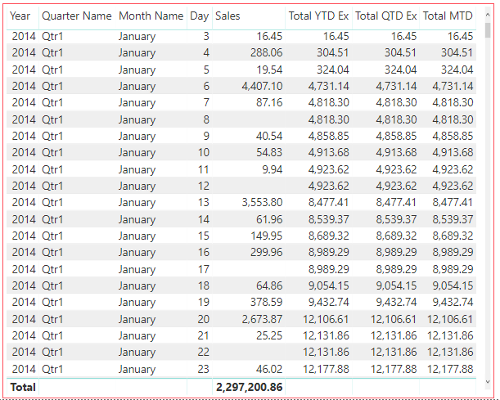

**PREVIOUSDAY**

Returns a table that contains a column of all dates representing the day that is previous to the first date in the dates column, in the current context.

**Example**

Previous Day = CALCULATE(SUM(Orders[Sales]), PREVIOUSDAY(Dim_Date[Date]))

**PREVIOUSMONTH**

Returns a table that contains a column of all dates from the previous month, based on the first date in the dates column, in the current context.

**Example**

Previous Month = CALCULATE(SUM(Orders[Sales]), PREVIOUSMONTH(Dim_Date[Date]))

**PREVIOUSQUARTER**

Returns a table that contains a column of all dates from the previous quarter, based on the first date in the dates column, in the current context.

**Example**

Previous Quarter = CALCULATE(SUM(Orders[Sales]), PREVIOUSQUARTER(Dim_Date[Date]))

**PREVIOUSYEAR**

Returns a table that contains a column of all dates from the previous year, given the last date in the dates column, in the current context.

**Example**

Previous Year = CALCULATE(SUM(Orders[Sales]), PREVIOUSYEAR(Dim_Date[Date]))

**NEXTDAY**

Returns a table that contains a column of all dates from the next day, based on the first date specified in the dates column in the current context.

**Example**

Next Day = CALCULATE ([Sum of Sales], NEXTDAY(Dim_Date[Date]))

**NEXTMONTH**

Returns a table that contains a column of all dates from the next month, based on the first date in the dates column in the current context.

**Example**

Next Month = CALCULATE ([Sum of Sales], NEXTMONTH(Dim_Date[Date]))

**NEXTQUARTER**

Returns a table that contains a column of all dates in the next quarter, based on the first date specified in the dates column, in the current context.

**Example**

Next Quarter = CALCULATE ([Sum of Sales], NEXTQUARTER(Dim_Date[Date]))

**NEXTYEAR**

Returns a table that contains a column of all dates in the next year, based on the first date in the dates column, in the current context.

**Example**

Next Year = CALCULATE ([Sum of Sales], NEXTYEAR(Dim_Date[Date]))

**SAMEPERIODLASTYEAR**

Returns a table that contains a column of dates shifted one year back in time from the dates in the specified dates column, in the current context.

**Example**

LastYearSales = CALCULATE(SUM(Orders[Sales]), SAMEPERIODLASTYEAR(Dim_Date[Date]))

By using **same period last year**, you will be knowing

* Last Year Same Month what is the value
* Last Year Same Quarter what is the value
* Last Year what is the Value

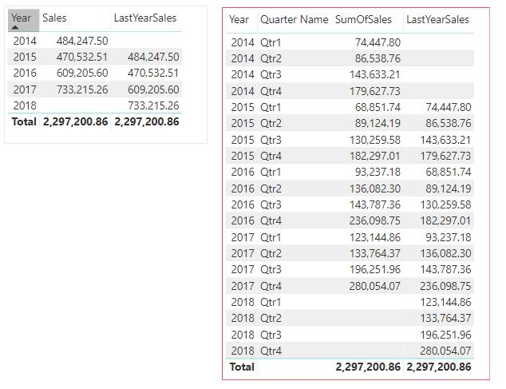

**Year Over Year (YOY Growth)**

Current Year Sales = SUM(Orders[Sales])

Last Year Sales = CALCULATE (SUM(Orders[Sales]), SAMEPERIODLASTYEAR(Dim_Date[Date]))

% YOY = DIVIDE ([Current Year Sales], [Last Year Sales], "NO LY Data")

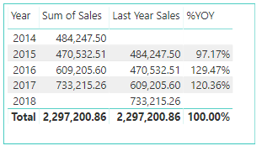

**MOM Growth**

Sum of Sales = SUM(Orders[Sales])

Last Month Sales = CALCULATE(SUM(Orders[Sales]), PREVIOUSMONTH(Dim_Date[Date]))

% MOM = DIVIDE ([Sum of Sales], [Last Month Sales])

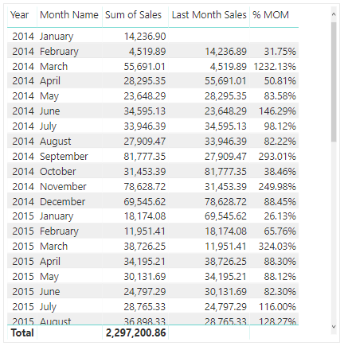

**8. Variables in DAX**

**Understanding Variables in DAX**

* Variables are used to store results from DAX Expressions.
* A Variable can be a hardcoded value or the result of a complex DAX Expression.
* Variables can be used in any type of DAX calculation including calculated columns, measures, and tables.
* Advantages - Code Readability and Performance.

**Syntax**

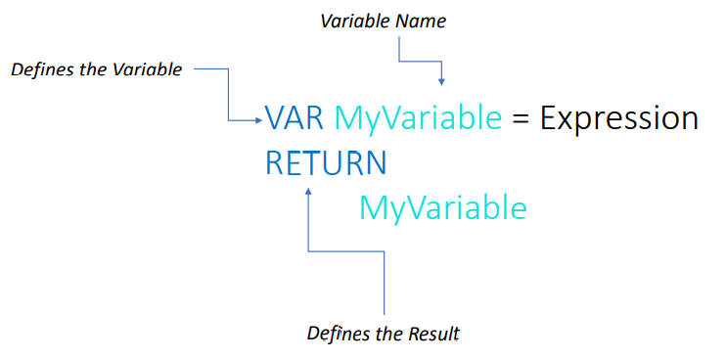

The VAR keyword introduces the definition of a variable. You can have as many variables as needed in a single expression, and each one has its own VAR definition. The RETURN keyword defines the expression to return as the result. Inside RETURN expression, you can use the variables, which are replaced by the computed value.

**Uses of Variables**

A very frequent usage of variables is to divide the calculation of a complex formula into logical steps, by assigning the result of each step to a variable.

%Sales =

**VAR** **SumOfSales**=SUM(Orders[Sales])

**VAR** **AllSales**=CALCULATE(SUM(Orders[Sales]),ALL(Orders))

**Return**

**SumOfSales**/**AllSales**

% YoY Growth =

**VAR** **CYSALES** = SUM(Orders[Sales])

**VAR** **PYSALES** = CALCULATE(SUM(Orders[Sales]),PREVIOUSYEAR(Dim_Date[Date]))

**RETURN**

DIVIDE(**CYSALES**-**PYSALES**,**PYSALES**)

DelSpeed =

IF (

( Orders[Ship Date] - Orders[Order Date] <= 2 ),

"QuickDel",

IF ( ( Orders[Ship Date] - Orders[Order Date] <= 5 ), "NormalDel", "LateDel" )

)

DelSpeedVar =

VAR DeltaDays = Orders[Ship Date] - Orders[Order Date]

RETURN

IF (DeltaDays <= 2, "QuickDel", IF (DeltaDays <= 5, "NormalDel", "LateDel" ) )

**9.ALL, ALLSELECTED _ ALLEXCEPT**

**ALL, ALLSELECTED & ALLEXCEPT**

**Requirement 1**

Calculating the percentage of the total (ALL)

**ALL**

ALL Function will Returns all the rows in a table, or all the values in a column, ignoring any filters that might have been applied.

ALL ( [<TableNameOrColumnName>] [, <ColumnName> [, <ColumnName> [, … ] ] ] )

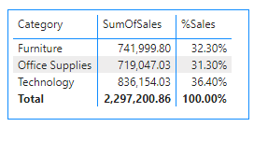

**Requirement 2**

Consider the filters applied to the visual (ALLSELECTED)

**ALLSELECTED**

ALLSELECTED Function will Returns all the rows in a table, or all the values in a column, ignoring any filters that might have been applied inside the query, but keeping filters that come from outside.

ALLSELECTED ( [<TableNameOrColumnName>] [, <ColumnName> [, <ColumnName> [, … ] ] ] )

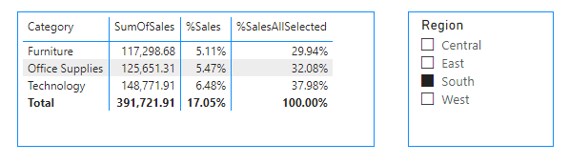

**Requirement 3**

How to calculate the percentage of the parent total? (ALLEXCEPT)

When dealing with hierarchical data, the requirement is to calculate % of the parent total.

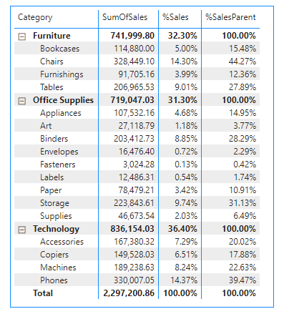

In the example above, there are two levels of filter contexts applied

Level 1: Product Category

Level 2: Product Sub-Category

The objective is to keep filters at Level 1 and not at Level 2

%ParentSales =  
SUM (Orders [Sales])  
    / CALCULATE ([SumOfSales], ALLEXCEPT (Orders, Orders [Category]))

When used as a modifier in CALCULATE, ALLEXCEPT removes the filters from the expanded table specified in the first argument, keeping only the filters in the columns specified in the following arguments.

ALLEXCEPT ( <TableName>, <ColumnName> [, <ColumnName> [, … ] ] )